The FRC model is designed to work collaboratively with partner agencies as part of a linked service system to engage, empower and enable individuals, families, and the wider community to make positive and lasting change.

The policy context for the FRC is aligned with, and achieves outcomes relevant to, several Queensland Government objectives and initiatives.
The Commission’s activities support the broader welfare reforms implemented across Cape York Peninsula since 2008 and the Queensland Government’s Objectives for the Community:
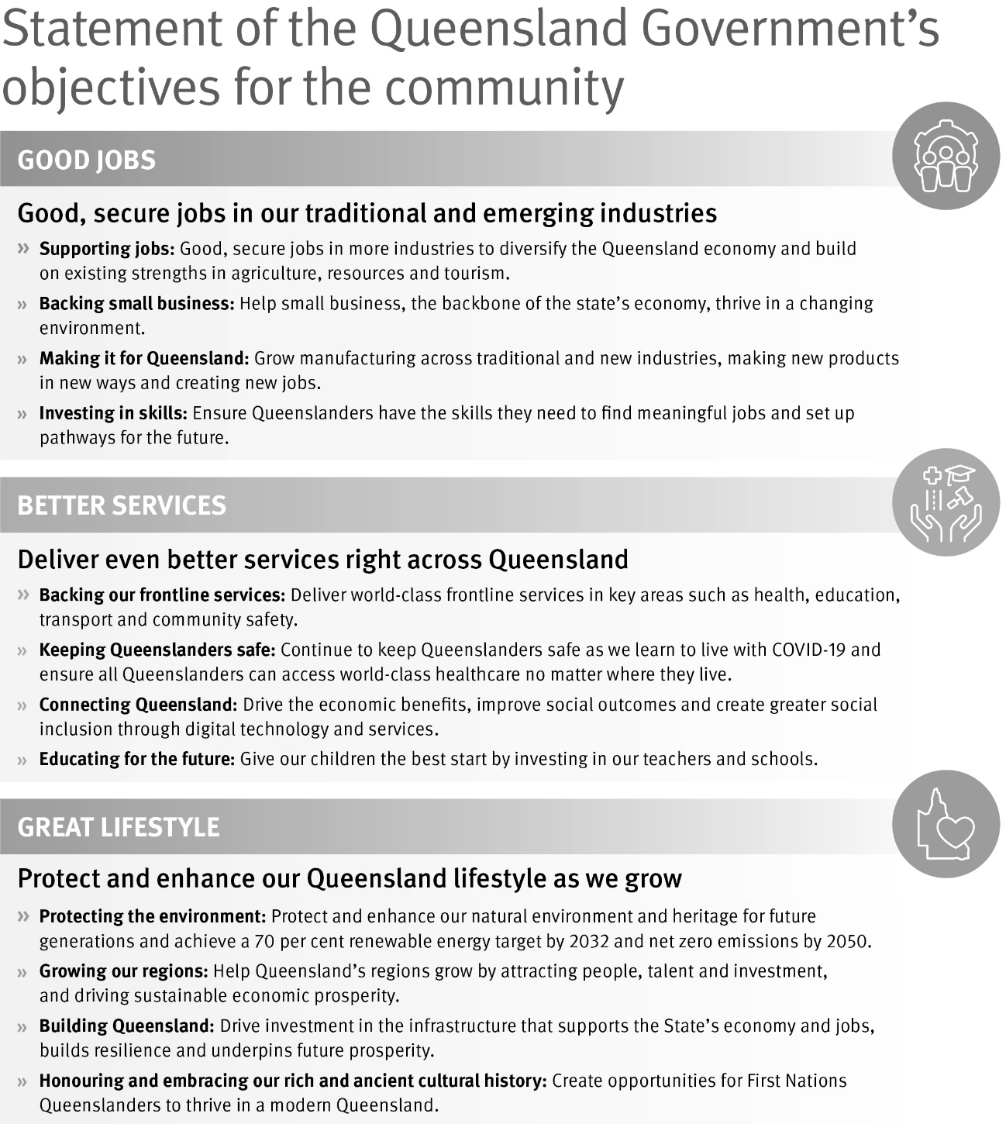
The Commission delivers services to five communities, all of which are culturally unique and some of which are geographically remote. Each community is different, yet each can be characterised by the entrenched disadvantage of Indigenous community members. High rates of welfare dependency and multi-generational poverty have resulted in communities with individuals and their families who have complex needs.
In meeting this challenge, the Commission works with community-based service providers and partner agencies with statutory requirements under the FRC Act and the Department of Treaty, Aboriginal and Torres Strait Islander Partnerships, Communities and the Arts (DTATSIPCA) as part of a linked service system to achieve individualised client outcomes.
In doing so the FRC complements several Queensland Government strategies and reforms such as:
- ‘Our Way’ strategy and ‘Breaking Cycles’ action plan – to build upon existing initiatives such as the FRC to ensure Indigenous children grow up in a safe and nurturing environment and address the over-representation of Indigenous children in Queensland’s child protection system. A detailed analysis of the alignment between the ‘Our Way’ strategy and the FRC Act can be found at Appendix B.
- ‘Path to Treaty’ – the Path to Treaty is a shared journey between the Queensland Government, Aboriginal and Torres Strait Islander peoples and non-Indigenous people – a key reform with the ultimate goal of negotiating a treaty, or treaties. The principle of Indigenous local authority is a cornerstone of the FRC model and is a primary example of true self-determination by Aboriginal people as decision-makers, supporting their community members to overcome life challenges and become primarily responsible for their own wellbeing.
- ‘Local Thriving Communities’ reform – reframing and reforming how the Queensland Government works with Indigenous communities to deliver better outcomes through the establishment and continued operations of the FRC (with locally appointed decision-makers) after extensive consultation with each of the five welfare reform community areas.
- ‘Queensland Indigenous Procurement Policy’ – providing a whole-of-government framework to increase procurement with Indigenous businesses to grow and develop a diverse and sustainable Indigenous business sector and improve employment outcomes and opportunities for Aboriginal and Torres Strait Islander peoples. The FRC’s annual budget (the reader is referred to page 90) allocates 69% to frontline operations, with the chief purpose of facilitating conferences and hearings in remote Aboriginal communities and undertaking ongoing case management of clients in collaboration with local service providers. This expenditure directly benefits local and regional economies and is consistent with the objectives of both the Queensland Indigenous Procurement Policy.

The FRC’s performance and activity data show linkages between client outcomes and the FRC’s strategic objectives and indicators.
The following statistical report and analysis of the Commission’s non-financial performance outcomes is for the period 1 July 2023 to 30 June 2024. This data, additional to the statistical information cited elsewhere in this report, is used by the FRC’s EMT to monitor the organisation’s progress in achieving the main objectives of the Strategic Plan 2023-2027.

The FRC knows its clients and communities.
From 1 July 2023 to 30 June 2024, the Commission received a total of 7,546 agency notices across a range of notifiable behaviours of which 5,067 notices relating to 1,186 clients were within jurisdiction, comprising:
Table 1: In jurisdiction notices by type and community 1 July 2023 to 30 June 2024
Type of notice | AU | CO | DM | HV | MG | Total
Supreme Court | 0 | 0 | 0 | 0 | 0 | 0
District Court | 24 | 1 | 0 | 0 | 4 | 29
Magistrates Court | 1,203 | 46 | 0 | 226 | 42 | 1,517
Domestic Violence Breach | 63 | 6 | 0 | 37 | 12 | 118
Domestic Violence Order | 125 | 14 | 0 | 65 | 17 | 221
School Attendance | 785 | 59 | 1,297 | 533 | 103 | 2,777
School Enrolment | 1 | 0 | 1 | 6 | 0 | 8
Child Safety and Welfare
Child Concern Reports | 113 | 12 | 126 | 61 | 7 | 319
Finalised Child  Protection Investigations | 37 | 0 | 2 | 23 | 4 | 66
Housing Tenancy | 9 | 0 | 0 | 1 | 2 | 12
Total | 2,360 | 138 | 1,426 | 952 | 191 | 5,067

Further details of notices within jurisdiction for each community are set out below:
- Aurukun (AU) received 2,360 notices relating to 489 clients (266 female and 223 male)
- Coen (CO) received 138 notices relating to 52 clients (25 female and 27 male)
- Doomadgee (DM) received 1,426 notices relating to 312 clients (218 female and 94 male)
- Hope Vale (HV) received 952 notices relating to 281 clients (144 female and 137 male)
- Mossman Gorge (MG) received 191 notices relating to 52 clients (29 female and 23 male).
Table 2: In jurisdiction notices by type and quarter 1 July 2023 to 30 June 2024
Type of notice | Qtr 61 | Qtr 62 | Qtr 63 | Qtr 64 | Total
Supreme Court | 0 | 0 | 0 | 0 | 0
District Court | 2 | 10 | 1 | 16 | 29
Magistrates Court | 432 | 378 | 322 | 385 | 1,517
Domestic Violence Breach | 47 | 29 | 21 | 21 | 118
Domestic Violence Order | 51 | 63 | 57 | 50 | 221
School Attendance | 745 | 693 | 619 | 720 | 2,777
School Enrolment | 1 | 0 | 1 | 6 | 8
Child Safety and Welfare | 150 | 93 | 65 | 77 | 385
Housing Tenancy | 6 | 0 | 1 | 5 | 12
Total | 1,434 | 1,266 | 1,087 | 1,280 | 5,067

Table 3: In jurisdiction notices by community and quarter 1 July 2023 to 30 June 2024
Number of notices | Qtr 61 | Qtr 62 | Qtr 63 | Qtr 64 | Total
Aurukun | 577 | 606 | 543 | 634 | 2,360
Coen | 68 | 22 | 22 | 26 | 138
Doomadgee | 407 | 345 | 313 | 361 | 1,426
Hope Vale | 317 | 246 | 176 | 213 | 952
Mossman Gorge | 65 | 47 | 33 | 46 | 191
Total | 1,434 | 1,266 | 1,087 | 1,280 | 5,067

Our clients have complex needs.
Over-crowded housing, high rates of Indigenous welfare dependency and multi-generational poverty have resulted in communities with high numbers of individuals and families with complex needs. Table 4 provides some insight into the complexity of the issues faced by many clients. During the financial year 815 clients (69%) were notified to the Commission with only one type of notice, whilst the remaining 371 clients (31%) received more than one type of notice.

Table 4: FRC clients by the  number of types of  notices 1 July 2023  to 30 June 2024 |  |  | 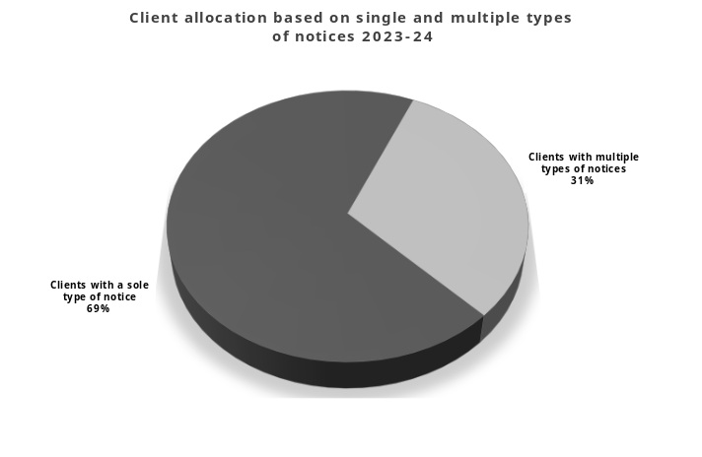
Number of types of notices received | Number of clients
1 | 815
2 | 280
3 | 71
4 | 19
5 | 1 |  | Graph 7: Client allocation based on single and multiple types of  notices 1 July 2023 to 30 June 2024
Total | 1,186

Analysis reveals the following information regarding the types of sole notices received by FRC clients during the reporting period:
- 35% received a school attendance (EQ) notice
- 18% received a Magistrates Court (MAG) notice
- 9% received a child safety and welfare (CS) notice
- 5% received a domestic violence order (DVO) notice
- 1% received a domestic violence breach (DVB) notice and
- 1% received a District Court (DIS) notice.
The remaining sole notices received for Commission clients were 1 client with a school enrolment breach (SEN) notice and 5 clients with a housing tenancy breach (HT) notice.
Additional insight into the complexity of issues faced by clients can be seen in the following table which shows the combination of notices received for the 371 clients with more than one type of notice. One can see that predominantly there is a nexus between court convictions and domestic violence orders/breaches with education notices and child safety issues, and also a strong nexus between child safety issues and education notices.

Table 5: FRC clients by number of types of notices 1 July 2023 to 30 June 2024
Type of notice/s | Number of clients |  | Type of notice/s³ | Number of clients
CS,DIS,DVB,DVO,MAG | 1 |  | DIS,DVO,MAG | 1
CS,DIS,DVO | 1 |  | DIS,MAG | 1
CS,DVB,DVO | 2 |  | DVB,DVO | 5
CS,DVB,DVO,EQ | 2 |  | DVB,DVO,EQ | 1
CS,DVB,DVO,MAG | 3 |  | DVB,DVO,EQ,MAG | 4
CS,DVB,EQ,MAG | 3 |  | DVB,DVO,MAG | 14
CS,DVB,MAG | 5 |  | DVB,DVO,MAG,SEN | 1
CS,DVO | 10 |  | DVB,EQ,MAG | 4
CS,DVO,EQ | 3 |  | DVB,MAG | 24
CS,DVO,EQ,MAG | 5 |  | DVO,EQ | 5
CS,DVO,MAG | 10 |  | DVO,EQ,MAG | 7
CS,EQ | 92 |  | DVO,HT,MAG | 2
CS,EQ,MAG | 16 |  | DVO,MAG | 51
CS,EQ,MAG,SEN | 1 |  | EQ,HT | 1
CS,EQ,SEN | 1 |  | EQ,HT,MAG | 1
CS,HT | 1 |  | EQ,MAG | 54
CS,MAG | 30 |  | EQ,MAG,SEN | 2
DIS,DVB | 2 |  | EQ,SEN | 2
DIS,DVB,MAG | 1 |  | HT,MAG | 1
DIS,DVO | 1
Total |  |  |  | 371

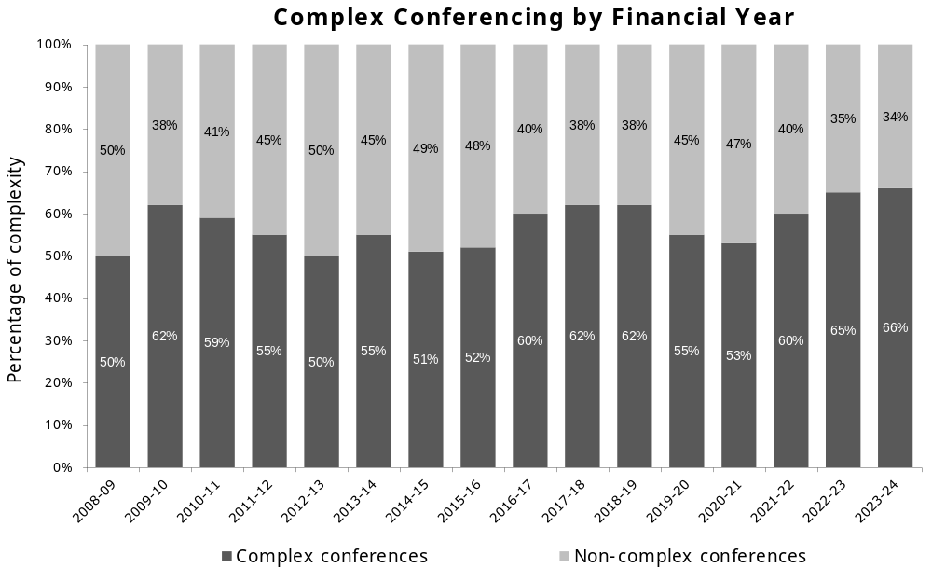
Most FRC conferences respond to high levels of complexity in terms of client needs. The FRC is primarily dealing with clients who suffer multiple and entrenched forms of disadvantage. There exists within this cohort clients who experience extreme complex disadvantage and are also unable or reluctant to seek support. In addition to the substantial work and preparation undertaken before every conference, the most complex matters represent a further ‘step up’ in the related workload. Conferencing such clients makes higher demands of the FRC to respond. The FRC has experienced an increase in the percentage of conferences conducted that are considered complex (whether it is multiple notices of the same type or multiple types of different notices) over the last three financial years.

Graph 8: Complex conferencing by financial year

The FRC improves community wellbeing by supporting the restoration of socially responsible standards of behaviour.
The FRC uses conferences as a forum to discuss with clients the issues outlined in an agency notice/s. Conferences are held in a manner which facilitates early intervention and encourages clients to take personal responsibility for their actions. From 1 July 2023 to 30 June 2024 a total of 984 conferences were held relating to 553 clients.

Table 6: Conferences by community and quarter 1 July 2023 to 30 June 2024
Conferences | Qtr 61 | Qtr 62 | Qtr 63 | Qtr 64 | Total
Aurukun | 88 | 122 | 92 | 85 | 387
Coen | 8 | 7 | 9 | 9 | 33
Doomadgee | 88 | 115 | 78 | 74 | 355
Hope Vale | 31 | 51 | 57 | 26 | 165
Mossman Gorge | 13 | 16 | 8 | 7 | 44
Total | 228 | 311 | 244 | 201 | 984

Conferences during the financial year resulted in 284 agreements to attend community support services (an increase of 7% from 2022-23), 100 orders made to attend community support services (a decrease of 32% from the previous reporting period) and 54 CIM orders issued (a 16% decrease from the previous reporting period). As a subset of the total number of conferences conducted for the financial year, 210 DV-related conferences were conducted in Aurukun, Coen, Hope Vale and Mossman Gorge, a decrease of 17% from 2022-23.

Clients on conditional income management
From 1 July 2023 to 30 June 2024, there was a total of 54 CIMs (a decrease of 16% from 64 CIMs in 2022-23) relating to 54 clients.
As at 30 June 2024, there were 13 clients subject to a CIM with 54% at 75 percent and 92% for a 6 month duration. As a subset of the total number of CIMs in the financial year, 8 CIMs were made at conference in relation to DV notifying behaviours.
The statistical information provided in graphs 9 and 10 demonstrates the FRC’s continued use of CIM is proportionate to the client’s circumstances and that CIM is used to encourage personal responsibility with terms and percentages of CIM orders and agreements adjusted according to the client’s progress or lack thereof. During the 2023-24 reporting period, 37% of CIM orders and agreements quarantined 60 percent, 41% of CIM orders and agreements quarantined 75 percent and 22% of CIM orders and agreements quarantined 90 percent of a client’s welfare payment. During the same period 83% were for a period of 6 months.

The Commission processed the 54 CIMs issued in 2023-24 as follows:
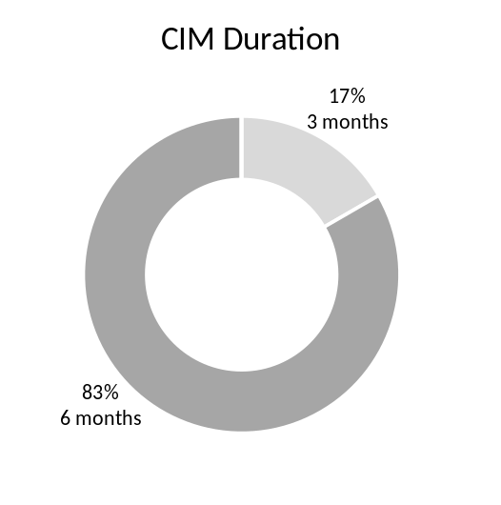 |  | 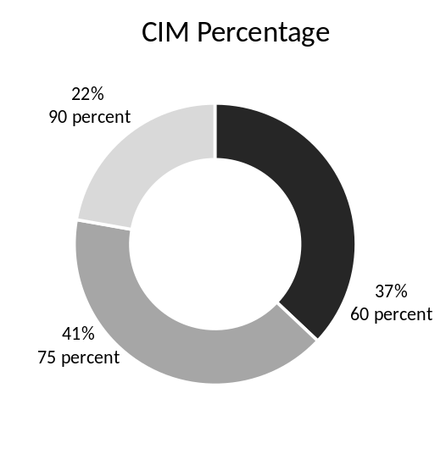
Graph 9: Breakdown of SmartCard CIMs by duration 1 July 2023 to 30 June 2024 |  | Graph 10: Breakdown of SmartCard CIMs by percentage 1 July 2023 to 30 June 2024

Clients on voluntary income management
The Commission processed 115 VIM agreements (a decrease of 3% from the 118 VIMs in 2022-23) for 104 clients (an increase of 4% from the 100 clients in 2022-23).
Since the commencement of the Commission, 397 clients (256 female and 141 male) have had an active VIM agreement. As at 30 June 2024, there were 63 clients on a VIM, with 81% at 60 percent and 33% for a 6 month duration and 52% for a 12 month duration.
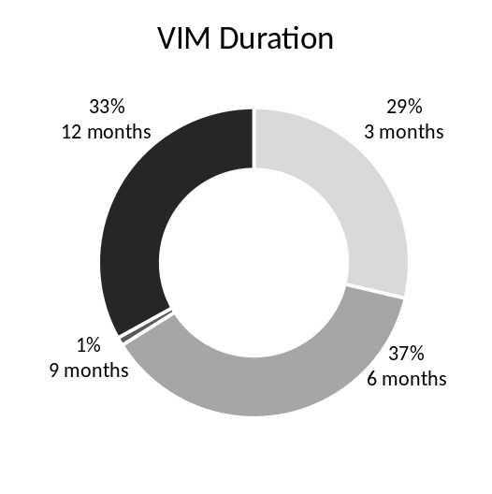
During the 2023-24 reporting period, 84% of VIMs quarantined 60 percent of a client’s welfare payment. During the same period, 29% were for a period of 3 months, 37% were for a period of 6 months, 1% were for a period of 9 months and 33% were for a period of 12 months.
 |  | 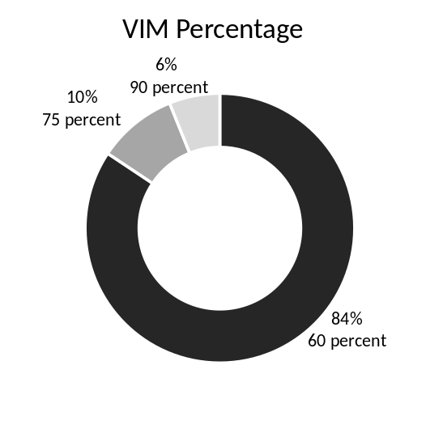
Graph 11: Breakdown of SmartCard VIMs by duration 1 July 2023 to 30 June 2024 |  | Graph 12: Breakdown of SmartCard VIMs by percentage 1 July 2023 to 30 June 2024

Conditional and voluntary income management age and gender breakdown
During 2023-24 most community members conditionally income managed by the FRC were in the 26-35 year age group, and females accounted for 80% of all the CIM orders and agreements. No community members older than 55 years were conditionally income-managed by the FRC during the financial year. For the 43 CIMs relating to females, 88% related to children in some way, whether it was for a notice regarding school attendance or school non-enrolment, or for a notice regarding child safety and welfare. For the 11 CIMs relating to males, 45% related to children in some way. These figures correlate to the often-female role of caregiver in the family structure.
The age ranges of clients exercising the option for VIM spanned all age cohorts from 18 to 85. Again, females represented the majority of all VIM agreements at 67%.

Graph 13: Breakdown of
SmartCard CIMs
by age cohort and gender
1 July 2023 to 30 June 2024
Graph 14: Breakdown of
SmartCard VIMs
by age cohort and gender
1 July 2023 to 30 June 2024

Voluntary income management respondent reasons
Since the introduction of the CDC and its replacement, the SmartCard, the FRC has recorded the reasons and circumstances of those requesting a VIM. During 2023-24 the primary reasons for applying for a VIM (reactive perspective) were to address the immediate need of buying food (83%) and to pay for bills (57%). The primary reasons for applying for a VIM from a proactive perspective were to set up a budget (60%) and save for something the client needed, e.g. a fridge or washing machine (50%). Circumstances given by the VIM participants when applying for the card were primarily to support themselves (83%), followed by the need to support their family (43%) and the need to support their children (34%).

Graph 15: Breakdown of SmartCard VIMs by circumstances
1 July 2023 to 30 June 2024
Graph 16: Breakdown of SmartCard VIMs  by reasons 1 July 2023 to 30 June 2024 | Future needs – proactive actions

The FRC improves community responsibility by building partnerships and helping people to resume primary responsibility.

Referrals help build individual client capabilities.
Referrals to service providers are an integral part of achieving the Commission’s strategic outcomes of improved community wellbeing and responsibility.
During 2023-24 a grand total of 662 referrals were put in place (inclusive of referrals from FRAs, orders and VCPs) relating to 454 clients.
As a subset of the above, during this reporting period 472 referrals were made (inclusive of FRAs and orders) to attend support services for 342 clients.

Table 7: FRC conditional referral pathways by referral type and quarter 1 July 2023 to 30 June 2024
Referral type | Qtr 61 | Qtr 62 | Qtr 63 | Qtr 64 | Total
Aurukun Mediation | 1 | 0 | 0 | 0 | 1
Cape Mental Health Alcohol and Other Drugs Services | 0 | 0 | 1 | 0 | 1
Cape York Employment | 1 | 1 | 1 | 0 | 3
Coen Regional Aboriginal Corporation | 2 | 2 | 5 | 2 | 11
Cooktown District Community Centre | 0 | 10 | 4 | 1 | 15
Gungarde (Family Wellbeing Services) | 1 | 3 | 1 | 0 | 5
Jabalbina Aboriginal Corporation | 0 | 1 | 0 | 0 | 1
Mossman Elders Justice Group | 0 | 3 | 2 | 1 | 6
MPower | 17 | 22 | 11 | 11 | 61
My Pathways | 1 | 3 | 1 | 0 | 5
Police-Citizens Youth Club | 0 | 1 | 0 | 1 | 2
QLD Health | 2 | 2 | 1 | 1 | 6
RAATSICC (Family Wellbeing Services) | 1 | 8 | 9 | 1 | 19
54 Reasons/Save the Children | 6 | 11 | 6 | 4 | 27
School Attendance Officer | 26 | 31 | 14 | 30 | 101
School Re-Engagement Program | 0 | 1 | 0 | 0 | 1
Wellbeing Centre - Apunipima | 33 | 63 | 58 | 44 | 198
Wellbeing Centre - NWRH | 1 | 5 | 0 | 2 | 8
Wuchopperen Health Service Ltd. | 0 | 0 | 1 | 0 | 1
Total | 92 | 167 | 115 | 98 | 472

The number of referrals from FRAs and orders for the financial year represents a slight decrease of 5% from the previous reporting period of 499 referrals. As a subset of the total number of these referrals, 142 referrals were made in relation to DV conferences.
A further 190 voluntary referrals (an increase of 245% from the 55 reported in 2022-23) to attend support services were requested from 152 clients.
Table 8: FRC voluntary referral pathways by referral type and quarter 1 July 2023 to 30 June 2024
Referral type | Qtr 61 | Qtr 62 | Qtr 63 | Qtr 64 | Total
Cape York Employment | 0 | 0 | 0 | 1 | 1
Coen Regional Aboriginal Corporation | 0 | 3 | 1 | 1 | 5
Cooktown District Community Centre | 0 | 2 | 4 | 14 | 20
Jabalbina Aboriginal Corporation | 0 | 0 | 4 | 1 | 5
Mossman Elders Justice Group | 0 | 1 | 4 | 0 | 5
MPower | 11 | 18 | 16 | 10 | 55
My Pathways | 0 | 0 | 1 | 0 | 1
QLD Health | 0 | 0 | 3 | 0 | 3
54 Reasons/Save the Children | 1 | 0 | 0 | 0 | 1
School Attendance Officer | 5 | 4 | 8 | 15 | 32
Wellbeing Centre - Apunipima | 10 | 8 | 25 | 19 | 62
Total | 27 | 36 | 66 | 61 | 190

Show Cause hearings are another tool available to hold clients accountable.
From 1 July 2023 to 30 June 2024 no Show Cause hearings were held. These hearings are intended by the FRC Act to be a formal mechanism to address non-compliance with a requirement under a case plan to attend a community support service.
Similar to the 2022-23 reporting period, no clients were issued with a Show Cause notice to come before the Commission for non-compliance of their case plan/s due to the following:
- limitations on availability of support services on the ground
- capacity of support services to accept and deal with the existing number of referrals from the FRC
- lack of confirmation from support services in some cases that client engagement has been attempted
- limited, (or no) information from which to proceed on a Show Cause for non-compliance
- ability to implement a CIM order at 90% to address non-compliance.
The need to conduct Show Cause assessments has also been diverted as a result of the number of clients demonstrating proactive steps to take personal accountability for their actions and commit to a journey towards self-improvement. This is demonstrated by clients entering into agreements to willingly accept referrals and be placed on a case plan, along with those self-referring community members seeking to voluntarily participate in income management and voluntary referrals.

Applications to amend/end agreements or orders
From 1 July 2023 to 30 June 2024, 26 applications relating to 24 clients (19 females and 5 males) to amend or end an agreement (including a voluntary agreement) or order were received. Where an amend/end application is received at the end of a financial year the decision on the application may take place in the following financial year.

Table 9: Applications to amend or end agreements or orders by community and quarter
1 July 2023 to 30 June 2024
Number of applications | Qtr 61 | Qtr 62 | Qtr 63 | Qtr 64 | Total
Aurukun | 2 | 2 | 3 | 6 | 13
Coen | 1 | 2 | 0 | 0 | 3
Doomadgee | 0 | 0 | 0 | 1 | 1
Hope Vale | 2 | 3 | 3 | 0 | 8
Mossman Gorge | 1 | 0 | 0 | 0 | 1
Total | 6 | 7 | 6 | 7 | 26

Application decisions
From 1 July 2023 to 30 June 2024, a total of 25 applications were decided:
- 6 applications for FRAs and orders
- 19 applications for VIMs.

Out of the 25 decisions made, 92% (23) of all applications were granted, whilst 2 were refused because the statutory requirements were not met.
Accepted applications to amend or end FRAs or orders were as follows:
- 3 CIM orders ended
- 2 CIM orders amended
- 1 CIM order and CCP ended.

Accepted applications to amend or end VIM agreements were as follows:
- 14 VIM agreements ended
- 1 VIM agreement amended from 60 percent to 90 percent for the remaining period of the existing agreement
- 1 VIM agreement amended from 60 percent to 75 percent for the remaining period of the existing agreement
- 1 VIM agreement amended from 90 percent to 60 percent for the remaining period of the existing agreement.

Department of Education, Department of Child Safety, Seniors and Disability Services, Department of Housing, Department of Justice and Attorney-General (Queensland Courts) and the Queensland Police Service.
Agency notices for the community of Doomadgee are presently received from the Department of Education and the Department of Child Safety, Seniors and Disability Services only.
Descriptions for each type of notice acronym can be found in the glossary.
.A client may choose one or more options to reflect their individual reasons and circumstances in participating in voluntary income management and therefore the percentage is derived by using the number of VIM agreements as the divisor.

