Annual Report 2024-2025

Family Responsibilities Commission

The annual report of the Family Responsibilities Commission summarises the Commission and its financial and corporate performance for the period 1 July 2024 to 30 June 2025.
Only limited copies of this annual report will be available in hard copy. To obtain a copy please contact:
Family Responsibilities Commission
PO Box 5438
Cairns QLD 4870
Ph: (07) 4081 8400
Fax: (07) 4041 0974

Alternatively, you can visit our website to access an electronic version of the annual report: www.frcq.org.au


The Family Responsibilities Commission is committed to providing accessible information and services to Queenslanders from all cultural and linguistic backgrounds. To talk to someone about this annual report in your preferred language call (07) 4081 8400 and we will arrange an interpreter to effectively communicate the report with you.

© State of Queensland (Family Responsibilities Commission) 2025
ISSN – 1837-4565

The Commission recognises we are visitors to the country we travel across and work in. We acknowledge that many of our Local Commissioners are Traditional Owners and Elders of their communities of Aurukun, Coen, Doomadgee, Hope Vale and Mossman Gorge. The Commission acknowledges and pays our respects to the Traditional Owners, Elders and Teachers of these lands; to those of the past whose unseen hands guide the actions and decisions of the Commissioners today; to those of the present working for their communities setting the example for the next generation; and to those of the future, the Elders not yet born who will inherit the legacy of our efforts.

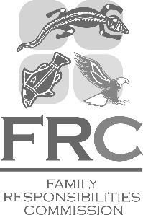 | Family Responsibilities Commission  184 Mulgrave Road, Cairns  PO Box 5438  Cairns Qld 4870  Ph: 07 4081 8400  Fax: 07 4041 0974  www.frcq.org.au

28 October 2025

The Honourable Fiona Simpson MP
Minister for Women and Women's Economic Security,
Minister for Aboriginal and Torres Strait Islander Partnerships and
Minister for Multiculturalism
PO Box 15397
CITY EAST QLD 4002

Dear Minister Simpson

I am pleased to submit for presentation to the Parliament the Annual Report 2024-25 including financial statements for the Family Responsibilities Commission.

I certify that this Annual Report complies with:
- the prescribed requirements of the Financial Accountability Act 2009 and the Financial and Performance Management Standard 2019, and
- the detailed requirements set out in the Annual Report Requirements for Queensland Government Agencies.

A checklist outlining the annual reporting requirements can be found at page 149 of this report.

Yours sincerely

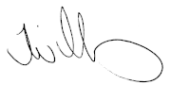
Tammy Williams
Commissioner
Family Responsibilities Commission

Service charter statement | 6
Preamble – Noel Pearson | 7
Commissioner Williams’ message | 8
About the FRC | 9
Our strategic objectives | 15
FRC registry and decision-making functions | 27
Non-financial performance outcomes | 42
Community operations
Aurukun | 57
Coen | 60
Doomadgee | 63
Hope Vale | 66
Mossman Gorge | 70
Significant events and achievements | 73
Challenges and outlook | 79
Governance | 89
Review of financial performance | 101
Financial statements | 104
Appendices
Appendix A – Strategic Plan 2023-2027 | 126
Appendix B – FRC Act’s alignment with ‘Our Way’ strategy | 128
Appendix C – Biographies of Commissioners and the Registrar | 130
Appendix D – Sittings calendar | 144
Appendix E – Client Engagement activities | 146
Appendix F – Compliance checklist | 149
Appendix G – Communities’ resident population | 151
Glossary of terms | 152
Contact details | 154

The Family Responsibilities Commission knows that you value efficient and effective engagement and support. Our aim is to provide the best service possible. We will partner with the Australian and Queensland Governments, stakeholders and clients to deliver outcomes that are responsive to the needs of the communities in which we work. In doing so, we will nurture a spirit of inquiry and innovation, and will embrace the challenge of sourcing unconventional and creative solutions to address the complex problems that confront those we serve.

The Family Responsibilities Commission (FRC) remains an important innovation. Lessons have been learnt since its inception and key insights are ready to scale.
In 2007, the Coalition Australian government under Prime Minister John Howard enacted complementary legislation to Labor Premier Anna Bligh’s Queensland government, which legislated the FRC to mandate family obligations. The Commission tackles the corrosion of responsibility caused by the passive welfare system—by obliging school attendance, children’s welfare and other obligations under the Family Responsibilities Commission Act 2008.
It uniquely:
- Joins the power of the federal welfare system together with the state’s service delivery system.
- Gives local leaders—Local Commissioners – the authority to make decisions about interventions and supports that oblige basic family responsibilities. This includes the power to impose Conditional Income Management when needed.
The FRC is one of the crucial pillars of the Cape York Welfare Reform. This reform is premised on the objective that in order to break the cycle of disadvantage and social breakdown – families and individuals need to build capabilities. Capabilities are built through the availability of opportunities and the taking of responsibility. Opportunities are usually provided from outside of the family, but responsibility must come from within. When the two combine, that’s when the power of capabilities is engaged. That’s when families can rebuild and change the life chances of their children.
Cape York Welfare Reform has proven that babies born at the bottom of Australian society—where disadvantage is entrenched, cyclical and intergenerational—can close the gap by the age of 21. It need not take generations. They do this by being supported by loving families, by getting good early childhood and primary school education, and completing Year 12. They then get jobs or undertake further study or training so that they close the income earning gap as young adults. Then they’re ready to start their journey of asset building through home ownership.
In FRC communities we see individuals and families who want a different life trajectory for their children, stepping up to take responsibility. They get their children to school. They are budgeting their money. They are creating safe homes for their children.
Taking responsibility alone is not enough to close the gap. It is necessary, but not sufficient.
The gap truly closes for young people by the age of 21, when individuals and families step up to take responsibility, and opportunities rise to meet them. Crucial opportunities such as access to good schools and employment are required, just as other Australians expect.
The FRC’s success obliging responsibility, if met with guaranteed opportunity in return, holds the key through which closing the gap in a single generation will become the norm.
I look forward to working closely with the FRC and its Local Commissioners, to build on its success to date. Further reforms are needed for Australia to break the cycle keeping so many First Nations people, and other Australians too, stuck at the bottom.

Noel Pearson

The FRC continues to support community members to build stronger futures through responsibility and opportunity.
The Family Responsibilities Commission (FRC) remains a beacon of innovation and collaboration, uniquely blending First Nations leadership with state and federal systems to drive meaningful change in Queensland’s Welfare Reform communities. Since its establishment in 2008, the FRC has been a cornerstone of the Cape York Welfare Reform, demonstrating that when responsibility is embraced and opportunities are provided, the cycle of disadvantage can be broken within a generation.
This year, the FRC has once again proven its ability to adapt and respond to the evolving needs of individuals and families in Aurukun, Coen, Doomadgee, Hope Vale, and Mossman Gorge. At the heart of this work are the Local Commissioners—First Nations leaders who bring cultural authority, lived experience, and deep community knowledge to their roles. Their efforts, supported by FRC staff, have empowered families to take responsibility for school attendance, child welfare, and financial management, creating safer and more stable homes for children.
The 2024–25 reporting period has seen a significant shift towards voluntary engagement, with more clients proactively seeking support and entering into agreements outside of formal conferences. These voluntary engagements, alongside the Commission’s targeted referrals to support services, are helping individuals build the capabilities needed to overcome challenges and create brighter futures for their families. This reflects growing trust in the FRC’s approach and a deepening sense of personal responsibility within communities.
The FRC’s work is underpinned by its commitment to Closing the Gap. By fostering self-determination and cultural respect, the Commission is helping to address systemic issues such as over-representation in child protection and the justice system. Importantly, the FRC’s partnerships with government agencies, community organisations, and schools have strengthened its ability to deliver holistic, client-centred support.
The FRC’s achievements would not be possible without the support of its valued partners—the Queensland Government, the Australian Government, and the Cape York Institute—who, as members of the Family Responsibilities Board, provide critical guidance and collaboration. I would also like to thank the Deputy Commissioner, Rod Curtin, Local Commissioners and registry staff, whose dedication and leadership are the backbone of the Commission’s success.
Finally, I acknowledge the efforts of the Registrar, Helen Weedon, and Michelle Synott, for their work in preparing this Annual Report, and Wayne Massey, Executive Officer (Corporate) for preparing the Financial statements and the Review of financial performance section. Their thoroughness has ensured the report reflects the scope of the Commission’s work and its ongoing impact.
With gratitude and determination, I look forward to continuing the Commission’s vital work in partnership with communities, governments, and organisations to create a brighter future for all.

Tammy Williams
Commissioner

The FRC is a key mechanism to support welfare reform community members and their families to restore socially responsible standards of behaviour and establish local authority.
Cape York Welfare Reform (CYWR) is a partnership between the Cape York Institute (CYI), the Queensland Government and the Australian Government. It is an initiative to support a positive change in social norms and community behaviours in response to chronic levels of passive welfare, social dysfunction and economic exclusion within the welfare reform communities. The reforms are designed to initiate early intervention to address issues and behaviours before they escalate, with a strong emphasis on partnership, capacity building, respect and the use of local authority.
A key feature of the welfare reforms was the creation of the FRC, an independent statutory authority established by the Family Responsibilities Commission Act 2008 (FRC Act). The Queensland Parliament passed the FRC Act on 13 March 2008, with bipartisan support. The Commission commenced operations on 1 July 2008.
The FRC’s registry and principal place of business is located in Cairns and services the five welfare reform communities of Aurukun, Coen, Doomadgee, Hope Vale and Mossman Gorge.

Jurisdiction, powers and functions of the Commission
The FRC operates within a legal framework to assist clients and their families living in welfare reform communities to address complex antisocial behaviours. The FRC Act sets out the statutory obligations of relevant Queensland Government departments to notify the Commission when a community member is not meeting pre-determined obligations. The FRC can intervene when it receives notification (an agency notice) in the following circumstances:
- a child of the person is either not enrolled at school, or not meeting designated school attendance requirements
- there is an intake involving the person by the Department of Families, Seniors, Disability Services and Child Safety in relation to alleged harm or risk of harm to a child
- the person, as a tenant, is in breach of a social housing tenancy agreement
- a court convicts the person of an offence or makes a domestic violence (DV) protection order against the person
- a child is convicted of an offence in the Childrens Court where the child was not a first-time offender.

Commission processes to engage and support community members
Assessment - Once the Commission receives these notices, the FRC Act sets out various procedural requirements that must be met to ensure effective safeguards are in place to protect the human rights of community members. Limitations of those rights can only occur when it is lawfully permissible to do so and must be reasonable and proportionate in the circumstances.
The FRC makes a careful assessment of the information it receives to determine the most appropriate, and least intrusive option to engage with the community member to help them, and sometimes their family, to holistically address the underlying issues raised in the agency notices. In some circumstances it may be necessary to hold a conference with the community member to discuss these issues, or on other occasions the information received does not justify such an approach at that time.
Conferencing clients - If it is necessary to hold a conference the FRC applies a locally based and culturally relevant process delivered by a panel of Elders and respected community leaders appointed as Local Commissioners, which is overseen by a legally qualified Commissioner. The purpose of a conference is to provide a forum for the community member and others who may have something useful to contribute, to discuss with the FRC why and how the person has come to be the subject of an agency notice. Conferences are held in a manner which facilitates early intervention, encourages community members to take responsibility for their actions and take active steps to address inappropriate behaviour before it escalates and requires serious remedial action by the justice, child protection, education or housing systems.
The FRC Act is to be administered in such a way that the wellbeing and best interests of children are paramount, and the interests, rights and wellbeing of other vulnerable people living in the community are preserved. The principles of natural justice and procedural fairness are to be observed, and the Commission must conduct its processes quickly and with as little formality as is consistent with the fair and proper consideration of the issues before it.
After assessing the community member’s circumstances, including the relevance of any contributing factors which caused the notifying behaviour, the FRC will attempt to enter into an agreement with the person to attend community support services or give Centrelink a notice for the partial management of a person’s welfare payment for a period of no more than 12 months, referred to as conditional income management. If an agreement cannot be reached with the person, the FRC can decide to: give the person a reprimand; recommend or direct that the person attends community support services to help address their behaviours through case management; and/or order conditional income management by giving Centrelink a notice for the partial management of a person’s welfare payment for a period of no more than 12 months.
The FRC Act provides a process to enable a person to request an amendment or termination of the Commission’s decision before it is due to expire and further provides an avenue to appeal a decision in the Magistrates Court. The legislation also sets out the circumstances and process where there has been non-compliance with a case plan.

Other Client Engagement (CE) approaches - The FRC Act also provides a process under which a community member may voluntarily seek help from the Commission, through a voluntary agreement for a referral under a Voluntary Case Plan (VCP) to attend a support service/s or to enter into a voluntary agreement for Voluntary Income Management (VIM). These clients are offered ongoing assistance and case management support as part of the FRC’s CE approach.
The Commission’s CE approach is an innovative way of working with clients outside of the formal processes of conference to encourage autonomy and decision-making for themselves and their families, and if needed, receive ongoing case management support to achieve their case plan goals. The aim of this approach is to build the confidence and capability of community members to progress along the continuum of help-seeking behaviours so they can assert self-determination over their own lives and resume primary responsibility for the wellbeing of their community, and the individuals and families of the community.

Legislative scheme
The FRC operates within the legislative framework of the Family Responsibilities Commission Act 2008 and the Family Responsibilities Commission Regulation 2014.
The FRC Act directly intersects with the following legislation:
- Child Protection Act 1999
- Criminal Law (Rehabilitation of Offenders) Act 1986
- Domestic and Family Violence Protection Act 2012
- Education (General Provisions) Act 2006
- Residential Tenancies and Rooming Accommodation Act 2008
- Social Security (Administration) Act 1999 (Cth)
- Youth Justice Act 1992.

The FRC is a public sector entity and must adhere to a range of laws and regulations set by the Queensland and Australian Parliament. Further information regarding the Commission’s compliance with these laws can be found in the Governance section of this report.

Organisational structure
The FRC as a legal decision-making entity is made up of two distinct components to perform the different statutory functions of the organisation:
- administration of the Commission is undertaken by the registry based in Cairns (further details about the activities of the registry during the reporting period are set out in the FRC registry and decision-making functions section of this report)
- the decision-making and client engagement aspect of the Commission primarily occurs within the communities of Aurukun, Coen, Doomadgee, Hope Vale and Mossman Gorge (details about the FRC’s operations and Local Commissioners’ activities in each community are set out in the Community operations sections of this report).

The FRC is an independent statutory authority and is not subject to direction by the Minister. The independence of the Commission was considered of importance by Parliament when passing the Family Responsibilities Commission Bill 2008. The Bill confirmed the authority of Commission members, including the Commissioner, Registrar and Local Commissioners to make decisions and administer the FRC Act within a robust legal framework (noting that Local Commissioners are limited to decisions made in conference).

The principle of Indigenous local authority is a cornerstone of the FRC model and a primary example of self-determination.
As at 30 June 2025 all members of the Commission’s decision-making arm are Aboriginal - comprising 36 Local Commissioners and the Commissioner, Tammy Williams, with the exception of Deputy Commissioner Rod Curtin whose powers as a decision-maker at conference are executed only upon delegation by the Commissioner.
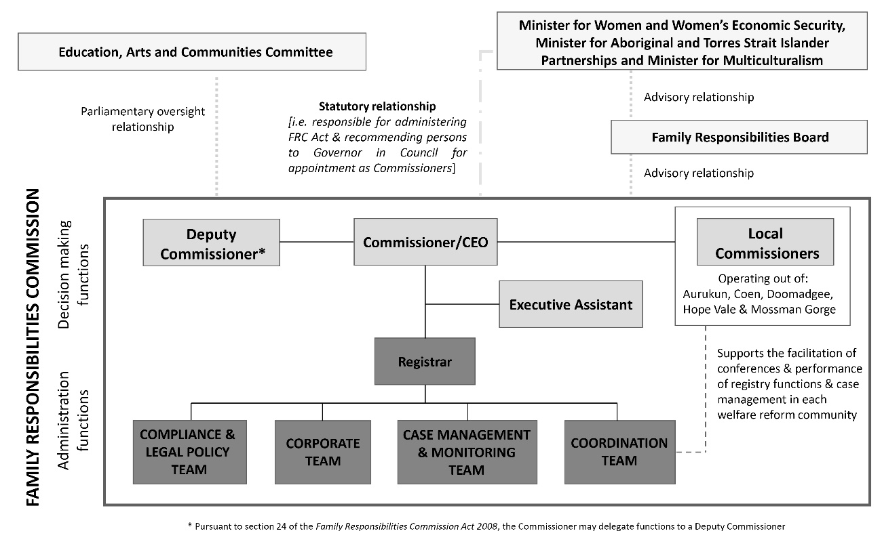
An innovative feature of the FRC is the establishment of the Family Responsibilities Board (FR Board) whose functions are provided for in the FRC Act. The FR Board comprises a membership of three, reflecting the tripartite partnership between the Australian and Queensland Governments and community, through CYI. Although it has an advisory function only the FR Board can play an important role, for example identifying actions the Australian or Queensland Governments could take to help improve the operations of the FRC within the welfare reform communities. Further details about the FR Board can be found on pages 89 and 90.

Our vision
Vibrant welfare reform communities that are responsible, healthy, safe and sustainable, built on cultural respect, self-determination and empowerment for a future of opportunity.

Our purpose
Supporting welfare reform community members to restore socially responsible standards of behaviour, local authority and wellbeing for themselves and their families.

Our values
Our core values provide the framework for our decisions, actions and behaviours, and underpin our commitment to human rights. Working to our values requires us to meet the highest standards of corporate behaviour. Our values are:
- Safety
- Respect
- Ownership
- Innovation
- Empowerment
- Diversity

Our challenges
- Maintaining legitimacy and improving levels of engagement and personal responsibility without a clear authorising environment.
- Sustaining, renewing and broadening the pool of Local Commissioners.
- Supporting a stronger commitment from service provider partners for suitable, available and accountable services for clients.
- Strengthening resilience and wellbeing in staff and Local Commissioners to meet evolving challenges.
- Protecting our information assets.

Our opportunities
- Embedding the FRC as a partner in the co-design and decision-making of government.
- Expanding our impact to new communities and with new triggers targeting areas of need.
- Increasing voluntary engagement, particularly through increasing options for VIM.

- Harnessing the evolution of the Local Commissioners’ role to increasingly support clients and communities outside of conference.
- Increasing recognition of the FRC’s model of self-determination, through the FRC’s local Indigenous-led decision-making, and the cultural capability of the registry.

Qld Government objectives for the community
The FRC partners with the Australian and Queensland Governments and FRC communities to help Close the Gap on life outcomes for our clients. The FRC supports the Queensland Government’s objectives for the community:

Good jobs: | Good, secure jobs in traditional and emerging industries
Better services: | Deliver even better services right across Queensland
Great lifestyle: | Protect and enhance our Queensland lifestyle as we grow

FRC strategic objectives
Our strategic objectives for 2023-2027 are to:
- support the restoration of socially responsible standards of behaviour and local authority in welfare reform communities
- help people in welfare reform communities to resume primary responsibility for the wellbeing of their communities and the individuals and families of their communities
- create a capable, culturally safe, agile and innovative organisation
- improve engagement through co-design and partnerships.

The Strategic Plan 2023-2027 can be found in the appendices (Appendix A).
As part of a broader upgrade to its information communications technology infrastructure and records management system (see page 77 for details) the FRC is progressively developing its performance monitoring and reporting framework to better align with the Commission’s strategic plan and objectives. The development of the FRC’s reporting framework continues. Where possible our performance against the Strategic Plan 2023-2027 is addressed throughout this report.

Strategic objective one
Support the restoration of socially responsible standards of behaviour and local authority in welfare reform communities.

Our achievements
This objective is achieved through the following strategies:

- Continue to implement proactive and agile responses to changing community needs that reflect all functions of the FRC Act.
- Support Local Commissioners and FRC staff to have meaningful and effective engagement with FRC communities.
- Strengthen self-determination by investing in individual leadership and decision-making capability development for Local Commissioners.
- Support Local Commissioners to advocate for their communities.
- Support partner agencies to provide information in a timely way within the FRC Act framework.

Performance Indicator 1: Retention and development of Local Commissioners

Local Commissioner training in community
With the reinstatement of the Youth Justice Childrens Court trigger notice, training was delivered to the Local Commissioners within their respective communities, by the Deputy Commissioner and the Manager, Compliance and Legal Policy, between September 2024 and June 2025. The training addressed the amendment to the FRC Act that operationalised the Childrens Court trigger notice, along with its impact on Local Commissioners and the resulting process changes in client conferencing and CE activities. More Local Commissioner training information can be found in the Governance section of this report.

Performance Indicator 2: Proportion of conferences held with Local Commissioners sitting independently
In 2024-25, 84% of Commission decisions at conference were made by three Local Commissioners sitting alone to constitute the panel.
Further details about Local Commissioner decision-making can be found on pages 31 to 35.

Performance Indicator 3: Rates of client participation in the decision-making process
The FRC continues to report high levels of client participation and personal agency in the Commission’s processes. In 2024-25, 88% of clients who were served a notice to attend a conference participated in the FRC’s decision-making process by attending at least once, with an overall conference attendance rate of 66.5% in 2024-25.
During the reporting period, of the total number of decisions at conference to attend a case plan, 65% were made by agreement with the client to attend the support service/s.
In 2024-25, of all voluntary agreements and final decisions at conference 58% were made with some form of agreement with the client. This highlights clients’ willingness to take personal responsibility for their wellbeing and the wellbeing of their families. More information about client participation in FRC’s decision-making processes commences at page 35.

Performance Indicator 4: Judicious use of Conditional Income Management (CIM)
In 2024-25 there were a total of 36 CIMs relating to 33 clients. As at 30 June 2025 there were 9 FRC clients subject to a CIM, claiming Centrelink payments for 20 children, of which 12 were of school age.
The FRC uses CIM in a very limited and nuanced way. In the 2024-25 financial year only 8.1% of finalised conferenced clients were placed on a CIM.
This demonstrates the FRC’s continued use of CIM is proportionate to the client’s circumstances and that CIM is used to encourage personal responsibility, with terms and percentages of CIM orders and agreements adjusted according to the client’s progress and circumstances. During the 2024-25 reporting period 53% of CIM orders and agreements quarantined 60 percent of a client’s welfare payment, 36% quarantined 75 percent and 11% quarantined 90 percent. During the same period 64% were for a period of 6 months, 30% for a duration of 3 months and 3% for 9 months and 12 months duration.
More information about income management is set out in the FRC registry and decision-making functions section of this report. Further analysis of income management data can also be found in the Non-financial performance outcomes section commencing at page 50.

Performance Indicator 5: Number of successful appeals against FRC decisions
There have not been any appeals against any FRC decisions during the reporting year.

Performance Indicator 6: Helping to Close the Gap on disadvantage for our clients in Aurukun, Coen, Doomadgee, Hope Vale and Mossman Gorge
The Commission continues to develop an appropriate assessment tool to best measure our contribution to Closing the Gap targets across the 4-year term of the Strategic Plan. The FRC hopes to report against this performance indicator in the future.

Strategic objective two
Help people in welfare reform communities to resume primary responsibility for the wellbeing of their communities and the individuals and families of their communities.

Our achievements
This objective is achieved through the following strategies:

- Support individuals and families to change through effective client engagement, conferencing, case plan referrals and income management.
- Protect children and other vulnerable people including through compulsion and income management where necessary.
- Continue to explore incentive projects to increase families’ capabilities and move towards pursuing opportunities.
- Engage families in recognising the importance of, and playing an active role in neonatal and early childhood development.
- Support evidence-based interventions for disengaged young people and employability skills training.
- Build mutual accountability and foster shared high expectations of service providers and community members.

Performance Indicator 1: Increased motivation of clients to change through personal responsibility
The types of client interactions evident during 2024-25 reinforce the Commission's belief that our clients are displaying a willingness to change and take personal responsibility for their wellbeing and the wellbeing of their families. Over the course of the financial year 64.8% of clients have at some point done one or more of the following: self-referred to the FRC for a VCP or a VIM; entered into a Family Responsibilities Agreement (FRA); successfully applied to end or amend their decision by order or agreement. As a subset of this, 42% of clients specifically entered into a voluntary agreement.
Since the introduction of the Cashless Debit Card (CDC) on 17 March 2021 and the subsequent transition to the enhanced Income Management SmartCard on 6 March 2023, the Commission has seen that having a prior CIM order or agreement is not an impediment to a client requesting to enter into a subsequent voluntary agreement for VIM. In fact, evidence is suggestive of the contrary – that CIM can be a pathway to clients later voluntarily seeking a period of income management. From 17 March 2021 to 30 June 2025 more than half (54%) of VIM clients have had a prior CIM.
A similar trend can be seen regarding clients seeking case plan support. From 17 March 2021 to 30 June 2025 the Commission’s data reveals that having a prior case plan made by the FRC on a conditional basis is not an impediment to a client entering into a subsequent voluntary agreement for a VCP. From 17 March 2021 to 30 June 2025, 75% of VCP clients have had a prior conditional case plan (CCP).
It is evident from the graph below that the Commission is still seeing a large number of voluntary interactions with clients over the last four financial years. Notably, there has been a 4% increase in VCP’s from 2023-24 to 2024-25. Prior to 2020 and before the onset of COVID, no VCPs were entered into by clients.
Graph 1: VIM and VCP agreements by financial year since 2014-15

More information about voluntary agreements can be found in the FRC registry and decision-making section of this report. Further analysis of VIM data can be found at page 51 and is also discussed further in the context of another performance indicator.

Performance Indicator 2: Increased periods of respite for clients from daily living pressures
The data in graph 2 tracks the length of time between final decisions made for clients at successive conferences. The increasing length of time between each conference decision may suggest personal responsibility is increasing.
The graph shows the length of time between final decisions has remained fairly stable from 2023-24 to 2024-25 apart from the shift in the “more than 6 months to 12 months” to “more than 12 months to 2 years” category. The FRC has identified a reduction in the percentage of clients who have not been the subject of a final decision of “more than 6 months to 12 months”, recording 26% as compared to 29% in 2023-24. There is a corresponding increase in the percentage of clients who have transitioned to the category of “more than 12 months to 2 years” increasing from 17% in 2023-24 to 23% in 2024-25.

Graph 2: Length of time between final decisions by financial year

Voluntary income management agreements
The uptake in the number of VIMs in recent years when compared to earlier years (see graph 1) is consistent with a broader and well-established trend of an increased willingness of clients to take steps towards personal responsibility. VIM has proven to be a useful budgeting tool for clients, to ensure household needs and financial obligations are met, and in some cases, to achieve savings goals. Clients experiencing financial abuse in relationships with domestic violence and/or coercive control have also reported that entering into a VIM is a way to provide stability and protection for children and other vulnerable members of the household.
Between 17 March 2021 and 30 June 2025, a total of 549 VIM agreements were entered into. Of the 549 agreements, 41% (223) specifically relate to an agreement where the client is considered an older Australian.
Between 17 March 2021 and 30 June 2025 a total of 125 VIM agreements have been entered into where the client indicated one of the reasons they were entering into a VIM agreement was to protect their payments. This represents a total of 23% of all VIM agreements over the same time period where the client wished to protect their payments. Out of the 125 VIM agreements where a client indicated the need to protect their payments, 63% (79) specifically relate to an agreement where the client was an older person.

Clients may not always wish to declare that the purpose of their VIM agreement is to protect their payments. Elders may be fearful of retribution or feel shame about being the subject of abuse. The FRC’s data collection provides for a range of other reasons including to buy food, to pay bills, or to save for something they need, which may be recorded in the alternative.
Between 17 March 2021 and 30 June 2025 a total of 397 VIM agreements have been entered into over the relevant time period where the client indicated one of the circumstances they were entering into a VIM agreement was “I need to support myself”. This represents a total of 72% of all VIM agreements over the time period where the client needed support for themselves. Out of the 397 VIM agreements where a client indicated they needed support for themselves, 44% (174) specifically relate to an agreement where the client is considered an older Australian. This indicates a high proportion of older clients are entering into VIM agreements to ensure their payments are being used to support themselves.

VIMs and VCPs provide access to coordinated support
Many clients opting to enter into a VIM agreement are also taking up VCPs, for referral to support services to assist with money management and/or social and emotional wellbeing. These clients are offered ongoing assistance and case management support as part of the Commission’s CE approach.
The FRC’s CE approach is an innovative way of working with clients outside of the formal processes of conference to encourage autonomy and decision-making for themselves and their families, and if needed, receive ongoing case management support to achieve their case plan goals. The aim of this approach is to build the confidence and capacity of community members. Where the FRC continues to have capacity to undertake this approach, it can bridge a significant gap in service provision for Elders experiencing abuse.
Even where no formal case plan is in place, where clients enter into a VIM agreement, it allows FRC staff and Local Commissioners to regularly check in on clients, for example, to ensure their card has arrived and is working, and to check in towards the end of the agreement to see if clients wish to renew their VIM before it expires.

VIMs empower people to retain agency over their financial decisions
FRC community members can seek to have different proportions of their eligible welfare payments managed. Where Elders are particularly vulnerable to abuse, up to 90% of their payments can be protected. In other circumstances, where people find it a helpful tool to assist with budgeting, a smaller proportion of their income can be quarantined onto the SmartCard.

During 2024-25 the most frequent reason chosen by clients to enter into a voluntary agreement for VIM was “to buy food” (65), followed by “to budget” (58), “to pay for bills” (48) and “to save for something I need” (45).
VIM Reason/s | 18-25 | 26-35 | 36-45 | 46-55 | 56-65 | 66-75 | 76-85 | 86+ | Total
I don’t wish to provide this information | 0 | 2 | 0 | 0 | 0 | 0 | 0 | 0 | 2
To budget | 1 | 22 | 8 | 11 | 8 | 6 | 2 | 0 | 58
To buy food | 4 | 19 | 14 | 8 | 10 | 7 | 3 | 0 | 65
To pay for bills (rent, electricity, fines) | 3 | 14 | 9 | 8 | 7 | 4 | 3 | 0 | 48
To protect my payments | 2 | 3 | 3 | 0 | 5 | 5 | 2 | 1 | 21
To save for something I need | 1 | 13 | 11 | 9 | 6 | 4 | 1 | 0 | 45
To stop gambling | 0 | 1 | 0 | 0 | 1 | 0 | 0 | 0 | 2
With general wellbeing | 0 | 2 | 1 | 0 | 1 | 1 | 0 | 0 | 5
Total | 11 | 76 | 46 | 36 | 38 | 27 | 11 | 1 | 246

During 2024-25 the highest circumstance chosen by clients to enter into a voluntary agreement for VIM was “I need support for myself” (80), followed by “I need help to support my children” (31) “I need help to support my family” (26), and “I like the SmartCard” (25).
VIM Circumstance/s | 18-25 | 26-35 | 36-45 | 46-55 | 56-65 | 66-75 | 76-85 | 86+ | Total
I don’t wish to provide this information | 0 | 0 | 0 | 0 | 0 | 0 | 0 | 0 | 0
I like the SmartCard | 1 | 7 | 6 | 2 | 3 | 5 | 1 | 0 | 25
I need help to support my children | 3 | 14 | 6 | 4 | 1 | 1 | 2 | 0 | 31
I need help to support my family | 4 | 10 | 5 | 3 | 0 | 3 | 1 | 0 | 26
I need support for myself | 6 | 21 | 15 | 12 | 14 | 8 | 3 | 1 | 80
Total | 14 | 52 | 32 | 21 | 18 | 17 | 7 | 1 | 162

The 26-35-year-old age bracket scored the highest for the “I need support for myself”, “I need help to support my children” and “I need help to support my family” circumstances followed closely by the 36-45-year-old age bracket, indicative of the 26-35 and 36-45-year-old age groups having the highest number of members, including children, to feed in a household.

Performance Indicator 3: Strength of mandated interventions decreased

FRC decisions are proportionate to individual circumstances
The FRC model is nuanced and tailored to the needs of each client. Commission decisions are applied proportionate to individual circumstances, for a defined period of no more than 12 months, after which it expires.
Graph 3 below illustrates the range of all total final decisions made by the Commission (inclusive of decisions made at conference, and voluntary agreements). As a total of all final decisions made by the Commission during 2024-25, the majority of decisions (58%) were made with some form of agreement with the client (voluntary income management, voluntary case plan and decision by agreement for a conditional case plan). Conversely, a small proportion of decisions (17%) could be categorised as ‘mandated interventions’ and were made by the Commission resulting in a client being placed on conditional income management and/or ordered to attend a service provider under a referral from a case plan from a decision.

Graph 3: Proportionate decisions 2024-25

The following table is further evidence of a trend over recent years of clients continuing to take steps towards greater personal responsibility by entering into voluntary agreements for a VCP.

Voluntary agreement | 2022-23 | 2023-24 | 2024-25
Voluntary agreements to attend community support services | 52 | 176 | 183

Performance Indicator 4: Increased client engagement with support services to build capacity
The FRC is collaborating with our partner service providers in FRC communities to find better ways to work together so the needs of our clients are met, to overcome barriers to engagement, and to facilitate the progression of case plans. Some clients require urgent support, with both the FRC and specialist providers on hand to help. Other clients, for example, are best supported through an initial ‘light touch’ approach to engagement, by the FRC facilitating early interactions between clients and service providers, often in culturally safe places elsewhere in the community and not in a clinical setting. We have found this strategy is often the tentative first step needed to help clients form a trusting relationship with service providers and lead to improved outcomes in line with their case plan goals.
For the 2024-25 financial year the FRC has been recording and collating these interactions. This data reveals there have been 546 occasions where a partner service provider has joined with an FRC staff member or Local Commissioner as part of our CE approach.
More information relating to the Commission’s CE approach can be found on pages 10, 26, 27, 29, 30, 50 and in each of the Community operations reports for Aurukun, Coen, Doomadgee, Hope Vale and Mossman Gorge. CE data is also a relevant consideration for other performance indicators listed over the next few pages.

Performance Indicator 5: Helping to Close the Gap on disadvantage for our clients in Aurukun, Coen, Doomadgee, Hope Vale and Mossman Gorge
The Commission continues to develop an appropriate assessment tool to best measure our contribution to Closing the Gap targets across the 4-year term of the Strategic Plan. The FRC hopes to report against this performance indicator in the future.

Strategic objective three
Create a capable, culturally safe, agile and innovative organisation.

Our achievements
This objective is achieved through the following strategies:

- Ensure the FRC attracts and values an agile, diverse, inclusive and high performing workforce to meet current and future business needs.
- Embed a culture of innovation and continuous improvement to deliver more flexible, effective and efficient services.
- Embed safety, including cultural and psychological safety, as a core value to enhance overall wellbeing and engagement in our work environment.
- Leverage technology, data and information to enhance outcomes.

Performance Indicator 1: Proportion of budget spent on frontline services
For 2024-25, 69% of FRC expenses were utilised to support frontline operations and maintain the Commission’s customer service standards to First Nations Queenslanders living in remote communities.

Performance Indicator 2: Employee retention and development
During the reporting period Commission staff undertook a varied range of development activities as required by their roles, such as First Aid training, or identified learning activities in employee Performance and Development Agreements (PDAs). The Commission continues to develop an appropriate assessment tool to best report against this performance indicator.

Performance Indicator 3: Increased diversity of our workforce
The Commission values diverse backgrounds and experience when hiring and continues to ensure the FRC is a safe and welcoming workplace. In the 2024-25 reporting year, the proportion of Aboriginal and Torres Strait Islander employees as defined by the Public Sector Commission is 15.8%. See page 96 for details relating to the Commission’s workforce profile.
Approximately 97% of the FRC’s 38 Commissioners, inclusive of the Commissioner, Deputy Commissioner and 36 Local Commissioners, identifies as Aboriginal. The knowledge and experience of our combined workforce makes the FRC, as a Queensland public sector entity, a leader in cultural capability and First Nations employment.

Strategic objective four
Improve engagement through co-design and partnerships.

Our achievements
This objective is achieved through the following strategies:

- Position the FRC as an invaluable part of the service ecosystem through collaborative and collegiate engagement with our partners.
- Provide quality advice to the Family Responsibilities Board, Ministers and Parliamentary Committees to inform policy, legislation and service delivery to our community members.
- Help clients have agency in their experience with the FRC by co-designing projects and services, and embracing First Nations ways of doing, being and knowing.

Performance Indicator 1: Number of partnerships and engagement activities
Over the course of the 2024-25 reporting year the FRC had 18 referral pathways to community support services, in which a total of 528 referrals were made relating to 391 clients. Details relating to the FRC’s client referrals to its community support service partners can be found at pages 54 and 55.
The FRC also formalised its partnership through a memorandum of understanding with the Aboriginal and Torres Strait Islander Legal Service (ATSILS).

Performance Indicator 2: Rate of stakeholder satisfaction
The Commission continues to develop an appropriate assessment tool to best record stakeholder satisfaction rates and service standards. The FRC hopes to report against this performance indicator in the future.

Performance Indicator 3: Rate of participation in project and service design
Although the Commission is yet to finalise an appropriate assessment tool to best report against this performance indicator, there have been several initiatives throughout 2024-25 in collaboration with clients, stakeholders, and FRC staff and Local Commissioners. These initiatives include:
- Elevated School Response (ESR) strategy. The ESR strategy was designed as an interim measure to support schools and parents as part of their school attendance and retention strategies. For instance, some communities do not have a reliable school bus or operational School Attendance Officer (SAO) programs and the FRC saw an important role for the Commission to scaffold these essential strategies.

The program in each of the participating communities has been co-designed to reflect the specific priorities of those clients, local schools and Local Commissioners. For instance:
- In Aurukun the initial focus was on long-term disengaged young people, including those students impacted by foetal alcohol spectrum disorders. From Term 1 2025 the Aurukun ESR strategy changed to focus on children and families who were willing to work with the FRC in getting their children to school. Discussions with the school Principal highlighted a significant need to support families dealing with chronic absenteeism, as well as a shortage of support staff at the school. The Commission is also focusing on supporting families with children who have complex health issues and aims to ensure that multiple services are working together effectively to achieve positive outcomes. For long-term disengaged children the FRC is working with families to identify underlying causes of disengagement and connect them with appropriate support services. The Local Commissioners are also visiting the school to engage with teachers and students, delivering key messages about ‘teasing, bullying and respect for everyone’. These visits enable Local Commissioners to discuss with families via CE and conferencing how these issues are being addressed at the school.
- In Doomadgee clients who already had a case plan referral to the SAO program were prioritised. Local Commissioners then worked with clients and their children to implement strategies to overcome barriers to school attendance and engagement.
- From Term 3 2024 to Term 1 2025 Hope Vale’s ESR strategy included targeting the early years as well as school aged children, and focussed on families whose children were eligible to start kindergarten and Prep. From Term 2 2025 the Hope Vale ESR project changed to focus on specific target groups including children with 60 to 80 per cent school attendance who could benefit from additional support to improve their school attendance, and children who are disengaged from school.
- Mossman Gorge’s strategy included responding to the wishes of the community by aiming to reduce behavioural issues on the school bus, as well as improving school attendance.
- Client Engagement approach. In 2024-25 there were 1,796 CEs with either the client, stakeholder or both relating to 721 clients, providing overwhelming evidence of the successful co-design of the initiative in response to the evolving needs of our community members. See pages 10, 26, 27, 29, 30, 50 and the Community operations reports for further details.

The registry is responsible for the administration of the Commission.

Operations
During the 2024-25 financial year data has been collected across the three main service delivery areas of the Commission’s operations: intake and assessment, facilitation of conferences and hearings, and supporting CE activities outside of conference.
The Commission received and assessed 6,831 notices of which 4,595 were within the Commission’s jurisdiction. The majority of within jurisdiction notices received this financial year were for school attendance, followed by Magistrates Court, domestic violence orders, child safety and welfare, and then Childrens Court notices. Information regarding our performance during the year is located in the Non-financial performance outcomes and the Review of financial performance sections.

At a glance – the 2024-25 year
6,831  Agency notices assessed | 4,595  Agency notices deemed within jurisdiction | 1,145  Community members deemed the subject of agency notices
793  Conferences and hearings held | 442  Community members prioritised for conferences and hearings | 479  Not served conference slots
1,796  CE activities held outside of conference | 721  Community members supported in the 1,796 CE activities | 543  Non-contact CE activities
509  Hours spent supporting CE activities | 0  Appeals of FRC decisions

A capable administrative workforce is key to an efficient, agile and innovative organisation.
The FRC’s administrative workforce in the Commission’s registry consists of:
- the Commissioner (appointed by the Governor in Council for a specified term) who as the Chief Executive Officer (CEO) is responsible for ensuring the efficient discharge of the Commission’s business, appropriate training for registry staff and Local Commissioners, the preparation of corporate documents and achieving the objects of the FRC Act as specified in section 22 of the FRC Act.
- the Deputy Commissioner. Under section 44 of the FRC Act the Commissioner may delegate the Commissioner’s functions to a Deputy Commissioner and under section 25 of the FRC Act the Deputy Commissioner may act as the Commissioner in certain circumstances.
- the Registrar who is responsible for managing the registry and the administrative affairs of the Commission and whose functions, powers and delegation are specified in sections 35 to 37 of the FRC Act
- the Executive Officer (Corporate) who is responsible for providing financial and strategic/corporate advice and support to the Commission’s operations across Cairns and the communities
- an Executive Assistant to support the Office of Commissioners plus 15 additional positions across the four teams of Compliance and Legal Policy, Corporate, Case Management and Monitoring, and Coordination. The Coordination team includes five Local Registry Coordinators appointed under section 38 of the FRC Act to support the efficient and effective operation of the Commission in each of the welfare reform communities.

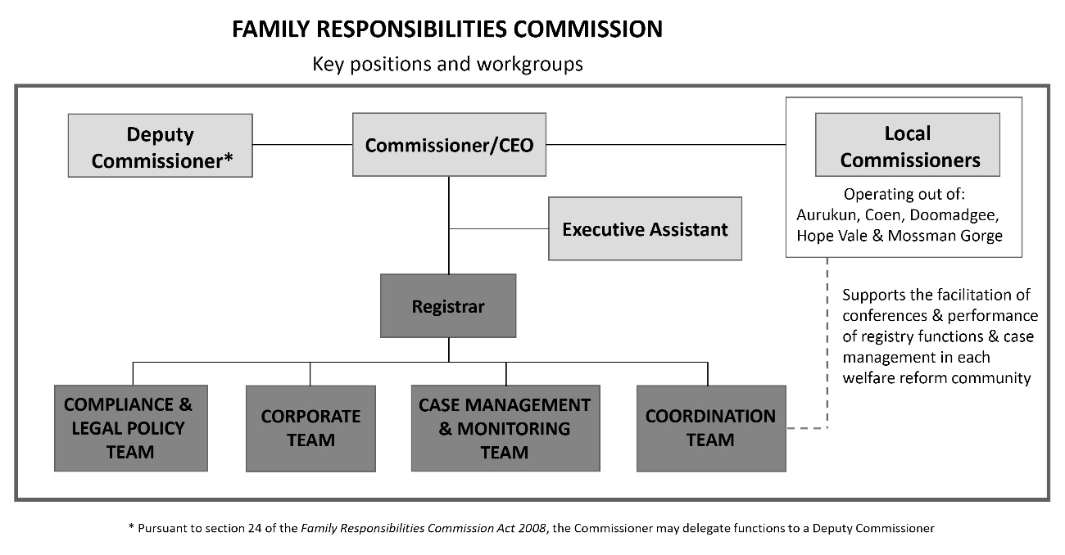
Further details relating to the Commission’s workforce profile can be located in the Governance section of this report. Biographies of Commissioners and the Registrar can be found in the appendices (Appendix C).

A client-centred approach to registry systems and processes
Business and operational strategies this year have continued a focus on maximising results for clients by internally strengthening the FRC model to achieve accountability and continued relevance in a changing policy environment.

Coordination team – Over the past year, the Coordination team has grown to include the Manager (Coordination) and five Local Registry Coordinators, each supporting one of the five welfare reform communities. The Local Registry Coordinators play a vital role in facilitating efficient operations across their communities, including the coordination of conferences, maintaining records and strengthening connections between clients and community support services.

Activity data for 2024-25 financial year: Snapshot of the Coordination team’s workload
793  Conferences and hearings held across five communities – averaging approximately 23 conferences and hearings per week over a 34-week schedule | 805  Occasions where notices were served on persons to attend conferences and hearings (including clients, support persons and other relevant persons) | 479  Not served conference slots
1,796  CE activities held outside of conference | 721  Community members supported in the 1,796 CE activities | 543  Non-contact CE activities
509  Hours spent supporting CE activities | 6.0  Full time employees of the Coordination team

A major focus for 2024-25 has been CE outside the formal conference setting. This proactive approach has helped maintain strong levels of positive engagement, with voluntary referrals to support services and voluntary income management reflecting steady community participation. These voluntary engagements reflect clients’ growing sense of personal responsibility and self-determination.
There has also been strengthened collaboration through the ESR initiative, promoting school attendance and addressing education-related matters through early engagement. This shift towards supporting clients through CE, aligns with our broader strategic goals to:
- increase voluntary participation and shared decision-making
- invest in education as a foundation for community development and Closing the Gap outcomes
- respond flexibly to changing community needs in line with the FRC Act.
In preparation for the reinstatement of the Childrens Court trigger, the Coordination team and Local Commissioners undertook targeted training. With the passing of legislative amendments to the FRC Act, the Commission can again receive Childrens Court advice notices for young offenders. This important change strengthens our ability to provide early, coordinated interventions and referral pathways for families of repeat youth offenders, with the goal of addressing underlying issues and preventing reoffending.

Case Management and Monitoring (CM&M) team – Responsibilities for the CM&M team include the following:
- receiving and processing agency notices
- determining jurisdiction
- gathering information for consideration of agency notices
- setting conference and CE timetables
- processing conference and CE outcomes
- managing CIM and VIM processes
- monitoring CCPs from FRAs and orders and VCPs
- ensuring compliance with the FRC Act.
The team also provide support to Local Registry Coordinators in their further engagement with community members outside of the conference setting through initiatives such as ESR and Intensive Case Management.

Activity data for 2024-25 financial year: Snapshot of the CM&M team’s workload
6,831  Agency notices assessed to determine jurisdiction – averaging approximately 131 notices assessed per week | 267  Community members on non-voluntary active case plans had their progress monitored throughout the year (for periods between 3 to 12 months) following conference. | 3.0  Full time employees of the CM&M team

The Coordination and CM&M teams together have established a cohesive group to provide high-level support and information to Local Commissioners to better inform the delivery of support to clients in line with the Commission’s focus on more intensive, quality, client-centred conferencing.

Compliance and Legal Policy (C&LP) team – The C&LP team are responsible for the delivery of compliance, legal and policy advice across the Commission’s operations. The C&LP team also plays a large role in strengthening and managing aspects of the Commission’s corporate governance, including quality assurance of decision-making.
In addition to the ongoing provision of internal and external advice the C&LP team have undertaken several major projects in the reporting year, including:
- beginning a holistic review of the Commission’s suite of policies
- preparing submissions and giving evidence to parliamentary inquiries on matters relevant to the FRC and its clients
- providing advice to government on proposed legislative changes, including the reinstatement of the Children’s Court ‘trigger’.

Corporate team – The Corporate team are responsible for the delivery of accounting, payroll and accounts payable functions, Information and Communications Technology (ICT), statistics and research, travel, infrastructure and other corporate related activities.
In addition, the Corporate team have undertaken several major projects in the reporting year, including:
- commencing the upgrade of its Customer Relationship Management (CRM) system and ICT infrastructure (refer page 77 for more details).
- assessing the FRC’s accounting functional requirements and exploring alternative software solutions, resulting in the identification of a successful supplier and the approval to proceed. The new accounting software system is expected to be implemented during the 2025-26 financial year (refer pages 77 and 78 for more details).
- the office relocation project which was a key focus during the 2024-25 financial year, involving extensive planning, coordination and preparation to ensure a smooth transition to the new premises.

Commissioners are responsible for decision-making at conferences and hearings.
Commissioner Williams, Deputy Commissioner Curtin and 36 Local Commissioners appointed across the five welfare reform community areas of Aurukun, Coen, Doomadgee, Hope Vale and Mossman Gorge, preside over locally convened conferences and hearings involving community members and make legally binding decisions.

Constitution of conferences and hearings
The FRC’s continuation of assurance and oversight mechanisms throughout the 2024-25 financial year resulted in quality decision-making with improved client-focused outcomes and contributed to the result of no appeals against Commission decisions by community members.

Commission decisions use local authority and are made within a legal framework.
The FRC Act requires the decision-making panel to include locally appointed Commissioners. During the reporting period 787 conferences were held and constituted by using the following combinations:
- three Local Commissioners sitting without the assistance/advice of the Commissioner or Deputy Commissioner (section 50A conferences, monitored under section 50B) with one of the Local Commissioners acting as the chairperson
- three Local Commissioners sitting as a panel (section 50A conferences, monitored under section 50B) with one of the Local Commissioners acting as the chairperson and with assistance/advice provided by the Commissioner or Deputy Commissioner
- two Local Commissioners sitting with the Commissioner or Deputy Commissioner acting as chairperson.

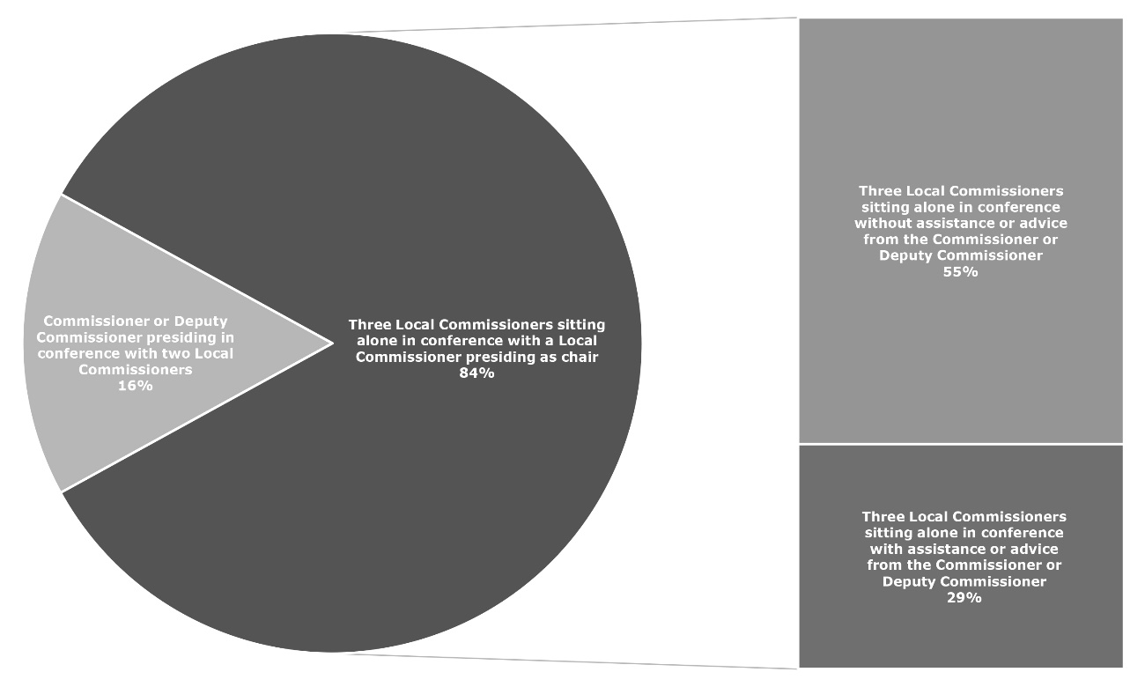
When deciding to hold a conference in relation to a community member named in an agency notice it is the function of the Commissioner to appoint up to three Local Commissioners to comprise the panel and decide the matter, having regard to the knowledge and experience of each Local Commissioner to determine the issues to which the agency notice relates, cultural and gender diversity considerations and potential conflicts of interests.

Conference Constituted 2024-25
Graph 4: Constitution of conferences 1 July 2024 to 30 June 2025
As seen in previous years the vast majority (84%) of Commission decisions at conference throughout 2024-25 continued to be made by three Local Commissioners sitting alone to constitute the panel.

Quality assurance and oversight of decisions
All Commission decisions are made within a legal framework. There are mechanisms in place to ensure appropriateness and consistency of FRC decisions including:
- the appointment of a legally trained and suitably qualified Commissioner, and Deputy Commissioner if appointed, with the statutory function to ensure the efficient discharge of Commission business including the holding of conferences and making decisions about agency notices under the FRC Act
- monitoring of Commission decisions when made at conference by a panel comprised of three Local Commissioners sitting alone
- the delivery of regular and appropriate training to Local Commissioners and registry staff to perform their statutory duties and achieve the objects of the FRC Act
- the creation of the Compliance and Legal Policy team within the registry to provide advice to the Commissioner and members of the Commission’s Executive Management Team (EMT), and drive quality assurance practices.

The Commissioner is required under the FRC Act to monitor all decisions made at conference by a panel constituted entirely by three Local Commissioners, to ensure consistency of decision-making. Commissioner Williams, with the assistance of Deputy Commissioner Curtin, does so in several ways.
Firstly, Local Commissioners can seek legal advice and guidance from the Commissioner or Deputy Commissioner prior to determining a matter at conference. Throughout the 2024-25 financial year 659 conferences were presided over and constituted by three Local Commissioners sitting alone, and for 229 of these conferences Local Commissioners sought legal advice and guidance from either the Commissioner or Deputy Commissioner (these are deemed ‘Commissioner assisted conferences’ for reporting purposes).
Secondly, following all conferences the Commissioner conducts a review of every outcome. In this reporting period 58% of decisions were monitored by Commissioner Williams within 28 days of the date of conference.
The FRC remains committed to building the capability of Local Commissioners, so they continue to make reasonable and proportionate decisions reflective of the evolving and often complex needs of community members, their families and broader community expectations and standards of behaviour. The FRC provides regular training and assistance to Local Commissioners to support their ongoing ability to perform their duties as statutory decision-makers.
During the reporting period Commissioner Williams and Deputy Commissioner Curtin delivered training content to Local Commissioners in small groups within their respective communities, on topics relevant to their individual capabilities and requirements. With the reintroduction of the Childrens Court notice, training was delivered to the Local Commissioners by the Deputy Commissioner and the Manager, Compliance and Legal Policy, between September 2024 and June 2025. The training covered the amendment to the FRC Act that operationalised the Childrens Court trigger notice, and the impact and process changes for the Local Commissioners in the course of client conferencing and CE activities.

Commissioner assisted conferences | 2022-23 | 2023-24 | 2024-25
Percentage of three Local Commissioners sitting without the assistance/advice of the Commissioner or Deputy Commissioner | 45% | 72% | 55%

Application hearings held to consider changing needs of community members
Each application to amend or end an agreement (including a voluntary agreement) or order follows a transparent process and is considered by the Commissioners on its own merit whilst observing the principles of natural justice. A timely decision on the application is made under the FRC Act pursuant to section 99 for a FRA or order, or section 109 for a voluntary agreement, and may include either agreeing or refusing to amend or end an agreement or order. Alternatively, if the Commissioners deem the application for an FRA or order frivolous or vexatious they may decide to dismiss the application.
For an application received under section 97 of the FRC Act, if the Commission fails to make a decision within two months of receipt of the application, section 101 of the FRC Act determines that the failure is taken to be a decision by the Commission to refuse to amend or end the FRA or order. For an application to amend or end a voluntary agreement, section 109(2) of the FRC Act states: “The Commissioner must amend or end a voluntary agreement as requested by the person, unless the Commissioner is satisfied the amendment or ending would be detrimental to the interests, rights and wellbeing of children and other vulnerable persons living in a welfare reform community area”.

Decisions on amend/end applications for FRAs or orders
Following the decision of the Commission at conference relating to an agency notice, a community member who is the subject of that decision can make an application to the FRC seeking to alter or end the original decision because their circumstances or behaviours have changed. During this reporting period 7 amend/end applications were decided for orders.

Decisions on amend/end applications for voluntary agreements
A person who has entered into a voluntary agreement about VIM with the Commissioner can ask the Commissioner at any time to amend or end the agreement. During this reporting period 17 amend/end applications were decided for VIM agreements.

Timeframe on deciding applications in 2024-25
Number of applications decided in  2024-25 | Average number of days to make a decision in 2024-25
7 applications to amend or end a CIM | 17.00 days
17 applications to amend or end a VIM | 8.23 days

The opportunity afforded in hearing these applications is utilised by the Commissioners to encourage clients to continue to address any remaining challenges and to exercise personal responsibility in their lives.

Timely decision-making with increased client participation
The Commission continued its focus throughout the 2024-25 reporting period on timely decision-making and on encouraging agreements to be made in the first instance (pursuant to sections 46 and 68 of the FRC Act). The efforts of Local Commissioners to encourage clients to have agency in the FRC’s decision-making process cannot be over-estimated. Increased client participation facilitates better outcomes through personal commitment and a shared consideration of a balance of options available to clients.

Conference attendance | 2022-23 | 2023-24 | 2024-25
Conference attendance | 67.0% | 65.7% | 66.5%

Additionally in 2024-25, the majority of conferenced agency notices were determined within two conferences (with the client), whilst 88% of clients who were served a notice to attend a conference participated in the FRC’s decision-making process by attending at least once.

FRC decisions have a focus on capacity-building and self-determination.
Decisions can be made by agreement or order of the Commission. Community members can also voluntarily request referrals or income management. A continuum of possible decisions made at conference follows.

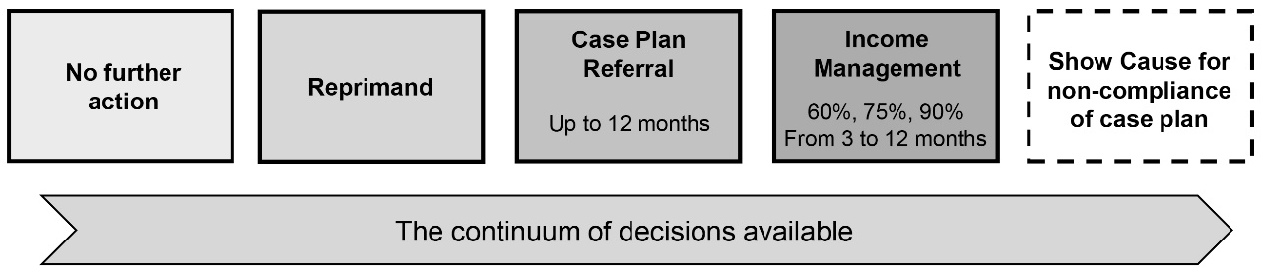

Section 5 of the FRC Act is clear in stipulating that matters should be dealt with in a manner that facilitates early intervention, delivers timely decisions, supports the change of behaviour sought, supports the exercise of local authority and makes use of community support services.

Engagement at conference
As can be seen from the table below, clients continue to assume personal responsibility demonstrating insight regarding their actions at the earliest opportunity (i.e., agreements entered into at conference). As a proportion of all decisions in 2024-25 to attend support services in conference, 65% were by agreement.

Conference outcomes | 2023-24 | 2024-25 | % change
Agreements to attend community support services | 284 | 190 | -33%
Orders made to attend community support services | 100 | 102 | +2%

Further information regarding conference activity and outcomes during the reporting period can be found in the Non-financial performance outcomes section.

Voluntary engagement – a ‘right fit’ for many who self-refer
The FRC Act sets out a process for voluntary engagement in which a community member can self-refer to the Commission and voluntarily seek help for a referral to a community support service under a VCP or to be subject to VIM.
The FRC is continuing to see a number of clients who engage with the FRC on a voluntary basis highlighting that community members are exhibiting a heightened self-awareness of their personal circumstances and are willing to accept assistance from the Commission at the earliest opportunity.

Voluntary income management
VIM agreements are seen as a useful tool to assist community members to manage their budgets and meet the cost of everyday essentials. A number of elderly community members (who have not otherwise been referred to the FRC) are volunteering to have a portion of their welfare payments subjected to income management to help safeguard funds for their own needs and protect from humbugging and/or other elder abuse or violence. The Australian Institute of Health and Welfare defines an “Older Indigenous Australian” as aged 50 and over. Out of the 89 clients who entered into a VIM during 2024-25, 38% (34) of these clients were aged 50 and over.

Number of voluntary agreements for VIM | 2022-23 | 2023-24 | 2024-25 | % change 2023-24 to 2024-25
Voluntary agreements for VIM | 118 | 115 | 97 | -16%

Number of clients with voluntary agreements for VIM | 2022-23 | 2023-24 | 2024-25 | % change 2023-24 to 2024-25
Clients with voluntary agreements for VIM | 100 | 104 | 89 | -14%%

As at 30 June 2025 there were 67 clients on a VIM who were claiming Centrelink payments for 51 children of which 32 were of school age.

Voluntary income management and conditional case plans
During conference Local Commissioners focus on reaching an agreement with clients in the first instance whilst explaining the benefits of service referrals, even if only to develop a budget and savings plan to aid in the management of money on the SmartCard.
The Commission is seeing a number of clients who attend conference and, although they may receive a compulsory referral under a CCP from an FRA or order (subject to show cause if required), they may also volunteer to be on a period of income management.

Clients on CCPs, VCPs and VIMs | 2022-23 | 2023-24 | 2024-25
Number of clients on a VIM with a CCP only | 42 | 22 | 13
Number of clients on a VIM, CCP and VCP only | 9 | 15 | 12

The Commission is seeing an increase in the number of clients who self-refer without a mandated requirement to attend conference. As can be seen in the next table these clients engage with the FRC on an entirely voluntary basis. The FRC considers these clients to be the best indicator of a community member’s willingness to take greater personal responsibility with increased expectations of themselves and their families.

Clients on VCPs and/or VIMs | 2022-23 | 2023-24 | 2024-25
Number of clients on a VIM only | 26 | 27 | 26
Number of clients on a VIM with a VCP only | 21 | 32 | 37
Number of clients on a VCP only | 11 | 78 | 85

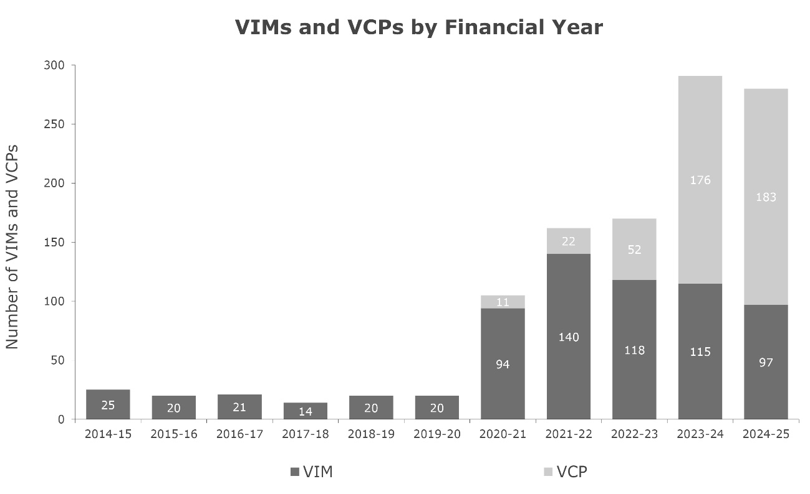
As is evident from the following graph, the Commission is seeing a continued overall increase in the number of voluntary case plans entered into with clients over the last four financial years.
Graph 5: Number of VIMs and VCPs by financial year 1 July 2014 to 30 June 2025

Number of VCPs and VIMs | 2020-21 | 2021-22 | 2022-23 | 2023-24 | 2024-25
Total number of voluntary agreements | 105 | 162 | 170 | 291 | 280

Conditional case plans and conditional income management
Conditional income management alone does not reduce welfare dependency and cannot be expected to rectify the multiple and complex issues of poverty, disempowerment, addiction, child abuse and neglect, violence and offending. The graduated range of FRC decisions provides a system of local authority through which FRC clients can be appropriately encouraged to take up responsibility and access the supports needed to build the capabilities required to break the cycle of disadvantage.
A total of 267 clients were placed on a CCP in 2024-25 either through a FRA or an order to attend community support services. Out of the 267 clients, 90% of these clients (241) were placed on a CCP without a CIM, reflecting the intent of the Local Commissioners decision-making powers to provide avenues for their community members to receive appropriate support to address their behavioural issues.

Clients placed on a CCP without a CIM | 2021-22 | 2022-23 | 2023-24 | 2024-25
Percentage of clients placed on a CCP without a CIM | 82% | 92% | 92% | 90%

Referral pathways and case management

Conditional referrals
Commissioners are guided by the FRC Act, sections 4 and 5, to encourage community members to engage in socially responsible standards of behaviour and in doing so, to make appropriate use of community support services. The Commissioners use the referral pathways available in each community to help strengthen clients’ resilience to face the challenges they experience, and to ensure the wellbeing and safety of children and vulnerable people.
During the conferencing process Commissioners may decide to refer the client to support services such as:
- Wellbeing Centres (WBCs) to address alcohol and/or drug misuse, gambling, DV or social and emotional health-related issues
- parenting programs to assist in implementing good parenting practices
- MPower, a money management program, to assist with budgeting and meeting priority financial needs
- School Attendance Officers to assist parents to ensure children attend a school
- other appropriate support services.

As demonstrated in the table below the Commissioners have continued to make a number of referrals from FRAs and orders.

Number of referrals from FRAs and orders | 2022-23 | 2023-24 | 2024-25
Conditional referrals to service providers | 499 | 472 | 342

During 2024-25, 267 clients were referred to attend support services under either an FRA or order. The percentage of finalised conferenced clients who were referred decreased from 67% in 2023-24 to 65% in 2024-25.

Percentage of finalised conferenced clients referred | 2022-23 | 2023-24 | 2024-25
Percentage of finalised conferenced clients referred | 62% | 67% | 65%

Where a client has multiple or complex issues to address Commissioners may refer the client to more than one support service. Referrals to support services may be made on the basis of an FRA, where a client agrees to attend a support service, and the client and Commissioners agree on the action to be taken together. Alternatively, Commissioners may make a decision to direct a client to attend a support service/s. Progress reports are received from service providers and clients are assessed to determine if they are fulfilling their obligations under the agreement or order. Together with local knowledge additional information may be sought from agencies and service providers, where appropriate, under Part 8 of the FRC Act to provide the best support possible for the client. Service providers and other persons who can make a useful contribution to the conferencing process are encouraged to attend conference proceedings and discuss the decision-making processes with the Commissioners.

Voluntary referrals
Under section 106(a) of the FRC Act a community member may ask the Local Registry Coordinator for a welfare reform community area to refer the person to a community support service.
The FRC has seen an increase of 4% in the number of VCPs entered into from 2023-24. This is indicative of the broader acceptance by community members to undertake personal responsibility.

Number of voluntary agreements for VCP | 2022-23 | 2023-24 | 2024-25 | % change 2023-24 to 2024-25
Voluntary agreements for VCP | 52 | 176 | 183 | +4%

Number of clients with voluntary agreements for VCP | 2022-23 | 2023-24 | 2024-25 | % change 2023-24 to 2024-25
Clients with voluntary agreements for VCP | 44 | 152 | 158 | +4%

Number of referrals from VCPs | 2022-23 | 2023-24 | 2024-25 | % change 2023-24 to 2024-25
Voluntary referrals to service providers | 55 | 190 | 186 | -2%

Conditional income management – a nuanced approach of ‘last resort’
At conference a decision may be made to issue a client with a CIM order. Due consideration is given to the individual circumstances of the client and whether alternative action is more appropriate. CIM orders are considered as a last resort, with Commissioners endeavouring to enter into an FRA with the client agreeing to CIM in the first instance.
Following conference, the Commission is required by the FRC Act to notify the Secretary of the Department of Social Services (DSS) with details of the CIM, whereby the community member’s welfare payments are income managed by DSS in accordance with the decision of the Commission and remain subject to FRC’s continued jurisdiction. The SmartCard is issued to the community member by Services Australia (SA) to reflect the Commission’s CIM under an order or agreement.
The Commissioners use CIM as a tool to support people and children at risk, promote socially responsible choices, and as an incentive to meet individual and community obligations by drawing together a network of support services to focus on the individual’s needs. CIMs are issued for a defined period (no longer than 12 months) with the Commissioners determining whether 60, 75 or 90 percent of fortnightly welfare payments are managed. Community members may apply to the Commission to have their CIM amended or ended. Commissioners consider each application to ascertain whether the client has made sufficient progress to justify an amend or end decision. Details of the process available to FRC clients, seeking to end or change their income management status are discussed in the relevant section on pages 34 and 35.

Number of CIMs | 2022-23 | 2023-24 | 2024-25 | % change 2023-24 to 2024-25
Number of CIMs | 64 | 54 | 36 | -33%

Percentage of finalised conferenced clients CIM’d | 2022-23 | 2023-24 | 2024-25
Percentage of finalised conferenced clients CIM’d | 11% | 11% | 8%

Applications to amend or end agreements or orders
Applications to amend or end an agreement (including a voluntary agreement) or order are considered an important means of ensuring that FRC decisions remain applicable to the changing needs and circumstances of clients. This mechanism affords clients an opportunity to apply to the Commission to amend or end their agreement or order by providing their reasons for making the application. Commissioners view the hearing of the applications as an opportunity to engage with clients.

Applications to amend or end received | 2022-23 | 2023-24 | 2024-25
Applications to amend or end received | 35 | 26 | 29

Statistical reporting and analysis of referenced data
Additional statistical reporting and analysis of the data referenced in this chapter can be found at the Commission’s Non-financial performance outcomes section of this report.

The FRC model is designed to work collaboratively with partner agencies as part of a linked service system to engage, empower and enable individuals, families, and the wider community to make positive and lasting change.

The policy context for the FRC is aligned with, and achieves outcomes relevant to, several Queensland Government objectives and initiatives.
The Commission’s activities support the broader welfare reforms implemented across Cape York Peninsula since 2008 and the Queensland Government’s Objectives for the Community:

Safety where you live
Making Queensland safer with stronger laws, better-equipped courts and more police with better tools, while restoring consequences for actions, fixing our Child Safety system, ensuring early intervention and a bigger focus on rehabilitation, giving victims more rights and better support, and taking critical action to arrest skyrocketing rates of domestic and family violence.
Health services when you need them
Restoring health services when Queenslanders need them most through transparent and targeted investment with real-time data, boosting frontline health services, driving resources where they’re needed most, improving our EDs, reopening regional maternity wards, fast-tracking access to elective surgeries, and helping patients to be seen faster.
A better lifestyle through a stronger economy
Growing our economy to drive down the cost of living and give Queenslanders a better lifestyle and a place to call home, by respecting your money and reinstating the Productivity Commission, growing the economy in our regions, backing small and family business, boosting home ownership, easing pressure on rents, ensuring affordable and reliable energy and public transport, taking care of Queensland’s vital existing and emerging industries, delivering more community housing and homelessness services, and boosting women’s economic security.
A plan for Queensland’s future
Planning for Queensland’s future, by building the roads and infrastructure needed for a growing population – including a safer Bruce Highway, putting more teachers in safer schools and preparing young Queenslanders for the future, conserving our pristine environment that draws visitors from across the world, improving water security, and delivering a world-class Olympic and Paralympic Games that leaves a positive legacy for Queenslanders.

The Commission delivers services to five communities, all of which are culturally unique and some of which are geographically remote. Each community is different, yet each can be characterised by the entrenched disadvantage of Indigenous community members. High rates of welfare dependency and multi-generational poverty have resulted in communities with individuals and their families who have complex needs.
In meeting this challenge, the Commission works with community-based service providers and partner agencies with statutory requirements under the FRC Act and the Department of Women, Aboriginal and Torres Strait Islander Partnerships and Multiculturalism (DWATSIPM), as part of a linked service system to achieve individualised client outcomes.
In doing so the FRC complements several Queensland Government strategies and reforms including the ‘Our Way’ strategy and ‘Breaking Cycles’ action plan. The Strategy outlines building upon existing initiatives such as the FRC to ensure Indigenous children grow up in a safe and nurturing environment and address the over-representation of Indigenous children in Queensland’s child protection system. A detailed analysis of the alignment between the ‘Our Way’ strategy and the FRC Act can be found at Appendix B.

The FRC’s performance and activity data show linkages between client outcomes and the FRC’s strategic objectives and indicators.
The following statistical report and analysis of the Commission’s non-financial performance outcomes is for the period 1 July 2024 to 30 June 2025. This data, additional to the statistical information cited elsewhere in this report, is used by the FRC’s EMT to monitor the organisation’s progress in achieving the main objectives of the Strategic Plan 2023-2027.

The FRC knows its clients and communities.
From 1 July 2024 to 30 June 2025, the Commission received a total of 6,831 agency notices for which jurisdiction could be determined across a range of notifiable behaviours of which 4,595 notices relating to 1,145 clients were within jurisdiction, comprising:
Table 1: In jurisdiction notices by community and quarter 1 July 2024 to 30 June 2025
Number of notices | Qtr 65 | Qtr 66 | Qtr 67 | Qtr 68 | Total
Aurukun | 514 | 506 | 418 | 459 | 1,897
Coen | 58 | 41 | 87 | 28 | 214
Doomadgee | 358 | 351 | 324 | 350 | 1,383
Hope Vale | 259 | 225 | 207 | 222 | 913
Mossman Gorge | 36 | 50 | 41 | 61 | 188
Total | 1,225 | 1,173 | 1,077 | 1,120 | 4,595

Table 2: In jurisdiction notices by type and community 1 July 2024 to 30 June 2025
Type of notice | AU | CO | DM | HV | MG | Total
Supreme Court | 0 | 0 | 0 | 0 | 0 | 0
District Court | 33 | 4 | 0 | 7 | 2 | 46
Childrens Court | 115 | 0 | 0 | 1 | 9 | 125
Magistrates Court | 718 | 83 | 0 | 184 | 55 | 1,040
Domestic Violence Breach | 42 | 5 | 0 | 45 | 10 | 102
Domestic Violence Order | 119 | 20 | 0 | 63 | 12 | 214
School Attendance | 782 | 84 | 1,322 | 560 | 96 | 2,844
School Enrolment | 6 | 0 | 1 | 2 | 0 | 9
Child Safety and Welfare
Child Concern Reports | 67 | 18 | 46 | 30 | 4 | 165
Finalised Child  Protection Investigations | 15 | 0 | 14 | 13 | 0 | 42
Housing Tenancy | 0 | 0 | 0 | 8 | 0 | 8
Total | 1,897 | 214 | 1,383 | 913 | 188 | 4,595

Further details of notices within jurisdiction for each community are set out below:
- Aurukun (AU) received 1,897 notices relating to 471 clients (249 female and 222 male)
- Coen (CO) received 214 notices relating to 74 clients (36 female and 38 male)
- Doomadgee (DM) received 1,383 notices relating to 278 clients (194 female and 84 male)
- Hope Vale (HV) received 913 notices relating to 268 clients (137 female and 131 male)
- Mossman Gorge (MG) received 188 notices relating to 54 clients (27 female and 27 male).

Table 3: In jurisdiction notices by type and quarter 1 July 2024 to 30 June 2025
Type of notice | Qtr 65 | Qtr 66 | Qtr 67 | Qtr 68 | Total
Supreme Court | 0 | 0 | 0 | 0 | 0
District Court | 16 | 11 | 14 | 5 | 46
Childrens Court | 0 | 0 | 24 | 101 | 125
Magistrates Court | 319 | 294 | 247 | 180 | 1,040
Domestic Violence Breach | 29 | 39 | 16 | 18 | 102
Domestic Violence Order | 53 | 36 | 69 | 56 | 214
School Attendance | 749 | 732 | 652 | 711 | 2,844
School Enrolment | 1 | 6 | 0 | 2 | 9
Child Safety and Welfare | 58 | 55 | 53 | 41 | 207
Housing Tenancy | 0 | 0 | 2 | 6 | 8
Total | 1,225 | 1,173 | 1,077 | 1,120 | 4,595

Notices received by the Commission which were unable to be accessed for jurisdiction
From 1 July 2024 to 30 June 2025 the Commission received a further 16 notices for which jurisdiction could not be assessed:
- 9 Childrens Court notices could not be assessed for jurisdiction due to a lack of parent information provided by the Court. The Commission was unable to generate a SA Personal Information Disclosure (PID) for the child record as they were under 16 and not receiving a welfare payment
- 7 Magistrates Court notices relating to one client for which jurisdiction could not be assessed. SA has the client record listed as ‘restricted’ and due to changes in SA policy the Commission is no longer granted temporary access to generate a PID. The PID lists address information and welfare payment eligibility used to assess whether the client is within jurisdiction at the time the Commission received the notice.

Our clients have complex needs.
Over-crowded housing, high rates of Indigenous welfare dependency and multi-generational poverty have resulted in communities with high numbers of individuals and families with complex needs. Table 4 provides some insight into the complexity of the issues faced by many clients. During the financial year 858 clients (75%) were notified to the Commission with only one type of notice, whilst the remaining 287 clients (25%) received more than one type of notice.

Table 4: FRC clients by the
number of types of
notices 1 July 2024
to 30 June 2025
Number of types of notices received | Number of clients
1 | 858
2 | 217
3 | 62
4 | 6
5 | 2 |  | Graph 6: Client allocation based on single and multiple types of  notices 1 July 2024 to 30 June 2025
Total | 1,145

Analysis reveals the following information regarding the types of sole notices received by FRC clients during the reporting period:
- 40% received a School Attendance (EQ) notice
- 18% received a Magistrates Court (MAG) notice
- 8% received a Domestic Violence Order (DVO) notice
- 5% received a Child Safety and Welfare (CS) notice
- 1% received a Domestic Violence Breach (DVB) notice
- 1% received a Childrens Court (CHI) notice and
- 1% received a District Court (DIS) notice.

The remaining sole notices received for Commission clients were 2 clients with a School Enrolment Breach (SEN) notice and 4 clients with a Housing Tenancy Breach (HT) notice.
Additional insight into the complexity of issues faced by clients can be seen in the following table which shows the combination of notices received for the 287 clients with more than one type of notice. One can see that predominantly there is a nexus between court convictions and domestic violence orders/breaches with education notices and child safety issues, and also a strong nexus between child safety issues and education notices.

Table 5: FRC clients by number of types of notices 1 July 2024 to 30 June 2025
Type of notice/s | Number of clients |  | Type of notice/s³ | Number of clients
CHI,CS,DVO | 1 |  | CS,HT | 1
CHI,CS,DVO,EQ,MAG | 1 |  | CS,MAG | 8
CHI,CS,EQ | 1 |  | DIS,DVB | 2
CHI,CS,MAG | 1 |  | DIS,DVB,MAG | 1
CHI,EQ | 1 |  | DIS,DVO,MAG | 1
CHI,EQ,MAG | 6 |  | DIS,EQ | 2
CHI,MAG | 2 |  | DIS,MAG | 1
CS,DIS | 1 |  | DVB,DVO | 5
CS,DVB | 2 |  | DVB,DVO,EQ | 1
CS,DVB,DVO,EQ,MAG | 1 |  | DVB,DVO,MAG | 11
CS,DVB,DVO,MAG | 2 |  | DVB,EQ | 2
CS,DVB,EQ,MAG | 2 |  | DVB,EQ,MAG | 4
CS,DVB,MAG | 3 |  | DVB,MAG | 24
CS,DVO | 7 |  | DVO,EQ | 6
CS,DVO,EQ | 2 |  | DVO,EQ,MAG | 5
CS,DVO,EQ,MAG | 2 |  | DVO,MAG | 50
CS,DVO,MAG | 2 |  | EQ,HT | 2
CS,EQ | 54 |  | EQ,MAG | 44
CS,EQ,HT | 1 |  | EQ,SEN | 2
CS,EQ,MAG | 20 |  | MAG,SEN | 1
CS,EQ,SEN | 2
Total |  |  |  | 287

Most FRC conferences respond to high levels of complexity in terms of client needs. The FRC primarily deals with clients who suffer multiple and entrenched forms of disadvantage. Within this cohort there are clients who experience extreme complex disadvantage and are also unable or reluctant to seek support. In addition to the substantial work and preparation undertaken before every conference, the most complex matters represent a further ‘step up’ in the related workload. Conferencing such clients makes higher demands of the FRC to respond. The FRC has experienced a decrease in the percentage of conferences conducted that are considered complex (whether it is multiple notices of the same type or multiple types of different notices) in 2024-25 compared to the prior three financial years.
Graph 7: Complex conferencing by financial year

The FRC improves community wellbeing by supporting the restoration of socially responsible standards of behaviour.

Conferencing
The FRC uses conferences as a forum to discuss with clients the issues outlined in an agency notice/s. Conferences are held in a manner which facilitates early intervention and encourages clients to take personal responsibility for their actions. From 1 July 2024 to 30 June 2025 a total of 787 conferences were held relating to 441 clients.
Conferences during the financial year resulted in 190 agreements to attend community support services (a decrease of 33% from 2023-24), 102 orders made to attend community support services (an increase of 2% from the previous reporting period) and 36 CIM orders issued (a 33% decrease from the previous reporting period).

Table 6: Conferences by community and quarter 1 July 2024 to 30 June 2025
Conferences | Qtr 65 | Qtr 66 | Qtr 67 | Qtr 68 | Total
Aurukun | 64 | 70 | 39 | 92 | 265
Coen | 7 | 8 | 5 | 4 | 24
Doomadgee | 75 | 69 | 73 | 84 | 301
Hope Vale | 26 | 39 | 54 | 47 | 166
Mossman Gorge | 4 | 10 | 3 | 14 | 31
Total | 176 | 196 | 174 | 241 | 787

As a subset of the total number of conferences conducted for the financial year, 171 DV-related conferences were conducted in Aurukun, Coen, Hope Vale and Mossman Gorge, a decrease of 19% from 2023-24.
In addition to the conferences held above in table 6 there were a further 478 instances in 2024-25 where a client was not served a notice to attend conference for the following reasons: medical, mental health reasons, no longer living in community, not suitable time, out of the community, in prison, sorry business, substance affected/aggressive and unable to locate. The most frequent reason for not serving was “out of community” (37%), followed by “unable to locate” (34%) and “sorry business” (18%).

Graph 8: Not served conference slots from 1 July 2024 to 30 June 2025

Client Engagement
Conferencing is only one avenue of engaging with a client. From 1 July 2024 to 30 June 2025 1,796 CEs were conducted outside of conference with either the client, stakeholder or both relating to 721 clients supported. CEs during the financial year resulted in 79 VIMs and 173 VCPs.
Table 7: CE engagement with either the client, stakeholder or both (excluding non-contact engagements) by community and quarter 1 July 2024 to 30 June 2025
Client Engagements | Qtr 65 | Qtr 66 | Qtr 67 | Qtr 68 | Total
Aurukun | 120 | 136 | 363 | 259 | 878
Coen | 0 | 27 | 44 | 70 | 141
Doomadgee | 87 | 15 | 46 | 90 | 238
Hope Vale | 37 | 10 | 160 | 174 | 381
Mossman Gorge | 15 | 25 | 62 | 56 | 158
Total | 259 | 213 | 675 | 649 | 1,796

In addition to the CEs held in 2024-25 (see table 7 above) there was 543 non-contact CE activities with 50 instances related to administrative support, such as preparation for upcoming CEs and 493 instances involved unsuccessful attempts to engage with a client for the following reasons: medical, no longer living in community, not suitable time, out of the community, in prison, sorry business, substance affected/aggressive and unable to locate. The most frequent reason for non-engagement was “unable to locate” (34%), followed by “out of community” (24%) and “sorry business” (18%).

Clients on conditional income management
From 1 July 2024 to 30 June 2025, there were a total of 36 CIMs (a decrease of 33% from 54 CIMs in 2023-24) relating to 33 clients.
As at 30 June 2025, there were 9 clients subject to a CIM with 44% at 60 percent, 44% at 75 percent and 44% for a 6 month duration. As a subset of the total number of CIMs in the financial year, 11 CIMs were made at conference in relation to DV notifying behaviours.
The statistical information provided in graphs 9 and 10 demonstrates the FRC’s continued use of CIM is proportionate to the client’s circumstances and that CIM is used to encourage personal responsibility with terms and percentages of CIM orders and agreements adjusted according to the client’s progress or lack thereof. During the 2024-25 reporting period, 53% of CIM orders and agreements quarantined 60 percent, 36% of CIM orders and agreements quarantined 75 percent and 11% of CIM orders and agreements quarantined 90 percent of a client’s welfare payment. During the same period 30% were for a period of 3 months, 64% for a period of 6 months and 3% for a period of both 9 and 12 months.
The Commission processed the 36 CIMs issued in 2024-25 as follows:
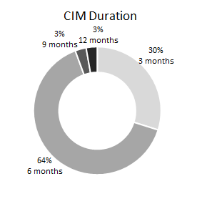 |  | 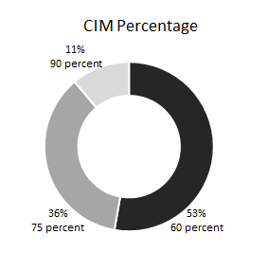
Graph 9: Breakdown of SmartCard CIMs by duration 1 July 2024 to 30 June 2025 |  | Graph 10: Breakdown of SmartCard CIMs by percentage 1 July 2024 to 30 June 2025

Clients on voluntary income management
The Commission processed 97 VIM agreements (a decrease of 16% from the 115 VIMs in 2023-24) for 89 clients.
Since the commencement of the Commission, 432 clients (274 female and 158 male) have had an active VIM agreement. As at 30 June 2025, there were 67 clients on a VIM, with 81% at 60 percent and 40% for a 6 month duration and 40% for a 12 month duration.
During the 2024-25 reporting period, 81% of VIMs quarantined 60 percent of a client’s welfare payment. During the same period, 28% were for a period of 3 months, 42% were for a period of 6 months, 1% was for a period of 9 months and 29% were for a period of 12 months.
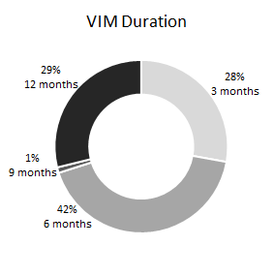 |  | 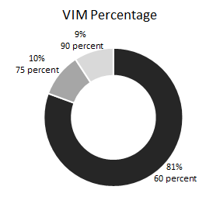
Graph 11: Breakdown of SmartCard VIMs by duration 1 July 2024 to 30 June 2025 |  | Graph 12: Breakdown of SmartCard VIMs by percentage 1 July 2024 to 30 June 2025

Conditional and voluntary income management age and gender breakdown
During 2024-25 most community members conditionally income managed by the FRC were in the 26-35 year age group, and females accounted for 78% of all the CIM orders and agreements. For the 28 CIMs relating to females, 79% related to children in some capacity, whether it was for a notice regarding school attendance or school non-enrolment, or for a notice regarding child safety and welfare. For the 8 CIMs relating to males, 25% related to children in some capacity. These figures correlate to the often-female role of caregiver in the family structure.
The age ranges of clients exercising the option for VIM spanned all age cohorts from 18 to 86+. Again, females represented the majority of all VIM agreements at 61%.

Graph 13: Breakdown of  SmartCard CIMs  by age cohort and gender  1 July 2024 to 30 June 2025 | 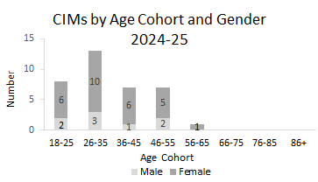
Graph 14: Breakdown of  SmartCard VIMs  by age cohort and gender  1 July 2024 to 30 June 2025 | 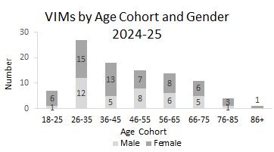

Voluntary income management respondent reasons
Since the introduction of the CDC and its replacement, the SmartCard, the FRC has recorded the reasons and circumstances of those requesting a VIM. During 2024-25 the primary reasons for applying for a VIM (reactive perspective) were to address the immediate need of buying food (67%) and to pay for bills (49%). The primary reasons for applying for a VIM from a proactive perspective were to set up a budget (60%) and save for something the client needed, e.g. a fridge or washing machine (46%). Circumstances given by the VIM participants when applying for the card were primarily to support themselves (82%), followed the need to support their children (32%) and the need to support their family (27%).

Graph 15: Breakdown of SmartCard VIMs by circumstances
1 July 2024 to 30 June 2025
Graph 16: Breakdown of SmartCard VIMs  by reasons 1 July 2024 to 30 June 2025 | Future needs – proactive actions

The FRC improves community responsibility by building partnerships and helping people to resume primary responsibility.

Referrals help build individual client capabilities.
Referrals to service providers are an integral part of achieving the Commission’s strategic outcomes of improved community wellbeing and responsibility.
During 2024-25 a grand total of 528 referrals were put in place (inclusive of referrals from FRAs, orders and VCPs) relating to 391 clients.
As a subset of the above, during this reporting period 342 referrals were made (inclusive of FRAs and orders) to attend support services for 267 clients.

Table 8: FRC conditional referral pathways by referral type and quarter 1 July 2024 to 30 June 2025
Referral type | Qtr 65 | Qtr 66 | Qtr 67 | Qtr 68 | Total
Aurukun Shire Council | 0 | 0 | 0 | 2 | 2
Bamanga Bubu Ngadimunka | 0 | 0 | 1 | 0 | 1
Cape York Employment | 0 | 2 | 3 | 2 | 7
Coen Regional Aboriginal Corporation | 1 | 4 | 1 | 0 | 6
Cooktown District Community Centre | 8 | 9 | 9 | 10 | 36
Gungarde (Family Wellbeing Services) | 0 | 1 | 1 | 2 | 4
Mossman Elders Justice Group | 0 | 3 | 0 | 0 | 3
Mossman Support Services | 0 | 0 | 0 | 2 | 2
MPower | 8 | 17 | 10 | 11 | 46
My Pathway | 1 | 0 | 1 | 0 | 2
RAATSICC | 0 | 0 | 0 | 2 | 2
Royal Flying Doctor Service | 0 | 0 | 1 | 1 | 2
54 Reasons/Save the Children | 0 | 5 | 5 | 6 | 16
School Attendance Officer | 18 | 30 | 14 | 34 | 96
TCHHS – Cape Mental Health | 1 | 0 | 0 | 0 | 1
Wellbeing Centre - Apunipima | 22 | 41 | 18 | 32 | 113
Wellbeing Centre - NWRH | 1 | 0 | 1 | 1 | 3
Total | 60 | 112 | 65 | 105 | 342

The number of referrals from FRAs and orders for the financial year represents a decrease of 28% from the previous reporting period of 472 referrals. As a subset of the total number of these referrals, 101 referrals were made in relation to DV conferences.
A further 186 voluntary referrals (a decrease of 2% from the 190 reported in 2023-24) to attend support services were requested from 158 clients (an increase of 4% from the 152 clients in 2023-24).
Table 9: FRC voluntary referral pathways by referral type and quarter 1 July 2024 to 30 June 2025
Referral type | Qtr 65 | Qtr 66 | Qtr 67 | Qtr 68 | Total
Aurukun Shire Council | 0 | 1 | 6 | 1 | 8
Cairns Community Legal Centre | 0 | 0 | 0 | 1 | 1
Cape York Employment | 0 | 0 | 3 | 1 | 4
Coen Regional Aboriginal Corporation | 0 | 0 | 2 | 3 | 5
Cooktown District Community Centre | 3 | 0 | 9 | 1 | 13
Gungarde (Family Wellbeing Services) | 0 | 0 | 0 | 1 | 1
MPower | 2 | 9 | 30 | 21 | 62
RAATSICC | 0 | 0 | 1 | 0 | 1
Royal Flying Doctor Service | 0 | 0 | 0 | 1 | 1
School Attendance Officer | 1 | 1 | 13 | 10 | 25
TCHHS – Cape Mental Health | 1 | 0 | 0 | 2 | 3
Wellbeing Centre - Apunipima | 7 | 11 | 31 | 13 | 62
Total | 14 | 22 | 95 | 55 | 186

Show Cause hearings are another tool available to hold clients accountable.
From 1 July 2024 to 30 June 2025 no Show Cause hearings were held. These hearings are intended by the FRC Act to be a formal mechanism to address non-compliance with a requirement under a case plan to attend a community support service.
Similar to the 2023-24 reporting period, no clients were issued with a Show Cause notice to come before the Commission for non-compliance of their case plan/s due to the following:
- limitations on availability of support services on the ground
- capacity of support services to accept and deal with the existing number of referrals from the FRC
- lack of confirmation from support services in some cases that client engagement has been attempted
- limited, (or no) information from which to proceed on a Show Cause for non-compliance
- ability to implement a CIM order at 90% to address non-compliance.

The need to conduct Show Cause assessments has also been diverted as a result of the number of clients demonstrating proactive steps to take personal accountability for their actions and commit to a journey towards self-improvement. This is demonstrated by clients entering into agreements to willingly accept referrals and be placed on a case plan, along with those self-referring community members seeking to voluntarily participate in income management and voluntary referrals.

Applications to amend/end agreements or orders
From 1 July 2024 to 30 June 2025, 29 applications relating to 25 clients (18 females and 7 males) to amend or end an agreement (including a voluntary agreement) or order were received. Where an amend/end application is received at the end of a financial year the decision on the application may take place in the following financial year.

Table 10: Applications to amend or end agreements or orders by community and quarter
1 July 2024 to 30 June 2025
Number of applications | Qtr 65 | Qtr 66 | Qtr 67 | Qtr 68 | Total
Aurukun | 3 | 2 | 0 | 7 | 12
Coen | 0 | 0 | 2 | 1 | 3
Doomadgee | 2 | 0 | 0 | 1 | 3
Hope Vale | 3 | 4 | 1 | 1 | 9
Mossman Gorge | 1 | 1 | 0 | 0 | 2
Total | 9 | 7 | 3 | 10 | 29

Application decisions
From 1 July 2024 to 30 June 2025, a total of 24 applications were decided:
- 7 applications for FRAs and orders
- 17 applications for VIMs.

Out of the 24 decisions made, 83% (20) of all applications were granted, whilst 4 were refused because the statutory requirements were not met.
Accepted applications to amend or end FRAs or orders were as follows:
- 4 CIM orders ended
- 1 CIM order amended.

Accepted applications to amend or end VIM agreements were as follows:
- 12 VIM agreements ended
- 1 VIM agreement amended from 60 percent to 75 percent for the remaining period of the existing agreement
- 2 VIM agreements amended from 75 percent to 60 percent for the remaining period of the existing agreement.

FRC operations in Aurukun were undertaken by Local Commissioners Edgar Kerindun, Doris Poonkamelya, Ada Woolla, Dorothy Pootchemunka, Vera Koomeeta, Keri Tamwoy and Dereck Walpo, supported by Local Registry Coordinators Cara Marks and Willy Smith. An account of their operations during the reporting period follows.

Aurukun Commissioners’ report
As the Aurukun Local Commissioners we carry out our responsibilities with deep pride and a genuine commitment to the wellbeing of our community. Our work is driven by a shared vision of positive change and we remain committed in our belief that true leadership begins with accountability, respect and service to our people.
We engage across all levels of the community, from individuals and families to service providers and local organisations, fostering relationships built on trust and mutual respect. By consistently showing up, listening and working alongside community members, we are strengthening the foundations for long-term change.
Our approach promotes self-determination, empowering community members to take control of their own lives while being supported on the journey. The positive response we have received from the community reflects a shift in mindset and a growing trust in the process.
This shift is evident in the increased number of people voluntarily accessing support services and choosing to participate in income management. These actions speak to the success of our engagement strategies and demonstrate that community members are not only open to support, but they are also actively seeking it. Such voluntary participation is a clear indication that we are moving in the right direction.
Together we are creating a pathway forward; one that respects culture, promotes healing and builds a stronger, more resilient Aurukun.

Significant achievements
- In 2023-24 with the implementation of client engagement at the start of the 2024 calendar year, we recorded 267 client engagement activities for the remaining six months of the financial year relating to 147 clients. In 2024-25 we have increased this number substantially with a total of 993 client engagement activities relating to 398 clients.
- Voluntary agreements increased by 32%, from 108 in 2023-24 to 143 in 2024-25. This increase can, in impart, be attributed to the Client Engagement approach.
- Conference attendance rose from 62% in 2023-24 to 70.2% in 2024-25, the highest it has been in the last seven years when a conference attendance rate of 70.3% was achieved in 2017-18
- Child Safety and Welfare notices within jurisdiction decreased from 150 in 2023-24 to 82 in 2024-25 – a decrease of 45%
- Domestic Violence Breach notices within jurisdiction deceased from 63 in 2023-24 to 42 in 2024-25 – a decrease of 33%
- Magistrates Court notices within jurisdiction decreased from 1,203 in 2023-24 to 718 in 2024-25 – a decrease of 40%.

Challenges

Community conflict
Ongoing community conflict continues to impact our ability to safely and effectively undertake our work. At times safety concerns, particularly related to alcohol misuse, and the presence of weapons, limit our capacity to engage with clients as intended. Without an operating drug and alcohol program in community opportunities for culturally grounded healing are lost. Persistent conflict within the community has far reaching consequences, contributing to increased incarceration, disrupting community development efforts and creating an environment where progress is difficult to sustain. We continue to support our community by encouraging mediation and the use of wellbeing support services. Our focus is to support changed behaviour and to encourage our people to be the leaders in their future.

Sorry business
Our community continues to experience compounding sorry business. With each individual passing, observing cultural protocols and the resultant closure of land and waterways has an immense impact on the entire community regardless of clan group. This is a heavy burden and is disruptive to our operations requiring us to alter the way in which we undertake our work. We believe our work is even more important at times of sorry business as we move respectfully around the community, working with our clients to offer support at a time when they are most vulnerable.

Other community matters

Aboriginal and Torres Strait Islander Legal Service (ATSILS) project
We have been working closely with ATSILS to support community members as they navigate the court process. Through this partnership we are able to share valuable information about the positive steps individuals have taken and their willingness to seek help and engage with support services in their efforts to change behaviour. The collaboration ensures the court has knowledge of the broader context of a person’s journey, highlighting their commitment to accountability and personal growth. The aim of this project is for the FRC to work towards the Closing the Gap target to reduce the rate of Aboriginal and Torres Strait Island adults held in incarceration and reduce penalties that clients receive for their matters.

Elder abuse
In April 2025, Local Commissioner Doris Poonkamelya and Local Registry Coordinator Cara Marks joined the FRC’s Manager of Compliance and Legal Policy, Camille Banks, appearing before the Education, Arts and Communities Committee, for Queensland Parliament’s inquiry into Elder Abuse in Queensland.
We spoke of our work with vulnerable elderly community members and our view that the most prevalent form of elder abuse experienced in Aurukun is financial. The lack of banking facilities and the acute pressure to support family members leaves elders at risk of not having the means to provide for themselves. We hope that our appearance at the inquiry, and the learnings we shared will provide insight into ways to better support elders in remote Indigenous communities.

The next 12 months

Client Engagement
As Local Commissioners we are deeply committed to seeing our community members succeed and thrive. Our belief is self-determination, the right of our people to make decisions for themselves, guided by their values, strengths and aspirations. Supporting self-determination means listening to our community members, walking alongside them, and creating space for them to grow. We empower our clients with the tools, and support them to take the lead in their journey. We will continue to work alongside our community in client engagement, with open conversations and shared insight being the future of our work.

Justice
For too long our people have been over-represented in the justice system and jails. This is a reality we can no longer accept and we are committed to working for better outcomes that keep our people out of the justice system and connected to their families, culture and community. Reducing incarceration isn’t just about justice, it’s about restoring hope, dignity and opportunity to our people.

Youth Justice
Following the re-commencement of the provision of Childrens Court notices to the FRC in March 2025, we look forward to using the youth justice trigger to enable us to engage with young people at the most appropriate opportunity. In doing so, we aim to support better decision making, strengthen relationships and ultimately improve outcomes for young people and their families. This trigger reflects our commitment to restorative supportive practices that place young people at the centre of positive change. Working with our partners in community and supporting the future of our community is one of our highest priorities.

Release Monitoring Group
Our involvement with community members throughout their justice journey is important. The Release Monitoring Group is an integral part of a person’s reintegration back into community following release from incarceration. The aim of the group is to support a return to community in a positive, supportive manner, to give our people the best possible start back home. Working with the group allows for the exchange of information pertinent to individuals, and insight into needs identified whilst incarcerated. Without support in place, our people are at risk of recidivism and we are delighted to have the opportunity to assist our clients. We will continue to support our people in a positive way as they navigate their return to community, with our aim being to work towards ensuring our adults and young people are not overrepresented in the criminal justice system.

FRC operations in Coen were undertaken by Local Commissioners May Kepple, Elaine Liddy, Alison Liddy, Maureen Liddy, Ramana Walker and Naomi Hobson, supported by Local Registry Coordinator Linda Saunders and Coordination Manager Sandi Rye.

Coen Commissioners’ report
The FRC continues to prioritise strong, meaningful engagement with vulnerable community members. Our approach remains embedded in visibility, presence and trust-building, meeting with people and working collaboratively with them to support their goals. Over the past year, we have seen a notable increase in voluntary participation, with many reaching out to us directly for support. This shift signals increased confidence in the FRC’s impact and validates the success of our strengths-based, client-led model in supporting meaningful change.
Our work within the broader community also continues to grow, including effective engagement with the local and visiting service providers, and collaboration with Coen Campus of Cape York Aboriginal Australian Academy (CYAAA). Our involvement in local events this year has provided an opportunity not only to observe the rich community spirit, but also to connect with families, carers and educators in informal and inclusive settings. These efforts contribute to a holistic strategy that strengthens community ties, promotes early engagement and supports the wellbeing of Coen residents across all life stages.

Significant achievements
- In 2023-24 with the implementation of client engagement at the start of the 2024 calendar year, we recorded 55 client engagement activities for the remaining six months of the financial year relating to 32 clients. In 2024-25 we have increased this number significantly with a total of 210 client engagement activities, involving 63 unique clients – representing 30.3% of Coen’s estimated resident adult population (as at 30 June 2024).
- Of these client engagement activities 95 or 45.2% were finance-related, all 19 Voluntary Income Management (VIM) agreements signed in 2024-25 directly related to client engagement activities. Out of the 19 VIMs, 9 were linked to an agreement for a Voluntary Case Plan (VCP) to Cape York Partnership’s MPower money management program.

Challenges

Local Commissioner availability
While client engagement outside of conference has benefited from the ongoing availability of at least one Local Commissioner, convening a consistent panel for conference for higher-level matters remains challenging due to the availability of Local Commissioners. Five of the six current Local Commissioners are employed full-time, some in senior roles and/or outside of the community for extended periods.
Recent nominations for new Local Commissioner appointments present a valuable opportunity to expand and diversify the team. These developments support efforts to strengthen culturally respectful and inclusive engagement. Broadening representation within the Local Commissioner panel enhances the ability to respond to community needs with greater cultural insight and gender balance.

Legislative constraints
Recruitment of new Local Commissioners remains hindered by existing legislation. The Family Responsibilities Commission Act 2008 disqualifies individuals who have previously been subject to an FRC agreement or decision, limiting the opportunity for otherwise respected and highly suitable candidates to be nominated. Legislative amendments would allow for greater participation and reduce pressure on current Local Commissioners who are balancing multiple responsibilities.

Other community matters

School attendance
Despite leadership and other staff transitions at the Coen Campus of CYAAA, which can be unsettling for a school community, attendance has remained strong. This reflects the establishment of effective attendance systems and succession planning at the school level, and the community’s shared commitment to the importance of education.

Community collaboration
The FRC’s continued collaboration with the Coen Campus of CYAAA and our ongoing support for students and their families has been recognised by CYAAA leadership as a key factor in maintaining one of the highest attendance rates among comparable communities.
The Coen Community Services Muster was a standout event uniting local and visiting services over two days. Services engaged directly with the community, providing licensing and Blue Card services, housing support and more. The FRC’s participation played a key role in linking community members with the services they needed. This support has contributed to a growing network of sustainable, community-led initiatives. A strong indicator of this success is the high number of local residents now employed in service roles, highlighting Coen’s ongoing progress in building capacity and fostering long-term resilience.

New homes for Coen
Over the past 12 months, six new homes were constructed providing much needed relief from overcrowding and easing household pressures. This development has significantly improved community wellbeing. Many of the new residents are voluntary clients of the FRC and their transition into stable housing has seen positive change. Tenants have demonstrated renewed motivation and commitment to healthier living environments by starting home gardens, setting boundaries to limit visits from intoxicated individuals, enrolling in income management programs and actively collaborating with local service providers. These proactive steps reflect a growing sense of stability, responsibility and community engagement.

The next 12 months
The FRC’s Client Engagement approach exemplifies a proactive and inclusive approach to helping people resume primary responsibility for the wellbeing of themselves, their families and the greater community. By promoting voluntary participation, fostering strong inter-agency collaboration and supporting responsive service delivery, the FRC will continue to help create and advocate for more effective and culturally appropriate support systems. Client engagement in Coen has been the catalyst for client success stories of personal growth and positive behaviour change, especially in financial management and domestic violence prevention.
We will strengthen partnerships with existing providers and address service delivery gaps, advocating for increased services in mental health, alcohol and other drugs support and children and youth programs. We will intensify efforts to support the early childhood sector, including the Kindergarten, through advocating school readiness activities, Kindergarten attendance and parenting support. Additionally, we recognise the critical need for support services for carers. Plans to gather information directly from community members who care for vulnerable people and children have commenced, to ensure we can identify their specific needs.

FRC operations in Doomadgee were undertaken by Local Commissioners Christopher Logan, Eleanor Logan, Elaine Cairns, Kaylene O’Keefe, Guy Douglas, Isabel Toby, Dawn Aplin, Wendy Taylor, Virginia Collins and Leila Cairns supported by Local Registry Coordinator Brenden Joinbee. An account of their operations during the reporting period follows.

Doomadgee Commissioners’ report
This year we continued to build on the positive relationships we have established with our clients and community members. In the second half of the financial year we have also undertaken more engagement initiatives with the Doomadgee school, which has yielded some very positive results. These engagement strategies will continue into the next year, as we believe it is important for our children to understand the opportunities that can open up for them with a good education.

Significant achievements
- Continuing from our efforts last year, we have again seen an increase in client attendance at conference, with the attendance rate up from 66.8% to an all-time high of 71.1%. This continued increase in conference attendance highlights the relationships we have built with our clients and reflects a high level of community trust in us as Local Commissioners.
- We have also experienced a growth in stakeholder confidence, with the First Nations Unit of the Queensland Police Service seeking Local Commissioner input and advice to assist with their induction process for new officers commencing employment in Doomadgee.
- Client Engagement (CE) is an initiative we commenced last year as we sought to continue to build trusting and respectful relationships with our clients outside of the more formal conference setting. We believe this work is vital in allowing us to work more closely with community members to achieve positive outcomes for their families. We have increased the number of client engagement activities in community from 376 recorded in the last six months of the 2023-24 financial year relating to 111 clients to a total of 426 client engagement activities in 2024-25 relating to 171 clients.

Challenges

School attendance
The Doomadgee State School attendance in Term 4 2024 dropped to the second lowest overall attendance rate recorded between Term 1 2021 and Term 4 2024, with an attendance rate of just 30.6%. It has been extremely disappointing to see the school attendance steadily decrease from 49.8% in Term 1 2024 to 30.6% Term 4 2024.
We continued to offer support to the school through engagement strategies with staff and students however, there was no uptake of our offers. The low attendance rate was also compounded by a lack of School Attendance Officers (SAOs) throughout 2024.

Sport and Recreation building not being utilised
Unfortunately, in November 2024 the Doomadgee Sport and Recreation building was broken into and substantial damage was caused by the children responsible. As a result of the damage the activities previously available to community members can no longer be offered.
Whilst concerns have been raised about youth criminal activity in the community, we are frustrated by our inability to deal with youth offenders due to the Youth Justice trigger not currently being utilised in Doomadgee.

Alcohol and drugs in community
There has been an increase in drugs and alcohol entering the community, leading to a rise in anti-social behaviour. People are intoxicated and fighting in the streets and having late night parties. These factors have impacted school attendance as children are being kept awake by the noise and fighting and are too tired to attend school the next morning.

Flooding
Although we did not face the same flooding levels as in previous years, the community was still heavily impacted by high water levels in the Nicholson River. The supply of food and provisions again became a significant problem for the community with supplies needing to be flown in, leading to further increases to already inflated prices. This situation results in enormous stress on already vulnerable community members. On a positive note, the fuel supply was restored in April, which was sooner than in previous years.

Other community matters

Principal of Doomadgee State School
The principal who oversaw the operations of the Doomadgee State School during 2024 departed at the end of the school year, with a temporary principal appointed whilst the Department of Education undertook a recruitment process for a replacement.
We are pleased to report that the 2025 school year commenced with a new principal and leadership team, with plans for a local recruitment drive to fill the vacant SAO positions.
Term 1 2025 saw a significant increase in the overall school attendance to 49.4% and a more positive community attitude. The principal engaged well with the community and service providers stating, “We understand that this is a community school, not a school in a community”.

This mindset gave us hope that the school could start heading in the right direction and we remain confident that this is the case with the new permanent appointment to the principal’s position. While we acknowledge there is still a way to go, we look forward to working with the new leadership team towards positive outcomes for Doomadgee children.
Under the new leadership team the school employed 38 community members in various positions, a significant increase on previous years and a demonstration of respect and inclusion.

The next 12 months
We will continue working with stakeholders to obtain the additional trigger notices we so desperately need and which are already legislated for the other FRC communities. Without these notices we are severely impacted in our ability to address all the issues that are impacting community members and their family units and support our clients holistically. We hope that the inclusion of other trigger notices will lead to a greater demand for the provision of support services in community and more employment opportunities for community members.
More employment and training opportunities will be another focus for the FRC in Doomadgee in the coming year. We will continue engaging with My Pathway to explore training and employment opportunities for our clients, with a particular focus on school leavers and clients returning to community after incarceration. Our Local Registry Coordinator will also continue engagement with QBuild in Doomadgee to ensure any employment or training opportunities are not missed.
We look forward to building on our relationship with the Doomadgee State School. The new principal and leadership team are committed to working with the FRC to achieve successful outcomes for the community and we can’t wait to see the results of our collaboration. We will continue to provide assistance under our own ‘Elevated School Response’ initiative to help achieve these results and we look forward with anticipation for what is to come.

FRC operations in Hope Vale were undertaken by Local Commissioners, Priscilla Gibson, Doreen Hart, Erica Deeral, Cheryl Cannon, Selina Kerr-Bowen, Kathryn (Dora) Gibson and Robert Gibson, supported by Local Registry Coordinator Kate Gooding. An account of their operations during the reporting period follows.

Hope Vale Commissioners’ report
This year we embraced the Client Engagement approach and changing needs of our clients with increased voluntary engagements outside of the traditional conference setting. We built on our capacity to assist community members to implement positive behaviour change and to take up responsibility for themselves and their families through voluntary income management and voluntary case plans, as evidenced in the statistics and report that follows.

Significant achievements
- In 2023-24 with the implementation of client engagement at the start of the 2024 calendar year, we recorded 122 client engagement activities for the remaining six months of the financial year relating to 60 clients. There has been a significant increase in client engagement activities this financial year with 502 interactions relating to 162 clients
- The number of voluntary agreements to attend a support service has increased to 40, a significant increase from previous years with 8 in 2022-23 and 27 in 2023-24
- These voluntary case plan agreements comprise 41 voluntary referrals to service providers
- A significant number of these voluntary referrals, 35 of them have been made in this calendar year since 1 January 2025
- The number of voluntary income management agreements remained steady at 21, compared to 19 in 2023-24.

Elevated School Response
The Elevated School Response (ESR) strategy was designed in alignment with the FRC Strategic Plan 2023-2027 to meet the objective: Support the restoration of socially responsible standards of behaviour and local authority in welfare reform communities. This was achieved by implementing the strategy to continue to implement proactive and agile responses to changing community needs that reflect all functions of the FRC Act. The aim of the ESR strategy is to encourage school engagement and improve attendance for children residing in Hope Vale with the purpose of investing in education to build a strong foundation for children and communities, in turn contributing to achieving some of the socio-economic targets outlined in the National Agreement on Closing the Gap.
The ESR was facilitated as a strategy for driving self-determination. It serves as an early intervention strategy to empower families to take personal responsibility, and to achieve better outcomes for children in the community. The ESR strategy focused on specific target groups including children with 60 to 80 per cent school attendance who could benefit from additional support to improve their school attendance, and children who are disengaged from school. Focusing on these target groups aims to support progress towards achieving the Closing the Gap outcomes, enabling Aboriginal and Torres Strait Islander students to achieve their full learning potential and Aboriginal and Torres Strait Islander youth to engage in employment or education.
The ESR strategy also specifically targeted children eligible for kindergarten and prep in 2025. Enabling Aboriginal and Torres Strait Islander children to participate in early childhood education and care is vital for supporting future development and helping children to be strong members of their families and communities. Early childhood education supports cognitive development and social and emotional maturity and can improve a child’s lifelong outcomes across health, education and wellbeing. The FRC has been informed the Hope Vale George Bowen Memorial Kindergarten is at full capacity, with 25 children enrolled. Additionally, the FRC assisted in supporting enrolments for children eligible for Prep, with all 27 eligible children being enrolled into early education. To support this transition to schooling and strive towards better outcomes, there were multiple referrals to a prep-readiness program through the Cooktown District Community Centre to assist in establishing school-ready routines. This worked towards achieving a key outcome of improved access to and early engagement in early childhood education. Focusing on this target group supports efforts to achieve the Closing the Gap target to increase the proportion of Aboriginal and Torres Strait Islander children enrolled in Year Before Fulltime Schooling early childhood education to 95 per cent.

Challenges

Disengaged youth and lack of appropriate youth programs
Disengaged youth remains a concern in Hope Vale. Due to the lack of community-based, targeted youth programs, we have been focusing on support for clients and their families to address the underlying causal factors leading to their children’s disengagement from the school system. There are further concerns that some of these disengaged young people are participating in youth crime within the community and becoming at-risk of entering the criminal justice system.
There is a need for targeted interventions and support systems that can effectively address the root causes of youth crime. We have been advocating for a youth hub for disengaged youth to attend, where they can be supported with finding suitable pathways towards training, employment and opportunities. We have also been advocating for On Country programs for young people with targeted interventions focused on self-determination, cultural connection, and resilience, whilst also addressing trauma and promoting healing.
Addressing the needs of long-term disengaged school students, and those who are committing crimes in the community, requires a multifaceted approach. Children disengaging from school and becoming at-risk of entering the criminal justice system can stem from complex issues. These can include social and economic disadvantage, lack of access to education and support services, lack of parenting foundations, and family dysfunction such as Domestic and Family Violence.

Culturally appropriate parenting programs
There is a lack of community-based, culturally appropriate parenting programs in Hope Vale, with the only current referral options being for programs outside of the community. Culturally appropriate parenting programs are crucial because they acknowledge and respect unique cultural values, beliefs and practices that shape cultural parenting and child-rearing. Raising children is viewed as a holistic process, encompassing spiritual, emotional and physical wellbeing. Culturally appropriate parenting programs are highly relevant as they emphasise the role of extended family, kin and community in raising children. These programs are designed to be relevant and effective by incorporating Indigenous knowledge and perspectives, trauma-informed practices and promoting positive outcomes for both children and families.

Domestic and family violence
In the 2024-25 reporting period the FRC received 63 Domestic Violence Order notices and 45 Domestic Violence Breach notices within jurisdiction for Hope Vale. The continuing high prevalence of Domestic and Family Violence (DFV) matters in the community remains a grave concern. DFV significantly impacts the entire family and the wider community. Exposure to DFV can profoundly impact a child’s school attendance and academic performance, leading to poorer overall outcomes. Children exposed to DFV are more likely to miss school due to trauma, fear and instability at home. The trauma of DFV can also impact a child’s ability to focus and concentrate in class. The FRC is committed to addressing DFV by providing relevant referrals to support services, as well as strengthening relationships with DFV service providers, law enforcement, the council and other key organisations contributing towards prevention and early intervention. These connections are crucial for creating a coordinated response to DFV within the community.

Other community matters

Increase in Client Engagement interactions
The focus on Client Engagement outside of the conference setting has resulted in a high number of positive interactions with FRC clients (502 client engagement activities), relating to 162 clients. Voluntary participation in referrals and income management has continually risen, with 41 voluntary referrals to support services and 21 voluntary income management agreements. Our clients increased willingness to accept and engage with supports on a voluntary basis is an indicator of resuming personal responsibility and self-determination over their own lives.

Increased voluntary referrals to support services
There were high numbers of referrals to community support services such as Cape York Partnerships OHub (21 referrals) and the Cooktown District Community Centre (13 referrals) with the remaining referrals consisting of 5 referrals to the Apunipima Wellbeing Centre and
1 referral each to Gungarde and the Royal Flying Doctor Service. These programs offer a wide range of support services, encompassing money management, social and emotional wellbeing counselling, drug and alcohol support, domestic violence support for both perpetrators and victims, as well as men’s and women’s groups for comprehensive wrap around supports. Although these services exist, the FRC continues to advocate for increased community-based, culturally appropriate services in these areas.

Improved financial outcomes
Voluntary income management remains an essential tool for our clients, including those who are vulnerable and elderly, in managing personal finances, fostering financial stability and protecting payments. Many community members who participate in voluntary income management also opt into voluntary case plans to Cape York Partnerships Opportunity Hub (OHub). In the 2024-25 financial year, there have been 21 voluntary referrals to the Hope Vale OHub, an increase of 600% from the 3 recorded in the previous financial year and is highest number of voluntary referrals to any support service in 2024-25. By voluntarily participating in these case plans, community members gain access to personalised budgeting assistance and financial counselling tailored to their unique circumstances. Community members participating in income management have an increased ability to prioritise essential expenses, save for future goals, and enhance overall money management skills, leading to better control and stability over their finances. Voluntary income management fosters a sense of empowerment and accountability, empowering community members to take control of their financial wellbeing and make informed decisions about their finances. Overall, voluntary income management plays a crucial role in promoting financial resilience and independence among participants.

The next 12 months
Over the next 12 months our focus will be on improving outcomes for young people within the community. With the resumed powers under the FRC Act and the reinstatement of the Childrens Court trigger, we will be able to support families and intervene when youth crime occurs. Our ESR strategy also supports young people to have access to quality education and provides support to prevent school disengagement, a key factor in youth offending. We will be able to intervene more effectively, provide crucial support and case plan referrals to address the root causes of youth offending.
We will also focus on further developing our Client Engagement approach over the next year. There is statistical evidence through increased voluntary agreements that community members are being empowered to take personal responsibility and restore socially responsible standards of behaviour. We are committed to maintaining this level of engagement with the community to create meaningful, lasting change and ultimately improve outcomes for the people in Hope Vale. We will continue to increase the recognition of the FRC as a model of self-determination.

FRC operations in Mossman Gorge were undertaken by Local Commissioners Loretta Spratt, George Ross-Kelly, Julie-Ann Williams, Zara Ryan, Jarrod Kulka and Daphne Creek, supported by Local Registry Coordinators Willy Smith and Kate Gooding. An account of their operations during the reporting period follows.

Mossman Gorge Local Commissioners’ report
Over the past 12 months our six Local Commissioners have continued their vital decision-making roles, providing support to individuals and families within our community. Throughout the year the team has demonstrated resilience, compassion, and adaptability when working with clients facing challenges.
Through consistent and respectful engagement we have strengthened client trust and encouraged greater participation which has led to positive outcomes around changed behaviours.

Significant achievements
- In 2023-24 with the implementation of client engagement at the start of the 2024 calendar year, we recorded 131 client engagement activities for the remaining six months of the financial year relating to 35 clients. With the shift towards voluntary engagement outside of the conference setting client engagement activities have significantly increased with 208 activities recorded in 2024-25 relating to 46 clients.
- The number of family responsibilities agreements to attend a support service increased from 12 in 2023-24 to 15 in 2024-25, an increase of 25%
- Conversely the number of family responsibilities orders to attend a support service decreased from 10 in 2023-24 to 1 in 2024-25, a decrease of 90%.

Challenges

Staffing transitions and the reduction in the number of conferences
The lack of a Local Registry Coordinator in the first half of the 2024-25 financial year resulted in a reduction in the number of conferences held in 2024-25, reducing from 44 in 2023-24 to 31 in 2024-25. Despite this we prioritised our conference matters according to the needs of our most vulnerable clients in community.

Sorry business
Sorry business continued to affect our community including our conference attendance rate reducing from 65.9% in 2023–24 to 64.5% in 2024–25. Despite the unavoidable impact on both service delivery and school attendance, our team adapted by prioritising cultural sensitivity whilst maintaining essential support where possible.

Lack of accessible DFV perpetrator intervention programs
The Mossman Gorge community has made promising progress in addressing Domestic and Family Violence (DFV). After a concerning rise in previous years, we have seen a continued decline in the numbers of Domestic Violence Orders (DVOs) and Domestic Violence Breaches (DVBs) received by the Commission within jurisdiction, with DVOs decreasing from 17 in 2023-24 to 12 in 2024-25 and DVBs decreasing from 12 in 2023-24 to 10 in 2024-25. While the reductions in the numbers of DVOs and DVBs are encouraging, we continue to call for culturally appropriate and accessible perpetrator intervention programs that align with strengthened legislation, enacted on 1 August 2023, under the Domestic and Family Violence Protection (Combating Coercive Control) and Other Legislation Amendment Act 2023.

School attendance
We remain committed to working on improving school attendance. A key challenge remains the re-engagement of long-term disengaged students, often without access to bridging programs. We continue to connect families with parenting support services, encouraging the development of routines and positive behaviour at home.
In preparation for the 2025 school year we compiled a list consisting of four children who were eligible to commence Prep and worked with the parents to actively encourage enrolment. Three of the four children who were eligible for Prep were successfully enrolled in school for the start of the 2025 school year, contributing to the national Closing the Gap target of 95% preschool enrolment. The remaining child and their family moved to Cairns and we have no further information.

Other community matters

Client Engagement
The Client Engagement approach is proving highly effective providing an avenue through which informal interactions and home visits have fostered a deeper trust with clients and supported their journey towards behavioural change. Voluntary participation in referrals and income management continues, reinforcing the value of this model in promoting personal responsibility.

Elevated School Response
Our Elevated School Response, co-designed with parents and local schools, continues to deliver positive outcomes. We implemented early intervention strategies ahead of the start of the school year and received encouraging feedback from both clients and educators.

Whole of community approach
The recommencement of monthly inter-agency complex case management meetings has strengthened our community network. These meetings bring together stakeholders to support families facing complex issues, ensuring no one falls through the cracks. This collaborative model continues to yield practical solutions and timely support.

The next 12 months
As Mossman Gorge Local Commissioners, we are proud of the progress made through the Client Engagement approach. Feedback from our clients, reaffirms its impact continues to empower individuals helping them to restore socially responsible behaviours.
In the coming year, we will continue to build on this momentum, strengthening partnerships, supporting families, and responding to community needs with dedication and care. Together, we remain committed to creating positive, lasting change.

Significant events

The past financial year has seen a number of significant events which have impacted on the operations of the FRC.

Hearing of the Parliamentary Joint Committee on Human Rights Inquiry into Compulsory Income Management
As noted in the 2023-24 FRC Annual Report, the Commission made a detailed submission to the Parliamentary Joint Committee on Human Rights (PJCHR) Inquiry into Compulsory Income Management. The Commissioner was invited to appear as a witness to the inquiry at a public hearing on 5 July 2024.
Commissioner Williams and Camille Banks, Manager, Compliance and Legal Policy, travelled to Canberra to appear at the hearing in person. The PJCHR, Chaired by Mr Josh Burns MP, asked questions regarding the FRC’s process, the proportion of income management administered by the FRC that is voluntary, as opposed to conditional, the measures of success of the FRC, and the availability and effectiveness of support services. Providing evidence at the hearing was an important opportunity for the FRC to explain the FRC’s model and demonstrate the positive results that have been achieved with the FRC’s proportionate and locally applied model of income management.
During the remainder of the hearing, several witnesses made reference to and showed interest in the FRC’s unique model of income management. The FRC’s submission and testimony to the inquiry was highlighted as an alternative to other models of income management that have blanket application.

Education, Arts and Communities Committee

Education, Arts and Communities Committee visited Hope Vale on 25 February 2025
The Education, Arts and Communities Committee has been assigned oversight responsibility for the FRC by Schedule 6 of the Standing Orders, and has responsibilities pursuant to Standing Order 194A to:
- monitor and review the FRC’s performance of its functions
- report to the Legislative Assembly on any matter concerning the FRC, its functions or the performance of its functions the committee considers should be drawn to the Legislative Assembly’s attention
- examine the FRC’s annual report and, if appropriate, to comment on any aspect of the report
- report to the Legislative Assembly any changes to the functions, structures and procedures of the FRC the committee considers desirable for the more effective operation of the FRC or its Act.
The following is an excerpt from the report on the committee’s visit to Hope Vale and Cooktown with the Family Responsibilities Commission, tabled in the QLD parliament.
The committee resolved in January 2025 to visit Hope Vale and Cooktown, at the invitation of the Family Responsibilities Commissioner, Tammy Williams. The committee agreed that the learnings to be garnered from the visit would inform the committee’s understanding of the unique role of the Family Responsibilities Commission (FRC) and would provide a foundation for the committee’s oversight of the FRC.
Commissioner Tammy Williams extended an invitation to the committee to join her on a visit to Hope Vale and Cooktown, as part of the committee’s oversight responsibilities of the FRC, as set out in Schedule 6 of the Standing Orders.
The Commissioner invited the committee to meet with Local Commissioners in Hope Vale and observe key FRC activities including FRC Client Conferences and Client Engagement (CE) sessions. The Commissioner suggested the committee join a Justice Reinvestment roundtable discussion with the FRC and staff of the Cape York Institute.
While in Hope Vale members of the committee visited the Hope Vale Opportunity Hub (O-Hub), a referral centre to support clients with tools to take responsibility for their personal finances, health and family expenses. The committee also visited the Hope Vale Wellbeing Centre to learn of its support programs.
The committee visited two state schools in Hope Vale and Cooktown to meet with students and teachers: Cooktown State School (P – 12) and the Hope Vale Campus of the Cape York Aboriginal Australian Academy (P – 6).

Meetings with the FRC

FRC Hope Vale Local Commissioners and staff
The committee met with Commissioner Williams, Local Commissioners Erica Deeral, Priscilla Gibson, and Selina Kerr-Bowen at the Hope Vale Business Precinct. The committee also met with FRC staff, including Hope Vale Local Registry Coordinator Kate Gooding.
Topics of discussion included:
- the role of Local Commissioners
- Client Conferences
- Client Engagement processes, to better empower members of the community in decision-making
- Voluntary Income Management, trends and outcomes
- recent changes to the FRC Act on 22 August 2024 in relation to the issuing of court notices about young offenders.

The group was joined by a local Queensland Police Service liaison officer. Discussion topics included:
- the challenges of staff retention and housing
- employment and training opportunities for community members, especially local tradespersons on the construction of state housing in the local area for police and teachers
- trends in domestic and family violence and the FRC response, including intervention to refer clients to appropriate services
- school attendance of local children.
Members of the committee were fortunate, with the permission of FRC Local Commissioners and members of the community participating, to observe a small number of FRC Client Conferences.

FRC and Cape York Institute
The committee joined a Justice Reinvestment roundtable discussion with staff from the FRC and representatives from the Cape York Institute.
Topics discussed included:
- community projects
- service delivery challenges
- skilling workers and employee screening
- education outcomes for young people
- over-representation of community members in the criminal justice system and ways to mitigate the imbalance
- strategies to ‘Close the Gap’ for members of the Hope Vale community
- rehabilitation programs for young people and programs to support people newly released from custodial sentences.

For Commissioner Williams’ response to Questions on Notice from the committee’s visit to Hope Vale please see the Challenges and outlook section of the annual report.

Tabling of the 2023-24 Annual Report
The Commission’s Annual Report for 2023-24 was provided to the Hon Leeanne Enoch MP, former Minister for Treaty, Aboriginal Torres Strait Islander Partnerships, Communities and the Arts on 21 October 2024. On 6 March 2025 the Family Responsibilities Commission’s Annual Report for 2023-24 was tabled by the Honourable Fiona Simpson MP, Minister for Women and Women's Economic Security, Minister for Aboriginal and Torres Strait Islander Partnerships and Minister for Multiculturalism in the Queensland Parliament.

Achievements

Childrens Court ‘Trigger’ reinstated by the Queensland Community Safety Act 2024
The FRC has reported numerous times in the quarterly reports and other reports on the need to operationalise the Childrens Court ‘trigger’ again. It is with great pleasure that we can report that on the 22 August 2024 the Queensland Parliament passed an amendment to the FRC Act, as part of the Queensland Community Safety Bill (the Bill) to reinstate the Childrens Court trigger.
Since the issue was again raised with the Family Responsibilities Board at their board meeting on 20 February 2024, the Commission worked closely with the then Department of Treaty, Aboriginal and Torres Strait Islander Partnerships, Communities and the Arts (DTATSIPCA), to advocate within government for the reinstatement of the Children’s Court trigger.
This work occurred in tandem with the FRC’s public submissions to the Youth Justice Reform Select (YJRS) Committee on 15 March 2024, and then to the Community Safety and Legal Affairs Committee on 16 May 2024. The submissions argued for an amendment to be made to the FRC Act as part of the Community Safety Bill (the Bill) that progressed some of the initiatives identified by the YJRS Committee. With the support of Kathy Parton, Deputy Director-General, and Clare O’Connor, (then) Director-General of DTATSIPCA, along with former Minister Leeanne Enoch, the amendments requested by the FRC were included in the Bill which was debated and passed on 22 August 2024.
The Explanatory Notes to the Bill acknowledge that the amendments represent the reinstatement of an existing power, and that they are in accordance with the original policy intent of the Childrens Court trigger. The Explanatory Notes also set out that reinstatement of court advice notices for young offenders will enable the FRC to intervene effectively and provide the support or referral of services to families of repeat offenders to address environmental factors that may have contributed to the young person’s offending behaviour.
The FRC has untaken work to implement the necessary administrative and operational changes that were required to start receiving and dealing with Childrens Court advice notices. The FRC wished to ensure that all Local Commissioners had the opportunity to receive appropriate training, and to ensure the readiness of service providers, other community stakeholders and clients for this change in the FRC’s operations.
The Commission particularly wishes to acknowledge the work of then DTATSIPCA officers under the leadership of Kathy Parton to ensure the amendments were included in the Bill in a very short time frame. The FRC also acknowledges the important part played by the Alliance of Guguu Yimithiir People of Hope Vale, by resolving to support the reinstatement of the Childrens Court trigger and promoting that resolution.
The Local Commissioners have also shown unwavering commitment and determination to see this critical issue through to its resolution. The resilience they have shown to keep taking opportunities to advocate for the youth justice trigger, year after year, in the service of their young people, cannot be understated. Their continuing strength and resolve on this issue demonstrates real local authority and self-determination at work. The FRC also acknowledges the ongoing work of all FRC staff to continue promoting and working towards this important amendment.

The amendment to the FRC Act is the culmination of more than eight years of advocacy, negotiations and hard work by FRC staff, Local Commissioners, and community stakeholders to seek a legislative resolution to the issue that has rendered the FRC unable to properly support young offenders and their families since 2016. The Commission looks forward to effectively implementing the Childrens Court trigger in each of the five FRC communities to assist in changing the trajectory of the lives of young people.

Information Communications Technology (ICT) upgrade
The FRC is undertaking an upgrade of its CRM system and ICT infrastructure. This upgrade is essential to assist with development of an enhanced performance framework, comply with QLD government cyber security requirements, enhance information security, minimise risks associated with software being out-of-warranty and to ensure it is fit-for-purpose for keeping official conference outcome records and data analysis.
Following the release of a Request for Quote (RFQ) on 17 December 2024, the FRC undertook a structured procurement process consistent with Queensland Government procurement policy. The RFQ closed on 3 February 2025 and attracted significant interest, with over 100 downloads by nearly 80 organisations and multiple vendors requesting meetings to better understand how the CRM is used.
Ten submissions were received and reviewed by the internal evaluation panel. As part of the process, the FRC sought feedback from relevant government agencies, including DWATSIPM, the Department of Families, Seniors and Disability Services and the National Indigenous Australians Agency (NIAA). Their input helped confirm that the evaluation approach was appropriate, impartial, and in line with best practice.
After individual assessments and follow up meetings with shortlisted suppliers, a preferred vendor was selected. The chosen supplier demonstrated a clear understanding of FRC’s requirements and the ability to deliver all core elements of the upgrade, including integrations.
Since selection, the vendor has completed preparatory upgrades and established a sandbox environment, where the new Dynamics 365 system is being configured. Current work is focused on redeveloping custom plugins, updating JavaScript components, and rebuilding system integrations.
The project remains on track, and as previously advised, all development is occurring in a separate environment to ensure there is no impact to daily operations.

Accounting software replacement
The FRC accounting software system is now outdated, inefficient and labour intensive, falling short of effectively meeting the accounting needs of the Commission. During the 2023-24 financial year additional audit issues with the current system were identified prompting approval to initiate a project aimed at assessing the FRC’s accounting functional requirements and exploring alternative software solutions.

A leading Australian audit and accounting organisation were engaged to support the FRC with the process of documenting the Commission’s requirements and supporting the implementation of a replacement system. The FRC’s functional requirements were distributed to potential suppliers who were invited to provide a submission, and an Accounting Software Evaluation Panel was established to evaluate and assess the submissions.
A successful supplier was identified and approval to proceed to implementation was granted by the Commissioner at the end of May 2025.
The new accounting software system is expected to be implemented during the 2025-26 financial year.

Office relocation
The Cairns registry has operated from the same office location since its inception in 2008. The size and facilities of the existing registry have long since been inadequate to meet the Commission’s evolving needs and requirements. However, the history of the FRC has been marked by significant uncertainty, largely driven by short term funding agreements and government reviews and inquiries. This instability has hindered the Commission’s ability to commit to and implement critical key projects aimed at upgrading and strengthening its operations. The signing of a three-year Memorandum of Understanding (MoU) in August of 2023 and a commitment to 3 years funding certainty, provided the stability needed for the Commission to finally advance its long overdue office relocation project.
Working in conjunction with the Queensland Government Accommodation Office (QGAO) the FRC commenced a formal process for approval to relocate to better suited premises. Relocation was approved by the QGAO and after conducting a market scan of the Cairns area QGAO put forward several potential premises to the FRC for review. A property was subsequently inspected and selected by the EMT as suitable to meet the Commission’s current and medium term requirements.
The property is a stand-alone building located in close proximity to the Cairns central business district and provides increased floor space, operational desk space and meeting capability including the opportunity to able to meet with clients and Local Commissioners on site, and conduct training.
Over the course of several months the FRC continued to work in conjunction with the QGAO and as per Queensland Government processes as the necessary leases were drawn up and signed. The office relocation project was a key focus during the 2024-25 financial year, involving extensive planning, coordination and preparation to ensure a smooth transition to the new premises. The groundwork and majority of the project milestones were completed during 2024-25 and the registry staff successfully relocated the new premises in the first week following the end of the financial year.

The FRC Commissioners and staff continued to evolve our operations to respond to the changing needs of clients and other external factors impacting our work.

Inability to determine jurisdiction for notices received

Services Australia (SA) Business Hub restrictions
For the first time in over 16 years the FRC has been unable to determine jurisdiction for some notices received during a quarter. In quarter 66 (1/10/2024 – 31/12/2024) the FRC received 7 Magistrates Court notices on 24/12/2024 for one client for which jurisdiction could not be assessed.
Under section 7 of the FRC Act the meaning of a community member states: A person is a community member if –
(a) the person is a welfare recipient; and
(b) either
(i) the person’s usual place of residence is, or was on the commencement of this section, in a welfare reform community area; or
(ii) the person has, at any time after the commencement of this section, lived in a welfare reform community area for at least 3 months.

Section 8 of the FRC Act relates to the definition of a welfare recipient.
The FRC determines jurisdiction each time a notice is received for a client through access to the SA Business Hub where a PID is generated, listing address information and welfare payment eligibility.
SA occasionally applies restrictions to customer accounts for reasons relating to security (both for the customer and SA). The FRC was advised by SA that it will no longer be granted access to the records of these customers. The Commission is trying to resolve this matter and to understand the basis upon which the FRC’s access has been restricted.
As the FRC is unable to pull a PID for this client, we are unable to assess if the Magistrates Court notices the Commission received are within or not within jurisdiction. The matters are therefore unable to progress to conference.
This has caused the Commission to change its own recording and reporting practices in our CRM database where all notices for a quarter will be reported on the date of verification not the date of receipt. The FRC will now include separate reporting for the number of notices for which it has not been able to assess jurisdiction.

Childrens Court ‘Trigger’ reinstated by the Queensland Community Safety Act 2024
In August 2024, the FRC Act was amended to operationalise the provision of Childrens Court Advice Notices, otherwise known as the Childrens Court, or Youth Justice ‘trigger’.
The FRC has undertaken significant work internally to prepare for the implementation of the Childrens Court ‘trigger’. This included developing and implementing changes to the CRM system and changes to the intake and jurisdiction checking processes undertaken by the Case Management and Monitoring team.
The FRC has also been working with the Queensland Department of Justice, Department of Youth Justice and Victim Support, and DWATSIPM to fully implement the notice requirements, including the provision of parent details, under s43 of the FRC Act. On 24 February 2025 Commissioner Williams used her powers pursuant to section 145 of the FRC Act to issue a Guideline setting out the procedures for the provision of, and receipt of Court Advice Notices by the FRC in circumstances where the person convicted of an offence is a child and is not a first-time offender pursuant to section 43(1)(a)(b) of the FRC Act. A copy of Guideline 1/25: Receipt of Childrens Court Advice Notices was sent to the Directors General of the relevant departments and took effect on the date of issue.
In that Guideline the Commission foreshadowed the need to make further requests to prescribed entities (i.e., Department of Justices) for information under section 93 of the FRC Act. In quarter 67
(1 January 2025 to 31 March 2025), the Commission commenced receiving Childrens Court notices after a lengthy absence of over eight years with the Commission last receiving Childrens Court notices in quarter 32 (April-June 2016). From 10 March 2025 to 30 June 2025, the Commission has received a total of 134 Childrens Court notices but has only been able to assess and then verify 125 of these notices as within jurisdiction. The remaining 9 Childrens Court notices could not be assessed for jurisdiction due to a lack of parent information recorded by the Court and the then resultant inability to generate a SA PID for the child record (under 16 and not receiving a welfare payment).
The Commission is undertaking a detailed assessment and considerations process to begin conferencing clients and their families. This process has confirmed the Commission’s preliminary view that further requests for information will be required (such as, for example, sentencing details to understand what interventions are already in place, and whether children are currently in detention and expected date of release), so that the FRC can consider all the relevant information available to make appropriate decisions at conference.
The Commission will continue to work with key stakeholders such as the Department of Justice to overcome these barriers and operationalise the Youth Justice trigger as originally intended by the FRC Act.

Submissions
One of the FRC’s key strategies to improve engagement through co-design and partnerships, is to provide quality advice to our government and Parliamentary colleagues to inform policy, legislation and service delivery to our community members. Accordingly, the FRC has devoted considerable time and resources over the 2024-25 year to making representations to the Queensland and Australian governments and parliamentary committees on matters that directly affect the FRC and its clients. A summary of these submissions follows.

Inquiry into Elder Abuse
On 10 April 2025, the FRC made a comprehensive submission to the Education, Arts and Communities Committee's Inquiry into Elder Abuse in Queensland. The submission highlights the FRC's unique perspective and role in addressing elder abuse within remote First Nations communities and provides recommendations to improve responses for this vulnerable cohort, including making voluntary income management available to people in other locations across the State.
The submission underscores the importance of a cohesive, culturally sensitive, and community-driven approach to addressing elder abuse, with the FRC positioned as a critical partner in these efforts.
It sets out that the FRC’s experience supporting clients in the communities of Aurukun, Coen, Doomadgee, Hope Vale and Mossman Gorge suggests that elder abuse, in particular, financial elder abuse is common and normalised. The circumstances of remoteness and entrenched disadvantage also make the impacts of this abuse severe. The perpetrators of this abuse are usually family members.
There is a critical lack of education and awareness campaigns and other initiatives that are specifically tailored to the needs and perspectives of older people in remote First Nations communities. However, there are strong protective factors that already exist in FRC communities, and these can be utilised to develop and implement tailored education and awareness campaigns.
There are significant service gaps specifically responding to elder abuse in remote communities. Older people who are the subject of financial elder abuse in FRC communities require intensive and cohesive support. Resources need to be directed to enabling a central support mechanism, such as an Adult Safeguarding Network, in communities that leverages existing infrastructure, including the FRC.
Whilst preventative measures and systemic and programmatic social support for elder abuse are imperative, making voluntary income management available to a broad range of people is a fast and effective way of empowering older people to protect their payments.
The recommendations made in the submission were that the committee:
- Notes in its final report the learnings of the FRC over 16 years of working in partnership with remote First Nations communities: that while there are significant risk factors for elder abuse and barriers to accessing support, there are also strong protective factors that can be harnessed and grown.

- Recommends the Queensland State Government funds the development and implementation of evidence based, culturally appropriate elder abuse education, and awareness campaigns:
- tailored for remote First Nations contexts
- delivered in-person in communities
- using existing infrastructure and relationships, including the FRC.
- Recommends the Queensland State Government directs funds to ensure that culturally appropriate and accessible in-person services to provide financial management tools, but also to help navigate family and community relationships, are available in remote First Nations communities. The Commission supports the establishment of local Adult Safeguarding Networks, as proposed by the Public Advocate.
- Recognises the unique role of the FRC, as a Queensland public sector entity, and recommends legislative amendments to the FRC Act to enable VIM to operate state-wide, administered by the FRC to empower vulnerable older Queenslanders to self-refer and utilise the benefits of voluntary income management.

On 14 May 2025, the Education, Arts and Communities Committee held a hearing on the Inquiry in Cairns, and the FRC were invited to appear. Local Commissioner Doris Poonkamelya travelled from Aurukun to give evidence to the Inquiry and was supported by Cara Marks, Local Registry Coordinator for Aurukun and Camille Banks, Manager, Compliance and Legal Policy. Commissioner Poonkamelya and Ms Marks have been working closely with older clients and community members, in partnership with the Aurukun Chivaree Aged Care Centre in Aurukun to support those experiencing or at risk of financial abuse.
At the hearing, the FRC highlighted issues of financial abuse, particularly humbugging, that are common in FRC communities, and explained that cost-of-living pressures and internet banking exploitation exacerbate elder abuse. The SmartCard was discussed as a tool to manage income and protect elders from financial exploitation. Commissioner Poonkamelya shared her experience of using the SmartCard to safeguard her pension and manage her finances. Ms Marks discussed the lack of banking infrastructure and digital literacy issues that hinder financial independence for elders.
Commissioner Poonkamelya explained that gambling, particularly internet-based gambling, is a significant issue in communities like Aurukun. The FRC emphasised the need for better financial support, education, and awareness programs tailored to First Nations communities. Addressing systemic issues like addiction and poverty among perpetrators of abuse was also recommended.

Domestic and Family Violence Protection and Other Legislation Amendment Bill 2025 (DFVOLA Bill)
The FRC has concerns regarding the proposed introduction of Police Protection Directions (PPDs) under the DFVOLA Bill. On 30 May 2025, the Commission made a submission to the Education, Arts and Communities Committee, highlighting the potential impact of PPDs on the Commission’s ability to fulfil its role in supporting victim-survivors and addressing domestic and family violence (DFV) in culturally appropriate ways.

The submission’s key points included:
- Impact on FRC operations:
  - PPDs, being distinct from court-ordered protection orders, would not trigger court advice notices to the FRC under section 43(1) of the FRC Act. This would significantly reduce the FRC’s visibility of DFV matters and limit opportunities for early intervention, culturally safe conferencing, and referrals to support services.
  - The FRC emphasised that its model, which involves Local Commissioners and community-based approaches, is critical for addressing DFV in remote First Nations communities.
  - In 2023-24, the FRC received 221 court advice notices for DFV orders, held 210 related conferences, and made 142 referrals to support services. A shift to PPDs could significantly reduce these activities, undermining the FRC’s ability to intervene early and provide culturally appropriate support.
- Concerns for First Nations Communities:
  - The Commission also gave the view that PPDs may exacerbate the overrepresentation of First Nations people in the criminal justice system due to limited understanding of PPD conditions and lack of access to legal or financial support.
  - The severity and normalisation of DFV in remote communities make it challenging to identify those most in need of protection, potentially reducing the effectiveness of PPDs.

The FRC’s recommendations to the committee were to:
- Amend section 43(1) of the FRC Act to ensure the FRC is notified of all PPDs issued within its jurisdiction.
- Carefully consider the broader impacts of PPDs on victim-survivor support, early intervention, and the overrepresentation of First Nations people in incarceration.

On 3 June 2025, the FRC were again invited to expand on the submission at a hearing on the Inquiry into the DFVOLA Bill in Cairns. Deputy Commissioner Curtin, and Camille Banks, Manager, Compliance and Legal Policy, gave evidence at the hearing. Deputy Commissioner Curtin highlighted that the introduction of PPDs, as currently proposed, would hinder its ability to intervene early in domestic and family violence cases. The lack of recognition of PPDs as agency notices under the FRC Act limits the FRC’s jurisdiction and ability to act effectively.
The FRC recommended amending section 43(1)(a) of the FRC Act to classify PPDs as agency notices. This change would enable the FRC to provide culturally appropriate support, facilitate community engagement, and address underlying issues such as addiction, trauma, and violence. Deputy Commissioner Curtin reiterated the concern that the current form of the bill could exacerbate the over-representation of First Nations people in the criminal justice system. He emphasised the importance of culturally sensitive interventions and the role of Local Commissioners in supporting victim-survivors and addressing the root causes of violence.
The FRC concluded by urging the committee to carefully consider its recommendations to ensure the proposed legislation supports effective intervention and reduces harm within communities.

Response to Questions on Notice following the Education, Arts and Communities Committee visit to Hope Vale on 25 February 2025
The following response to the questions on notice from the committee was provided on 28 March 2025 by Commissioner Tammy Williams prior to the public hearing on Monday 28 April 2025 between the FRC and the committee.
Question 1:
The barriers preventing qualified tradespersons within the communities under your remit from being employed by QBuild on construction of government employee housing.
Response:
i. Instability of policy settings and program longevity is a barrier to achieving sustainable employment in remote communities.
Cape York Welfare Reform (‘CYWR’ or ‘Welfare Reform’) was established in 2008 as a tri-partite arrangement between the Cape York Institute for Policy and Leadership, the Queensland Government and the Australian Government. The objective was to support a positive change in social norms and community behaviours in response to chronic levels of passive welfare, social dysfunction and economic exclusion.
The reform proposed ‘pathways for Indigenous people to participate in economic activity in and beyond the communities… and [was] designed with an emphasis on partnership, capacity building, local authority and service enhancement.’ A key feature of the welfare reforms was the creation of the Family Responsibilities Commission (the ‘FRC’ or ‘Commission’), an independent statutory authority established by the Family Responsibilities Commission Act 2008 (FRC Act). The Explanatory Notes to the FRC Act describe the underlying policy rationale for the reforms and the Commission as:
‘a range of policy, program and service reforms and practical on-the-ground initiatives to help reduce dependency and dysfunction and provide pathways to participation in the real economy including … interventions in employment [and], enterprise…’
However, those early interventions or government economic development initiatives intended to be delivered as part of the tri-partite reforms have waned over the years or key components were arguably not delivered. The Cape York Institute for Policy and Leadership, a partner of the Queensland and Australian Governments to the reforms makes the following assessment.
“The design of [Cape York Welfare Reform] CYWR emphasised economic development and employment including through reforms to the Community Development Employment Program (‘CDEP’, which was the employment services program at the time), ‘Lighthouse Projects’ in each community, increasing ‘Local Jobs for Local People’, as well as activating ‘Orbiting’ so that people could take up employment opportunity elsewhere. Largely, however, the essential welfare to work dimensions were not delivered.”
This is contrasted with the National Agreement on ‘Closing the Gap’ reform, where it is acknowledged, a generational approach to policy intent and commitment is needed, if there is to be any hope of achieving targets or desired outcomes. The FRC, instead, has operated since its inception, with limitations, in so far as it does not have a full suite of employment and training referral pathways and complementary wellbeing services to support the continuum of behavioural change of community members, as originally intended in the CYWR’s program logic. This gap has stymied progress towards real improvements being made to the life outcomes of FRC client’s and their families.
The FRC notes the Premier’s Charter Letter, dated 8 November 2024, addressed to the Honourable Fiona Simpson MP, Minister for Women and Women's Economic Security, Aboriginal and Torres Strait Islander Partnerships and Multicultural Affairs. Of relevance is the Premier’s direction to ‘form an Economic Security team to drive positive outcomes for Queenslanders across all economic portfolios.’ As a Queensland public sector entity, the FRC remains committed to working as part of a whole-of-government strategy and welcomes the opportunity to ‘work closely with other agencies to improve health, educational and employment outcomes’ to overcome the entrenched and generational disadvantage of community members in Aurukun, Coen, Doomadgee, Hope Vale and Mossman Gorge.

ii. Limited visibility and accessibility to employment pathways.
The FRC notes QBuild is a business area within the Department of Housing and Public Works. QBuild is described on the department’s website as ‘the Queensland Government’s trusted builder’ and ‘plays a vital role in supporting our state’s $59 billion building and construction sector.’ The website explains QBuild is currently seeking qualified tradespeople to ‘help deliver a massive pipeline of works for Queensland with a variety of career options at QBuild across 20 offices, 35 depots and 3 Rapid Accommodation and Apprenticeship Centres located throughout the state.’ Doomadgee is the only location, out of the five communities the FRC operates in, listed as having a QBuild facility (a depot). See QBuild regional map for details.
A recent search of the ‘Visit QBuild Careers’ page showed no current vacancies or apprenticeships. The department’s website also states QBuild partners with Registered Training Organisations, yet the location of those entities could not be found on the webpage.
The FRC does not believe information about QBuild’s career opportunities is widely known in the five welfare reform communities within the Commission’s jurisdiction. Accessibility issues may also arise if dissemination of this information, or the application process itself, is limited to online.
The Department of Housing and Public Works has already identified the need to establish career pathways for community members, albeit in regional areas. It is unknown whether the strategy extends to remote communities. One of the department’s goals in its Diversity, Equity and Inclusion Plan is to advance opportunities for career development for diversity groups and regions, enabling career pathways and progression, regardless of background, occupational group or workplace location.

A focus area for achieving this goal is to undertake actions throughout 2024-26 across three phases. This will require mapping of ‘potential career pathways to improve opportunities for regional career progression through a deep dive into regional experiences relating to job progression, and for the department to ‘consult and engage stakeholders to address inequities.’ The FRC would be pleased to provide feedback and identify other community-based entities suitable to join the department’s stakeholder group.

Question 2
The role of the FRC in supporting people, and their families after release from correctional custody and return to the community, and any limitations in the scope of the FRC’s responsibilities to adequately support the reintegration process.
Response:
i. The FRC can better support young people released from detention, and their families if legislative amendments are made to permit information exchange.
Section 93 of the FRC Act allows the Commissioner to ask a prescribed entity for relevant information in the entity’s possession or control. Currently, the list of prescribed entities in section 90 of the FRC Act includes the department responsible for adult corrective services, but not for youth corrective services. Including a new prescribed entity to encompass youth corrective services in section 90 of the FRC Act would allow the FRC to request information from youth corrective services such as details of release dates, supervision orders, and programs or interventions the young person has completed in detention.
The ability to request this information, where appropriate, would serve to improve outcomes for young people and their families by enabling the FRC to work collaboratively with youth corrective services following a young person’s release back into their community. This will provide opportunity for appropriate and effective early intervention and rehabilitation programs to be put in place, using referrals to community-based service providers, as part of a holistic and multi-disciplinary approach to support the young person, and their family (if appropriate). The FRC can then provide ongoing case management to clients and their family for up to a period of 12 months (at a time), with the aim of reducing recidivism.

ii. There is an opportunity for a stronger formal partnership with Queensland Corrective Services (QCS) to support prisoner reintegration into the community.
In May 2022, the FRC undertook an operational analysis and made a submission to the former DTATSIPCA. Community concerns about rates of re-offending and disruption caused by people returning from custody, and the need for coordinated case management approaches for these individuals, were raised. Consequently, the FRC identified the need for a partnership with QCS to be formalised, which would enable Local Commissioners to conference a client upon their return to the community at the first available opportunity. Unfortunately, the department did not, at the time, act upon the Commission’s advice. The FRC nonetheless continues to see merit in this proposal and briefly sets out its reasoning on the following page.

The FRC, pursuant to section 43 of the FRC Act, already receives agency notification from the Courts when an adult community member is convicted of an offence. The Act also permits information sharing between the FRC and QCS. In practice, however, the provision of this information by the Courts and QCS to the FRC is not provided in a coordinated manner. For example, while the FRC receives a notice from the Court for adults within days of conviction, the FRC is not always aware of sentencing and release details, or the details of programs undertaken while in custody. This can make it difficult for the FRC to schedule timely conference hearings following the prisoner’s release, or coordinate case management in a meaningful and holistic way with community-based service providers, and other government agencies that complement the programs undertaken whilst in custody.
Previously Local Commissioners had visited Lotus Glen Correctional Centre near Mareeba, where many (but not all) men from Cape York are imprisoned. While COVID-19 disrupted prison visits over a long period, the FRC would like to embed these visits as a regular practice, as part of a strengthened partnership with QCS. Such visits provide the opportunity for Local Commissioners to talk to members of the FRC communities about kinship connections, and shared community values and expectations of personal responsibility, and to begin the process of reintegration even during the incarceration period. The FRC believes this foundational engagement is a necessary precursor for an impactful conference with Local Commissioners upon the prisoners’ return to their community and increase the chances of a successful reintegration.

Local Registry Coordinator staffing shortage
Quarter 65 (1 July 2024 – 30 September 2024) and 66 (1 October 2024 to 31 December 2024) presented a very challenging time for the Commission with an unprecedented Local Registry Coordinator staffing shortage for Coen, Hope Vale and Mossman Gorge. This resulted in fewer conferences held and CE activities undertaken.

Policy Review project
The FRC is committed to building and maintaining robust and integrated corporate governance that will assure stakeholders that the FRC is pursuing its objectives and fulfilling its responsibilities with due diligence and accountability.
The Policy Review project was identified as a major project for the Commission’s Compliance and Legal Policy team during the 2024-25 financial year. The project involves the review, update and development of the entire suite of the FRC’s operational (Human Resources and Corporate) policies for relevance, currency and overall compliance with Queensland Government’s legislative/regulative requirements and best practice.

In addition to ensuring robust corporate governance, the review is focused on establishing the FRC’s legislative compliance and discharging its obligations under new requirements in the Public Records Act 2023, Public Sector Act 2022, Information Privacy and Other Legislation Amendment Act 2023, and the Child Safe Organisations Act 2024.
A policy development framework has been established, outlining the project methodology and incorporating a policy hierarchy and map that illustrates the relationships between policies, procedures and supporting documents. The team is progressing its work program in a series of prioritised tranches determined by urgency of upcoming legislative changes and operational requirements. The first tranche of policies is currently undergoing review and development with active consultation involving key internal and external stakeholders to ensure alignment with organisational needs and compliance obligations.
The FRC is participating in a trial of the Queensland Government’s AI chatbot, QChat, offered to public authorities. QChat has so far been successful in generating efficiencies in the Policy Review project. As part of the QChat trial, the FRC is undertaking a Foundational AI Risk Assessment, and developing guidance for staff in the use of Generative AI for work purposes.

Increased statutory compliance requirements
As a Queensland public sector entity, the FRC is obligated to ensure compliance with Queensland Government legislation. As one of the smallest public sector entities, the FRC faces a considerable legislative burden, commensurate with central agencies. Recent legislative amendments have significantly increased the compliance and governance obligations placed on the Commission.
To support these enhanced requirements, the FRC was awarded a grant of $595,000 from DWATSIPM. This funding will assist the Commission in meeting its legislative compliance obligations and supporting general administration. Key initiatives include work required to fulfil its responsibilities as a child safe entity and reporting under the Child Safe Organisations Act 2024, including training for staff and Local Commissioners.
The grant, provided as a one-off payment during the 2024-25 financial year, is available for use over the subsequent two financial years (2025-26 and 2026-27).
The Commission extends its gratitude to DWATSIPM for their generous support and for providing this critical funding to enable the FRC to meet its compliance and governance responsibilities effectively.

Ministerial portfolio
For the period 1 July 2024 to 27 October 2024 the Minister responsible for administering the FRC Act was the Honourable Leeanne Enoch MP, Minister for Treaty, Minister for Aboriginal and Torres Strait Islander Partnerships, Minister for Communities and Minister for the Arts. On 1 November 2024 the Honourable Fiona Simpson MP was sworn in as Minister for Women and Women's Economic Security, Minister for Aboriginal and Torres Strait Islander Partnerships and Minister for Multiculturalism and assumed responsibility for the FRC Act’s administration.

External governance
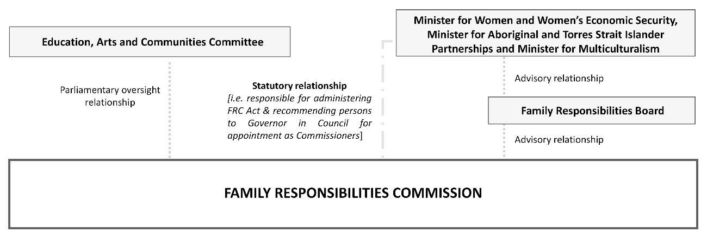
The FRC, as an independent statutory authority, falls under the umbrella of DWATSIPM, previously known as DTATSIPCA. The Commissioner, Deputy Commissioner and Local Commissioners are appointed by the Governor in Council under recommendation by the Minister for Women and Women's Economic Security, Minister for Aboriginal and Torres Strait Islander Partnerships and Minister for Multiculturalism. The Minister and FR Board have advisory relationships to the Commissioner.

Family Responsibilities Board
Part 12 of the FRC Act provides for the establishment of the Family Responsibilities Board (FR Board). Under section 117 of the FRC Act, the FR Board has a mandate to: give advice and make recommendations to the State Minister about the operation of the Commission; if asked by the Commissioner, give advice and make recommendations to the Commission about the performance of its functions; and consider the reports submitted by the Commission.

The FR Board consists of one person nominated by the State Minister (chairperson of the FR Board), one person nominated by the Australian Government and one person nominated by the Cape York Institute. FR Board members are appointed by the Governor in Council for the term stated in the member’s instrument of appointment.
The FR Board members as at 30 June 2025 were:
Ms Kathy Parton Acting Director-General, DWATSIPM as the Chair
Ms Jody Broun CEO, NIAA
Mr Noel Pearson Founder, Cape York Partnership representing CYI.

The FRC Act requires the FR Board to meet every six months. The meeting may be held by using any technology available which will allow for efficient and effective communication. The FR Board members must meet in person at least once a year. A quorum for the FR Board is comprised of two members. Meetings during the reporting period are reflected below.

Date of FR Board meeting | Venue | Board Attendees
6 August 2024 | Level 13 – Gudamulli Conference Room, 111 George Street, Brisbane | Ms Clare O’Connor (Chair), Director General DTATSIPCA; Ms Jody Broun CEO, NIAA; Mr Noel Pearson, Founder and Director, CYI.
4 February 2025 | Boardroom 32.02, 1 William Street, Brisbane | Ms Kathy Parton (Chair), Acting Director General DWATSIPM; Ms Jody Borun, CEO, NIAA; Mr Noel Pearson, Founder and Director, CYI.

Executive Management Team
The Commission’s EMT is comprised of the Commissioner, the Deputy Commissioner, the Registrar, and the Executive Officer (Corporate). The EMT plays a critical role in the corporate governance and service delivery of the Commission by:
- providing value-based leadership whilst being a role model for innovation, teamwork and problem solving
- demonstrating and incorporating high standards of integrity and ethical behaviour
- ensuring transparency and accountability through effective decision-making and communication with employees and service providers
- providing a clear future direction for the Commission
- providing leadership and direction on:
- issues relating to the ongoing financial and non-financial operations of the Commission and the performance of its governance structure
- the operation, performance and reporting of the Commission regarding its obligations under the FRC Act and other relevant legislation.
Due to the small size of the Commission, the role of the EMT also encompasses the corporate stewardship functions associated with the Commission’s operational performance. In addition, the EMT oversees the operations of finance, information management, human resources and planning, audit, risk management, systems review and workload and performance management. The EMT met on a regular basis throughout the 2024-25 year.

Queensland public service values

Customers first |  | Be courageous
 | - Know your customers  - Deliver what matters  - Make decisions with empathy |  | - Own your actions, successes and mistakes  - Take calculated risks  - Act with transparency
Ideas into action |  | Empower people
 | - Challenge the norm and suggest solutions  - Encourage and embrace new ideas  - Work across boundaries |  | - Lead, empower and trust  - Play to everyone's strengths  - Develop yourself and those around you
Unleash potential
 | - Expect greatness  - Lead and set clear expectations  - Seek, provide and act on feedback

The Commission has structured its operations in accordance with the objects and principles of the FRC Act and the Queensland public service values: customers first, ideas into action, unleash potential, be courageous and empower people. The Commission’s Service Charter pledges the best service we can provide and to work with the Australian and Queensland Governments, stakeholders and clients to deliver outcomes for the welfare reform communities. In doing so the Commission nurtures a spirit of inquiry and innovation. Our Local Commissioners and registry staff know their customers and value the cultural needs and family connectedness of community members. Decisions are made with an understanding of where each client comes from and what has influenced their behaviour. The exercise of authority under the FRC Act is governed by this empathy. The Commissioners are challenging the negative social norms in their communities every day, encouraging clients to cross the boundaries of their inappropriate social behaviours. To do so requires courage from the Local Commissioners and registry staff, and from Commission clients.

Public sector ethics and Code of Conduct
Apart from the Commissioner, Deputy Commissioner, and the Local Commissioners – who are appointed by Governor in Council – staff of the Commission are employed under the Public Sector
Act 2022. Employees are made aware of their ongoing responsibilities, duty of care and requirements under the core legislation governing the Commission as published through Commission policies, protocols and guidelines which are readily available to employees. Online Fraud and Corruption, Conflict of Interest and Code of Conduct training is included in induction processes for new employees and is completed by all employees on an annual basis. To further assist Commission employees with ethical decision-making and in understanding the Code of Conduct, the Commission has a supplementary policy document titled Workplace Policy. This policy presents a broad framework for ethical behaviour, supports the Code of Conduct and is consistent with the requirements of the Public Sector Act 2022, the Public Sector Ethics Act 1994, the FRC Act and relevant Public Service Commission (PSC) policies and directives. The Code of Conduct and Workplace Policy are both available in hard copy at all Commission premises.
The Local Registry Coordinators for the five FRC communities conduct Code of Conduct training for the Local Commissioners on an annual basis. Aside from the fundamental principles of the Queensland Public Service Code of Conduct which are strictly adhered to, the principles of natural justice, conflict of interest and confidentiality are established and strongly reinforced with Local Commissioners through the Local Commissioners’ Handbook. Confidentiality is specifically legislated by section 147 ‘Preservation of confidentiality’ in the FRC Act which stipulates that a Commission member, FR Board member, member of staff or a person engaged by a support service must not record, disclose or use confidential information gained through involvement in the administration of the FRC Act unless for lawful purposes as defined in the section.
Alignment with the ethics principles is further achieved through the Commission’s Strategic Plan which incorporates objectives based on enhancing and strengthening socially responsible standards of behaviour both within the registry and in the five welfare reform communities. The Strategic Plan 2023-2027 was published on the FRC website from 1 July 2023.

Human Rights
The Human Rights Act 2019 came into effect on 1 January 2020. The Act is a framework for the Queensland public sector and places the human rights of individuals at the forefront of government and public sector service delivery. It is therefore clear that as employees in a public entity, and as employers, we must consider the impact of our decisions and actions on the human rights of those we serve.
The Commission is committed to building a culture that respects and promotes human rights. To build upon this commitment, all employees complete mandatory annual online training through DWATSIPM’s learning management system in regard to the legislative requirements of the Human Rights Act 2019.

The Commission’s complaints management policies incorporate the need to identify and deal appropriately with a human rights complaint in a transparent process. The Commission has adopted the ‘receive/assess/consider/resolve/respond/learn/report’ methodology to handle human rights complaints. The policy states the Commission will act and make decisions in a way that is compatible with human rights and will properly consider human rights when making decisions regarding complaints. The Commission received no human rights complaints during the reporting period.

Legislative compliance
The FRC complies with a range of obligations under various legislative frameworks. This includes:
- Embedding workplace health and safety within our culture and practices. It is everyone’s responsibility to create and maintain a safe workplace. We expect all staff to identify, report and address workplace health and safety risks.
- Ensuring our policies and workplace practices prevent discrimination, sexual harassment, vilification, and victimisation in line with the Anti-Discrimination Act 1991.
- Promoting the protection of personal information under the Information Privacy Act 2009 and access to information under the Right to Information Act 2009. The Commission has devoted significant resources to understanding and implementing the changes made by the Information Privacy and Other Legislation Amendment Act 2023.
- The implementation of changes and new directives under the Public Sector Act 2022.
- Preparatory work on compliance requirements under Queensland’s new child safeguarding law, the Child Safe Organisations Act 2024.

Risk management
The Commission’s risk management framework establishes a mechanism to identify, assess and manage real or potential risks. The framework supports a positive risk minimisation and management culture which focuses on:
- strategic risks – risks which present as challenges to the Commission’s strategic direction and vision
- operational risks – risks which present as challenges to the daily activities of the Commission in delivering its services.

In applying the risk management principles, the Commission has a Business Continuity Plan (BCP). The framework of this plan incorporates five key elements: prevention, preparedness, response, recovery and review. The plan states a shared legal responsibility and accountability between, and a commitment by, all employees to implement the BCP. Employees are individually responsible for contributing to the BCP and to the health and safety of others by reporting workplace injury, incidents, illness and hazards. Employees are also responsible for seeking to reduce the vulnerability of the Commission to internal and external events and influences that may impede achieving the goals of the Commission. The BCP commences with an integrated approach to managing all risks that may impact strategic and business objectives and moves to reviewing and re-evaluating identified risks and reporting to the EMT.

Internal audit
The Commission is a small organisation, and as such a separate audit committee has not been established. Additionally, a specific internal audit function is not required unless directed by the Minister for Women and Women’s Economic Security, Minister for Aboriginal and Torres Strait Islander Partnerships and Minister for Multiculturalism. Responsibility for audit functions is included as part of the role of the EMT in the corporate governance and service delivery of the Commission.
The Executive Officer (Corporate) is responsible for performing internal audits to ensure efficiency and economy of systems and to identify financial, operational and business continuity risks. Audit results are reported to the Commissioner and Registrar to determine whether remedial actions are required and to establish compliance with statutory requirements and best practice.
Throughout the reporting period, the Commission’s CRM system was periodically audited for quality assurance purposes. These audits were undertaken to assist in maintaining the integrity of our underlying data used for operational and statistical reporting purposes, as well as to ensure continuous improvement in delivering flexible, effective and efficient services.
The results of internal audits undertaken during the reporting period did not identify any significant deficiencies in internal control processes nor any operational or financial risks of a systemic nature that required external remedial action.

External scrutiny
The Queensland Parliament’s Education, Arts and Communities Committee has oversight responsibility for the FRC, as established by Schedule 6 of the Standing Rules and Orders of the Queensland Legislative Assembly (Standing Orders).
Under the Standing Orders (SO194A), the committee's functions with respect to the FRC are to:
- monitor and review the FRC’s performance of its functions
- report to the Assembly on any matter concerning the FRC, its functions or the performance of its functions that the committee considers should be drawn to the Assembly's attention
- examine each annual report tabled in the Assembly under the FRC Act and, if appropriate, comment on any aspect of the report
- report to the Assembly any changes to the functions, structures and procedures of the FRC that the committee considers desirable for the more effective operation of the FRC or of the FRC Act.

The committee does not have the power to reconsider a decision or finding of the FRC. The committee does not act as an appeal body in respect of decisions made by the FRC.
On 28 April 2025, by invitation, Commissioner Williams and Registrar Helen Weedon appeared in person at a Public Hearing of the Education, Arts and Communities Committee of the Queensland State Parliament. The purpose of the hearing was to assist the committee with its oversight of the functions and performance of the Commission. At the hearing the Registrar gave an opening address to the committee before Commissioner Williams and the Registrar responded to a number of questions from committee members on the operation of the Commission.

Topics discussed included:
- the strategic evolution of the FRC
- the empowerment and leadership of the Local Commissioners and FRC clients
- voluntary income management
- challenges faced by the Commission, including the uncertainty of short-term funding arrangements.

Information systems and records governance
The Commission’s ICT system plays a vital role in supporting employees in the Cairns registry and regional offices. The Commission has policies and protocols in place to ensure all employees have a clear understanding of their responsibilities regarding ethical information access, transference, usage, and management. These systems capture and retain information, ensure reliable availability, preserve the integrity of information, and provide a high level of security and confidentiality. Commission employees are required to complete annual online information security training in order to protect the integrity of our systems.
The Commission has policies and protocols in place for the provision of information and communication technology services. These policies ensure that the Commission complies with the Information Privacy Act 2009 whilst providing a high level of security and support. All information security implementation complies with the Australian Cyber Security Centre’s ‘essential eight cyber security strategies’ and the Queensland Government Information Security Policy (IS18:2018), where the focus is primarily on the prevention of unauthorised access, non-compliance, leakage, data disclosure, and damage caused through malware or virus infiltrations.
During the reporting period, the FRC undertook a number of preparedness activities to implement the new Public Records Act 2023. The FRC has reviewed records governance policies, notified the State Archivist of records potentially at risk, and provided feedback on draft mandatory standards.
Section 141 of the FRC Act requires the Commissioner to destroy agency notices and any other documents obtained by the Commission as soon as practicable after the Commissioner is satisfied no relevant person for the agency notice is a community member. The FRC refers to these notices as ‘not within jurisdiction’. During the reporting period, the FRC destroyed 1,098 not within jurisdiction notices.

Workforce profile
At 30 June 2025 the Commission had an employee establishment of 23 full time equivalent positions (FTE) occupied by a headcount of 19 staff members equating to 17.4 FTE.
Additionally, the Commission employs 36 Indigenous Local Commissioners on a fee for service basis under the Remuneration Procedures for Part-Time Chairs and Members of Queensland Government Bodies. The Commission employs a Deputy Commissioner (included in the figures above) who is engaged subject to a delegation from the Commissioner to perform her functions under section 24 of the FRC Act as needed. The Deputy Commissioner is paid at an hourly rate commensurate with that of a Magistrate under the Judicial Remuneration Act 2007 and may act as the Commissioner (if appointed under section 25 of the FRC Act) if the Commissioner is not available to perform the Commissioner’s functions, or there is a vacancy in the office of the Commissioner.

The figures in the workforce profile table below are based on the workforce profile of the Commission, including the Commissioner as CEO, and the Deputy Commissioner, but excluding the Local Commissioners.

Gender
Gender | Number (Headcount) | Percentage of total workforce (Calculated on headcount)
Woman | 14 | 73.7
Man | 5 | 26.3
Non-binary | 0 | 0
Another term | 0 | 0
Not disclosed | 0 | 0

Diversity target group data
Diversity groups | Number (Headcount) | Percentage of total workforce (Calculated on headcount)
Women | 14 | 73.7
Aboriginal Peoples and Torres Strait Islander Peoples | <5 | <26.3
People with disability | <5 | <26.3
Culturally and Linguistically Diverse – Speak a language at home other than English | 6 | 31.6

Target group data for Women in Leadership Roles
 | Number (Headcount) | Percentage of total workforce (Calculated on headcount)
Senior Officers  (Classified, s122 and s155 combined) | <5 | <26.3
Senior Executive Service, High-level senior executives and Chief Executives  (Classified, s122 and s155 combined) | <5 | <26.3
The Commission conducts all recruitment and selection processes in accordance with the requirements of the Public Sector Act 2022 and relevant PSC policies and directives. New employees are welcomed through the Commission’s induction process which provides information regarding the Commission and links to all human resource policies. Each new employee is mentored by a staff member to assist them to become familiar with the Commission and what is expected of them in their role.
The Commission is committed to both maximising permanent employment as reflected in the State Government Entities Certified Agreement 2023 and relevant PSC directives, and maximising employment security as reflected in the whole of government Employment Security Policy.
During the period 1 July 2024 to 30 June 2025 no redundancy, early retirement or retrenchment packages were paid.

Charter of Victims’ Rights
 | Number
Total number of complaints received | 0
Number of complaints made in relation to general right 1 | N/A
Number of complaints made in relation to general right 2 | N/A
Number of complaints made in relation to general right 3 | N/A
Number of complaints made in relation to rights relating to the criminal justice system | N/A
Number of complaints referred to another government entity | N/A

The FRC responded to an information request made by the Victims Commissioner regarding how the Charter of Victims' Rights (the Charter) contained in the Victims’ Commissioner and Sexual Violence Review Board Act 2024 has been operationalised. The Commission acknowledged that we are not yet fully compliant with the requirements of the Charter. Nevertheless, the Commission is actively addressing these gaps as part of a comprehensive wholesale Policy Review project that is currently underway. The project aims to align our policies, procedures, and practices with a suite of new legislative requirements for public sector entities, including those obligations outlined in the Charter, to enhance our support for victims of violent crime.

Performance management
To facilitate employee development, each manager is instructed to enter into a PDA with the employees in their team. The PDA is linked to the Commission’s strategic objectives and forms part of a broad system of human resource management processes including induction and compulsory online training. The agreement sets out identified learning activities, supports the development of competencies, professional skills and personal attributes, and is designed to identify and record knowledge and skills gaps together with learning objectives.

Flexible working arrangements and wellbeing
The Commission promotes policies and activities to support a healthy work-life balance. Flexible work arrangements are actively accessed, and employees are provided the opportunity to work from home where appropriate. Part-time or job share work opportunities exist, and hours of work arrangements including the opportunity for purchased leave are available. These flexible arrangements are also offered to assist in balancing work and carer roles where required. Employees are encouraged to use their annual leave.
To prevent the onset of desk-related neck, back, shoulder, elbow and wrist injuries, and to manage symptoms which may already exist the Commission offers employees access to ergonomic specialist services.

Professional development

Local Commissioner Training
Throughout the reporting period the Local Commissioners received tailored training specific to their roles. Between September and October 2024 registry staff travelled to Mossman Gorge, and Mt Isa, to deliver face to face training to Mossman Gorge and Doomadgee Local Commissioners. Local Commissioners from Hope Vale, Aurukun and Coen travelled to Cairns and received in-person training in November 2024. The training included:
- Workplace Health and Safety Incident training took place between the months of September and November 2024. The training was delivered to the Local Commissioners by the Registrar and covered the Commission’s incident reporting framework and provided guidance on when and how to complete an incident form.
- Workplace Behaviour training: Understanding Everyday Issues and Obligations was delivered to Local Commissioners by the Registrar following the Workplace Health and Safety training. The training presentation was initially developed by external employment law specialists Peters Bosel Lawyers and covered expected workplace conduct, with particular focus on the use of social media, workplace bullying, discrimination and sexual harassment.
- Training for the Youth Justice Childrens Court trigger notice was delivered to the Local Commissioners by the Deputy Commissioner and the Manager Compliance and Legal Policy between September 2024 and June 2025. The training covered the amendment to the FRC Act that operationalised the Childrens Court trigger notice, and the impact and process changes for the Local Commissioners in the course of client conferencing and CE activities. The Local Commissioners began to discuss the key considerations for young people and their families in each of their communities, to identify service providers that may be appropriate, and identify where service gaps were apparent.

The Commission is committed to providing professional development to the Local Commissioners on an ongoing basis to ensure it actively works to restore local authority by:
- assisting the Local Commissioners to enhance and expand upon relationships with other Indigenous organisations, service providers, government departments and agencies
- assisting the Local Commissioners with the delivery of training modules on statutory interpretation and applying a decision-making framework consistent with the FRC Act
- conducting an annual training week during which the Local Commissioners will receive professional training
- conducting round table discussions to set strategic priorities, analyse unique challenges and develop a vision for the future
- conducting a review of operations via individual community dashboards through which statistics are presented and analysed, key performance indicators are set and assessed, and goals refreshed.

The broader focus of the Commission’s professional development program for employees is on:
- promoting skills development, career enhancement, and supporting a culture of ongoing learning through participation in internal workshops
- on-the-job training and courses conducted by specialist external training providers
- ongoing in-house training delivered by the Commissioner on statutory interpretation and application of the FRC Act to registry practices and procedures
- building a resilient workforce by providing online courses in Ethical Decision-Making, leadership and people management skills, Recognise, Respond, Refer – Domestic and Family Violence, Fraud and Corruption Control, Information Privacy, Conflict of Interest, Human Rights Act Public Entities Decision Making (online), Phishing – Information Security Awareness and Finance and Procurement Fundamentals
- promoting cultural capacity by providing Aboriginal and Torres Strait Islander Cultural Awareness training
- facilitating visits to welfare reform communities for new employees to increase their awareness of each unique community and enhance their understanding of the conferencing environment
- providing flexible work practices to enable employees to study whilst continuing to meet operational and client needs
- providing financial assistance and leave arrangements under the Commission’s Study and Research Assistance Scheme.

In line with the above strategies and practices, employees are offered backfill roles in higher duty positions where appropriate in order to ensure continuity of work processes, mitigate downtime, minimise disruption to workflows and enhance employee retention. Backfilling and cross-training safeguards employee expertise and corporate knowledge, whilst maximising succession planning.

During 2024-25 employee professional development, training, and workshops cost $17,555 excluding travel costs. This investment provides a platform for the Commission to foster the development of new skills, monitor, evaluate and improve business processes and improve service delivery.

Publication of information online
For information regarding right to information and information privacy refer to the Right to Information section on the Commission website. For Indigenous matters and complaints management, refer to the Additional Published Information under Right to Information on the Commission’s website at https://www.frcq.org.au. For consultancy, contractor and overseas travel expenditure in 2024-25 refer to the Queensland Government Open Data website at https://data.qld.gov.au.

Publications by the Commission during 2024-25
- Annual Report 2023-2024
- Quarterly Reports 62 - 65 (October 2023 to September 2024)

All publications are available on the FRC’s website: https://www.frcq.org.au.

Financial summary
The FRC is a statutory body under the Family Responsibilities Act 2008 and for the purposes of the:
- Financial Accountability Act 2009
- Financial and Performance Management Standard 2019
- Statutory Bodies Financial Arrangements Act 1982.
This summary provides an overview of the FRC’s financial performance for 2024-25 and a comparison to 2023-24. A comprehensive set of 2024-25 financial statements covering all aspects of the Commission’s activities commences on page 104.

Our overall performance
Table 11: Summary of financial performance
Summary statement | 30 Jun 2025 | 30 Jun 2024
Summary statement | $000 | $000
Income | 5,211 | 4,802
Less: expenses | 4,946 | 4,873
Operating surplus | 265 | (71)

Income
Table 12: Summary of income by type
Income by type | 30 Jun 2025 | 30 Jun 2024
Income by type | $000 | $000
State Government funding | 2,878 | 2,565
Australian Government funding | 2,060 | 2,000
Interest income | 273 | 237
Other income | 0 | 0
Total | 5,211 | 4,802

The increase in funding is in line with the MoU signed between the FRC and the Australian and Queensland Governments on 9 August 2023 including a $236k Consumer Price Index (CPI) adjustment in relation to the Queensland Government funding contribution.

Expenses
Table 13: Summary of expenses by type
Expenses by type | 30 Jun 2025 | 30 Jun 2024
Expenses by type | $000 | $000
Employee expenses | 3,586 | 3,321
Supplies and services | 1,311 | 1,479
Depreciation and amortisation | 4 | 12
Finance/borrowing costs | 1 | 8
Other expenses | 44 | 53
Total | 4,946 | 4,873

Employee expenses represent 73% of the total expenditure in 2024-25 compared to 68% in 2023-24. The increase of 8% from the prior year is in part attributable to the 4% wage increase for most employees and a movement from staff engaged through temporary employment services to being directly employed by the FRC. Payments to Local Commissioners were at similar levels to the prior year.
The overall decrease in supplies and services is primarily attributed to a reduction in the use of temporary employment services to fill vacancies throughout the year, followed by lower ICT expenses. However, this was partially offset by higher travel costs due to increased levels of community engagement.
The expenditure of the FRC can be categorised as follows:
- Community operations – further broken down into:
  - On-the-ground community operational expenses including the operational expenses in each of the five communities to conduct conferences and hearings, prepare and monitor case plans for clients for attendance at community support services, prepare and monitor income management orders and agreements and undertake CE activities.

- Support and facilitation expenses including costs associated with facilitating the holding of conferences and hearings in the five communities, providing support to the Local Commissioners and Local Registry Coordinators to hold conferences, hearings and CE activities, assisting with the ongoing monitoring of case plans for clients through the provision of data and other information and processing income management orders and agreements.
- Corporate governance includes finance, statistical reporting, corporate governance, compliance, information technology, training and other administrative functions to ensure the effective and efficient operations of the Commission.

The allocation of the FRC’s costs in 2024-25 based on the above was:
Graph 17: Allocation of expenses
1 July 2024 to 30 June 2025
These expenses can be further categorised as front-line and non-frontline in accordance with the Queensland Public Service Commission definitions.
Community operations, conference facilitation and CE expenses are frontline expenses and are conducted on-the-ground in community by Local Registry Coordinators and Local Commissioners, and in the Cairns registry office to support the holding of FRC conferences, hearings and CE activities across the five communities.
The Local Commissioners are paid sessional fees per Level 3 Adjudication and determination in accordance with the Remuneration Procedures for Part-Time Chairs and Members of Queensland Government Bodies. When engaged, the Local Commissioners could be holding conferences and/or hearings, serving notices, attending meetings, undertaking CE activities and professional development.
The work undertaken by the CM&M team in the Cairns registry includes duties which are undertaken to support conference prioritisation and scheduling, preparation of information for CE activities, preparation of client records for consideration by the Local Commissioners, processing decisions made and preparing and monitoring case plans and/or income management orders and agreements. This work is essential in supporting the Local Commissioners during conferencing and client engagement and cannot be effectively or efficiently carried out within the communities themselves.
For 2024-25 69% of FRC expenses were utilised to support frontline operations, whilst 31% supported corporate governance.

Our position
Total assets as at 30 June 2025 consisted of current assets of cash, prepayments and receivables in addition to non-current right-of-use assets.
Total liabilities as at 30 June 2025 consisted of payables, accrued employee benefits and lease liabilities.
Table 14: Statement of financial position
Statement of financial position | 30 Jun 2025 | 30 Jun 2023
Statement of financial position | $000 | $000
Total assets | 4,871 | 3,952
Total liabilities | 997 | 343
Net assets | 3,874 | 3,609
Total equity | 3,874 | 3,609

This page is intentionally left blank.

White pages 1

White pages 2

White pages 3

White pages 4

White pages 5

White pages 6

White pages 7

White pages 8

White pages 9

White pages 10

White pages 11

White pages 12

White pages 13

White pages 14

White pages 15

White pages 16

White pages 17

White pages 18

White pages 19

White pages 20

White pages 21

This page is intentionally left blank.

Appendix A – Strategic Plan 2023-2027
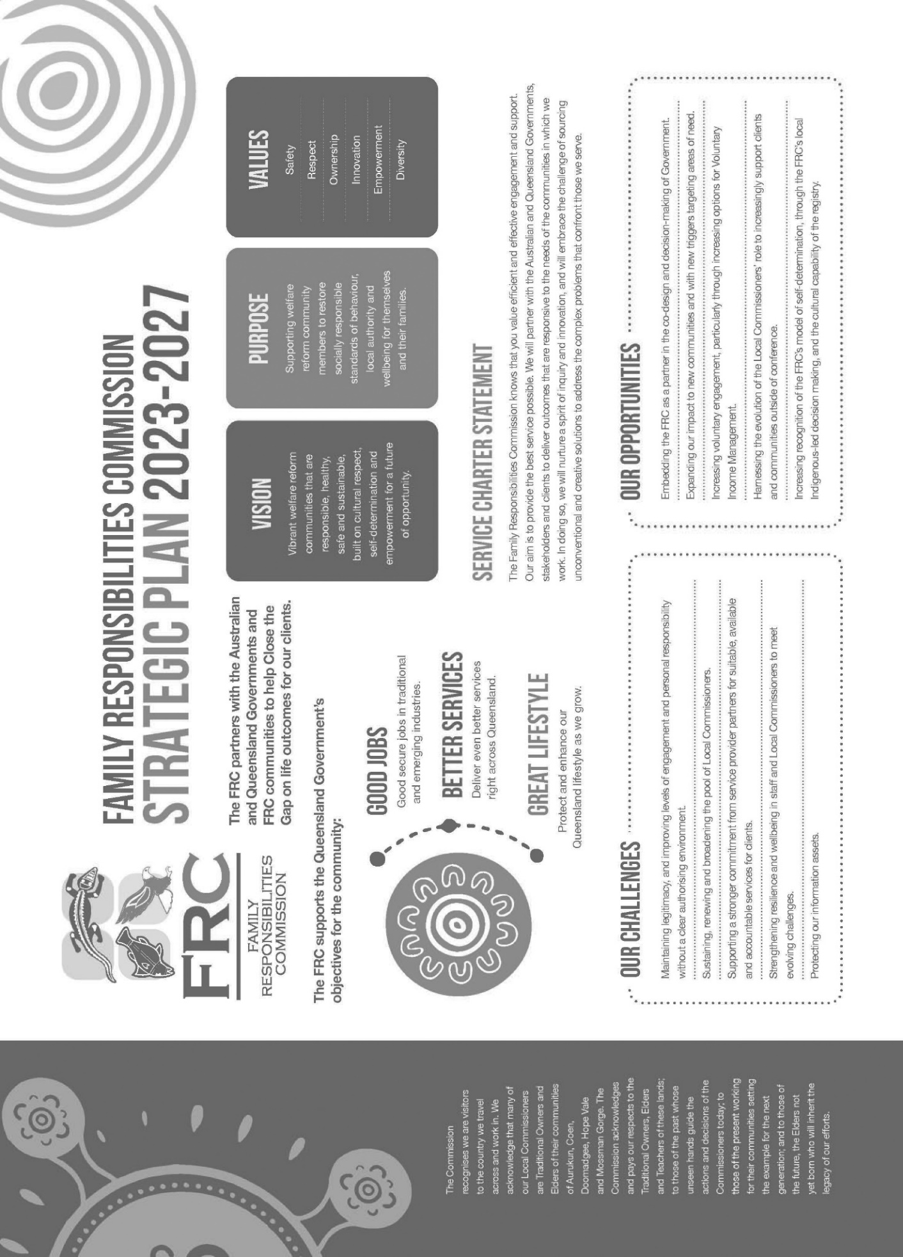

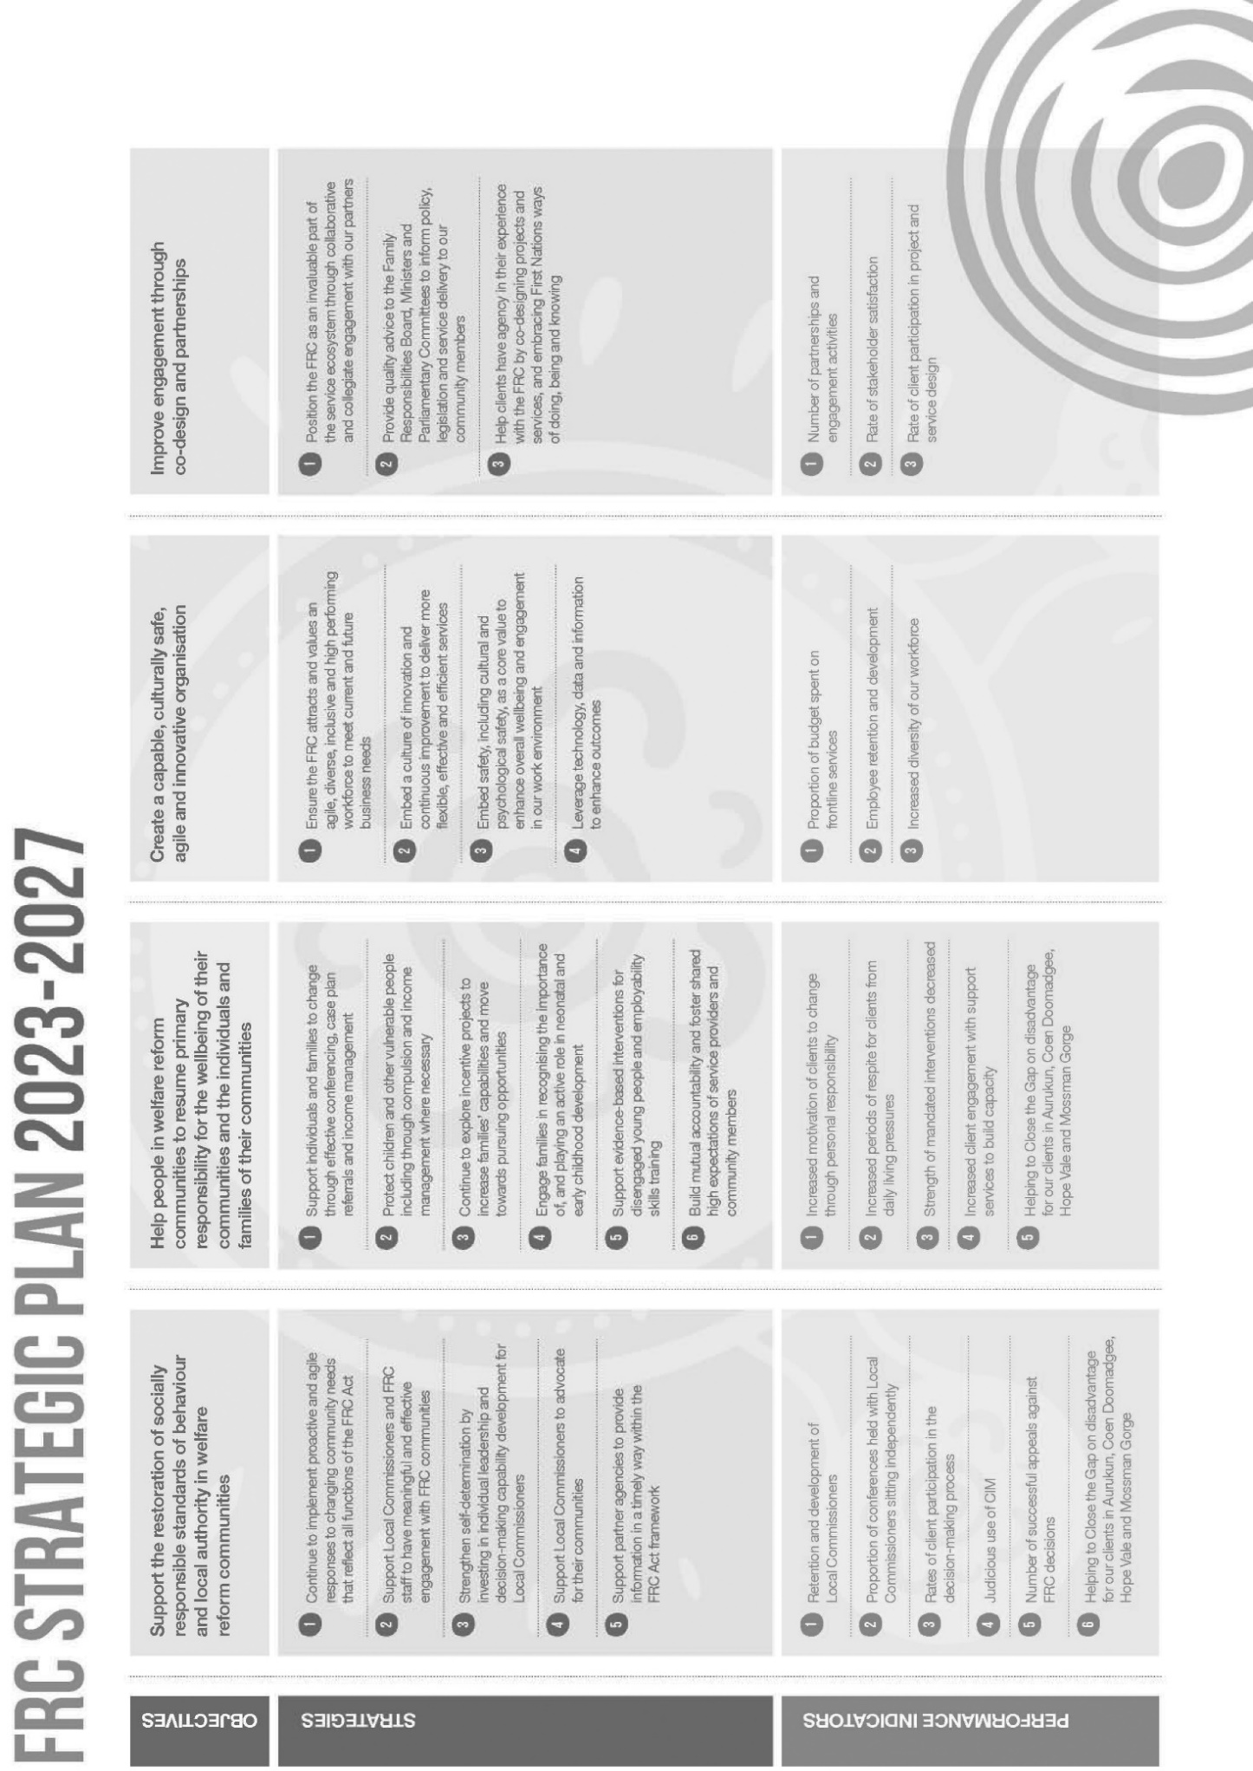
Appendix A continued

Appendix B – Analysis of the Queensland Government’s ‘Our Way’ strategy and the Family Responsibilities Commission Act 2008.
The FRC Act supports Queensland’s ‘Our Way’ strategy, initiated to address the over-representation of Indigenous children in Queensland’s child protection system, as demonstrated in the following table.

Our Way Strategy  Enablers and Building Blocks | Family Responsibilities Commission Act 2008  Objects and Principles
Focus on the child | Best interests of children  s5(1): The FRC Act is to be administered under the principle that the wellbeing and best interests of a child are paramount.  s5(2)(b): In a conference about an agency notice involving a child, the child’s views and wishes should be taken into account in a way that has regard to the child’s age and ability to understand.
Empower Aboriginal and Torres Strait Islander parents, families and communities | Early intervention and local authority  s4(1)(b): A main object of the FRC Act is to help people in welfare reform community areas to resume primary responsibility for the wellbeing of their community and the individuals and families of the community.  s5(2)(a)(i) & (iii): The Commission should deal with matters in a way that facilitates early intervention…and makes appropriate use of community support services.  s5(2)(c): Aboriginal tradition and Island custom must be taken into account in matters involving Aboriginal people or Torres Strait Islanders.
Enable self-determination | Local authority and decision-making  s50: Constitution of commission for conferences requires Local Commissioners appointed for the welfare reform community area from where the client lives or lived.  s51(3): In appointing Local Commissioners for conference the FRC must consider their appropriateness, having regard to the clan or family group to which the person belongs; and consider whether the Local Commissioners should be male or female.  The decision-making power of the FRC at conference is held by Aboriginal Commissioners.
Appendix B continued

Our Way Strategy  Enablers and Building Blocks | Family Responsibilities Commission Act 2008  Objects and Principles
Set high expectations and positive norms | Socially responsible standards of behaviour  s4(1)(a): A main object of the FRC Act is to support the restoration of socially responsible standards of behaviour and local authority in welfare reform community areas.  s4(2)(b) The objects are to be achieved mainly by establishing the FRC… to deal with matters in a way that:  - encourages community members to engage in socially responsible standards of behaviour; and  - promotes the interests, rights and wellbeing of children and other vulnerable persons living in a welfare reform community area.

Appendix C – Biographies of Commissioners and the Registrar

Family Responsibilities Commissioner

Commissioner Tammy Williams
Tammy Williams was appointed as Commissioner of the FRC on 2 September 2019. Since her appointment she has been working hard to apply her own work culture and extensive business acumen to Commission operations. Commissioner Williams leads by using an adaptive and authentic leadership style drawn equally from both her professional and lived experiences as an Aboriginal woman.
Tammy Williams is a Murri woman from the Guwa people near Winton and the Wangan and Jagalingou peoples of central Queensland. She was awarded a law degree from the Queensland University of Technology in 2001, after which she was admitted as a Barrister to the Supreme Court of Queensland and High Court of Australia in 2002. She is a highly experienced professional who has worked successfully within and outside government. She has a great understanding of the Commission and welfare reform communities, having acted as the Director-General for the Department of Aboriginal and Torres Strait Islander Partnerships in the past, and as such, a member of the FR Board.

Deputy Commissioner Rodney Curtin
Deputy Commissioner Rodney (Rod) Curtin was born and raised in Cairns and completed his secondary education at St Augustine’s College. He attained a Bachelor of Law degree through the Queensland University of Technology and was appointed a Barrister-at-Law to the Supreme Court of Queensland and the High Court of Australia in 1987. Deputy Commissioner Curtin’s practice has been predominately in the jurisdictions of Family Law and Criminal Law. His experience has involved the conduct of circuits in the Cape York Peninsula and Torres Strait regions for more than 25 years. Over the years he has been called on to conduct many seminars and training sessions for students at James Cook University, the Department of Education and Family Court counsellors on family law and domestic violence issues. Deputy Commissioner Curtin has also mentored young solicitors and field officers attached to the Aboriginal and Torres Strait Islander Legal Service.
Deputy Commissioner Curtin is passionate in the pursuit of access to justice services for Indigenous people. He advocates for the advancement of programs to provide better resources and achieve better outcomes for Indigenous people who appear before the courts. Deputy Commissioner Curtin has been involved with the Cape York Peninsula Youth Justice Program and has been a strong advocate for Juvenile Justice issues. His service to the Indigenous communities has been acknowledged as dedicated and compassionate, having an in-depth knowledge of the cultural and social issues of people within those communities. Rod’s original appointment as Deputy Commissioner from July 2010 expired in December 2018. He was reappointed to the role in July 2020. Deputy Commissioner Curtin advises that he thoroughly enjoys his work, the most rewarding aspect of which has been his association with the Local Commissioners. Their dedication and tireless persistence in striving toward creating a better community and setting a wonderful example for the next generation has been inspirational.

Local Commissioners

Aurukun
Commissioner Edgar KERINDUN OAM (Sara Clan) was born and raised in Aurukun and is a traditional owner of the area. Before his election as a Councillor for the Aurukun Shire Council in 2012 Commissioner Kerindun worked as an Engagement Officer at Queensland Health. He served as a Councillor for eight years, including four years as Deputy Mayor, until 2020 when he decided not to run for re-election. On 26 January 2015 Commissioner Kerindun was awarded the Medal of the Order of Australia (OAM) for his services to the community. One of the original Community Police Officers in Aurukun, he continues to advocate for justice and rehabilitation for ex-offenders. Along with his partner, Commissioner Doris Poonkamelya, he cares for three children from their extended family. Commissioner Kerindun believes that showing respect to everyone fosters mutual respect.
Commissioner Doris POONKAMELYA OAM (Putch Clan) was born at the Kendall River Outstation and moved with her family to Aurukun when she was a child. She dedicated 29 years of her life to working as a senior health worker for Queensland Health, retiring in 2009. On 26 January 2015 Commissioner Poonkamelya was awarded the Medal of the Order of Australia (OAM) for her services to the community. From 2016 to 2020 she served as a Councillor for the Aurukun Shire Council but chose not to run in the 2020 Local Government elections. A founding member of the Aurukun Community Justice Group, Commissioner Poonkamelya is also deeply committed to education as a pathway to employment and a promising future for young people. As a carer for Child Safety Services, she believes in creating a safe environment for children to grow and mature.
Commissioner Ada Panawya WOOLLA OAM (Winchanum Clan) was born and raised in Aurukun, leaving the community to attend boarding school and later Cairns Business College. From 2012 to 2020 Commissioner Woolla served as a Councillor on the Aurukun Shire Council, deciding not to stand for re-election in 2020. Upon her election to Councillor in April 2012 she retired from her position as a Recognised Entity where she assisted families and children in Aurukun.
In September 2014 Commissioner Woolla was appointed to the Special Taskforce on Domestic and Family Violence in Queensland, established by former QLD Premier Campbell Newman and chaired by the Honourable Quentin Bryce AD CVO and former Governor-General of Australia. On 26 January 2015 she was awarded the Medal of the Order of Australia (OAM) for her services to the community. In September 2018 she was appointed to the Queensland First Children and Families Board, which oversees the implementation of “Our Way” – a generational strategy and “Changing Tracks,” an action plan for Aboriginal and Torres Strait Islander children and families (2017 – 2019).
Commissioner Woolla is also a foster and kinship carer, an office bearer in the Aurukun Church, a founding member of the Aurukun Community Justice Group, and a respected mediator and community elder. Her support for the education and training of young people is well recognised. Alongside her husband Dereck Walpo, she strives to improve opportunities for her community.
Commissioner Dorothy POOTCHEMUNKA (Winchanum / Aplach Clans) was born, raised, and educated in Aurukun. She has 10 children, 17 grandchildren and six great-grandchildren. Commissioner Pootchemunka’s interests encompass a wide range of traditional activities including fishing, camping and basket weaving using Pandanus and Cabbage leaves. Her baskets are displayed in national galleries in Australia and overseas. In 2023 Aurukun State School engaged Commissioner Pootchemunka to deliver cultural classes to senior students, teaching weaving, collecting roots to extract dye, and fire building.
Commissioner Pootchemunka is a registered Wik interpreter, and her expertise is utilised within the court system and by the Department of Human Services. More recently she worked with the Youth Justice team as an interpreter for local Aurukun youth. She became an Aurukun Local Commissioner on 4 March 2010. Commissioner Pootchemunka views education as the key to employment and encourages all students to make the most of their education and training to enhance future job opportunities.
Commissioner Vera KOOMEETA OAM (Aplach Clan) was born in Aurukun and attended primary school there. She continued her studies at Scots PGC College in Warwick, completing Year 10, and later earned a qualification in community teaching from Technical and Further Education (TAFE) in Cairns. From 2012 to 2020 Commissioner Koomeeta served as a Councillor in the Aurukun Shire Council, choosing not to run in the 2020 Local Government elections. On 26 January 2015 she was awarded the Medal of the Order of Australia (OAM) for her services to the community.
Commissioner Koomeeta is a Justice of the Peace (Magistrates Court) and a registered interpreter, as well as a member of the Aurukun Community Justice Group. As a representative of her clan group, she is involved in several committees and holds positions on multiple boards. Her extensive experience enhances her ability to make independent and informed decisions as a Local Commissioner. In 2022 she joined the Aurukun School Board (Paamp) to support school attendance and children’s wellbeing. When not working Commissioner Koomeeta can been found fishing and camping with her grandchildren. Commissioner Koomeeta is an established artist, with her paintings featuring at the Cairns Indigenous Art Fair.
Commissioner Keri TAMWOY (Putch Clan) was born in Cairns but has spent her entire life in Aurukun. She met her husband Gerald Tamwoy when they were 17 and 18 years old respectively. Together they have raised their six children in Aurukun, deeply embedding themselves in the community.
Commissioner Tamwoy has extensive experience as a mediator and has successfully run the mediation program in Aurukun which has been instrumental in helping families resolve conflicts without resorting to violence. She considers the mediation program a valued service in Aurukun.
Professionally, Commissioner Tamwoy has previously worked as the Office Manager for the Aak Puul Ngantam Ranger Program and currently serves as the chairperson of the organisation. She is also a Director of her husband's business and runs her own business delivering cultural and community awareness workshops for Aurukun stakeholders.
Commissioner Tamwoy became an Aurukun Local Commissioner on 1 January 2018 at the age of 44. She was elected Mayor of the Aurukun Shire Council in the Local Government elections on 28 March 2020. Throughout her term of four years, she was dedicated to supporting the Wik people of Aurukun, striving to empower them and enhance their community.
On 1 December 2021 Commissioner Tamwoy was honoured with the National NAIDOC Person of the Year award. In 2022 she became an active member of the Paamp Aurukun State School Board, which was established to address the attendance and wellbeing of Aurukun's school-aged children. Commissioner Tamwoy believes that education is the foundation for children's futures and supports personalised learning for each child.
In her spare time Commissioner Keri Tamwoy enjoys fishing and camping or simply relaxing at home watching movies with her seven grandchildren.
Commissioner Dereck WALPO (Kiadilt Clan) was born and raised on Mornington Island. After completing his primary schooling on Mornington Island, he completed his senior studies while boarding in Warwick Queensland. Commissioner Walpo then moved to Cape York where he met his partner of 40 years, fellow Commissioner Ada Woolla of the Winchanum Clan. He has worked in various positions across Aurukun including in plumbing, as a road worker and machinery driver before finding work in the health system and becoming the Team Leader of the Wellbeing Centre. In 2016 Commissioner Walpo joined the Apunipima Board to support the Aurukun community and ensure their voices are heard. He recognises the importance of mental health support and the need for services to support remote Indigenous communities such as Aurukun.
From 2012 to 2020 Commissioner Walpo held the position of Mayor in the Aurukun Shire Council using his authority to work towards improving social norms and helping the community of Aurukun grow. In November 2023 Commissioner Walpo joined the Aurukun Community Indigenous Corporation as a member of the board.
Commissioner Walpo has two children and nine grandchildren and enjoys spending the weekends with his grandchildren fishing and hunting. Commissioner Walpo became an Aurukun Local Commissioner on 5 May 2022. He wants to use his role as a Local Commissioner to further restore social norms and encourage community members to take responsibility for their futures.

Coen
Commissioner May Mary KEPPLE OAM (Wik-Munkan Clan) is a Justice of the Peace (Qualified). Commissioner Kepple has had a variety of positions in retail and sales and enjoys painting on canvas. As an accredited foster carer since 2007 she remains committed to the welfare of children, ensuring they receive opportunities for self-development and a bright future. From 2011 to 2014, Commissioner Kepple worked in housekeeping for local accommodation businesses, then from February 2014 to 2018 Commissioner Kepple worked with Cape York/Gulf Remote Area Aboriginal & Torres Strait Islander Child Care (RAATSICC) as a Community Recognised Entity and Advisor. On 23 December 2021 Coen Commissioner Kepple retired from the Department of Justice and Attorney-General as a Member Elder where she was responsible for providing court support to the Justice Group Coordinator and clients, and networking with other stakeholders to advocate for clients in relation to referrals, programs and activities.
On 26 January 2015 Coen Commissioner Kepple was awarded a Medal of the Order of Australia (OAM) in recognition of her services to the community. Commissioner Kepple spends her weekends on country with her daughter and grandchildren passing on culture and the ways of the Elders.
Commissioner Elaine Louise LIDDY OAM (Lama Lama Clan) was born in Cairns. She is a fluent Umpithamu language speaker and has contributed to the dictionary of the Umpithamu language. Coen Commissioner Elaine Liddy has been pivotal in establishing the Lama Lama Rangers who live and work on her Lama Lama homelands of Port Stewart and is now a full-time Cultural Heritage Adviser Team Leader. She is a Justice of the Peace (Qualified) and is a highly respected leader of the Lama Lama Clan. On 26 January 2015 Coen Commissioner Elaine Liddy was awarded a Medal of the Order of Australia (OAM) in recognition of her services to the community. Commissioner Elaine Liddy devotes her spare time to the care of her homelands, and to passing on tradition and culture to future generations.
Commissioner Alison LIDDY (Lama Lama Clan) commenced with the Commission on 14 May 2015. Coen Commissioner Alison Liddy was born in Cairns and completed most of her schooling in North Queensland. Furthering her educational qualifications, Commissioner Alison Liddy attained a Certificate III in Indigenous Community Service and Primary Health Care. She has held many positions over the years, working in administrative roles as an Indigenous Health Worker with the Coen Primary Health Care Centre, Community Engagement Officer with the Royal Flying Doctor Service (RFDS) and Apunipima Cape York Health Council at the Coen Wellbeing Centre. Coen Commissioner Alison Liddy is currently employed as the Junior Ranger Coordinator and Administrator for the Yintjinnga Aboriginal Corporation and the Lama Lama Ranger Service. Working locally in Coen for many years and being involved in the community has enabled her to gain a broad understanding of the issues that affect those living in Coen. Her interest in becoming a Local Commissioner was inspired through her sister, Elaine Liddy, who has been a Coen Commissioner since the commencement of the Commission in 2008.
Commissioner Maureen LIDDY (Lama Lama Clan) also commenced with the Commission on 14 May 2015. Coen Commissioner Maureen Liddy has worked extensively with families and children across Cape York. She taught at a number of schools in the far north, including Bloomfield River State School where she had the privilege of relieving for a couple of weeks as the Acting Principal. She was the Coen State School Principal for some five years and then was the Hope Vale State School Principal. For four years in Hope Vale, she was seconded to the Department of Aboriginal and Torres Strait Islander Partnerships Cape York Strategy Unit as part of the Government Champions Program where she coordinated the Negotiation Tables throughout Cape York between the communities and their Government Champions. She resigned as the Principal of Hope Vale State School and took on the role of Transition Officer for the Department of Education, assisting in moving children from primary schools to secondary schooling, and even further education.
Since 2010 Coen Commissioner Maureen Liddy has held several positions including with Cape York Partnership as a manager involved with the academy schools and teachers, with the RFDS in Coen as a Community Development Officer and as Team Leader of the Coen Wellbeing Centre with RFDS. She stayed on as Team Leader when the Coen Wellbeing Centre transitioned to be managed by Apunipima Cape York Health Council. Commissioner Liddy also held a position with Good to Great Schools in the role of Community Partnership Engagement Manager, and more recently as Implementation Manager with Pama Futures. Commissioner Liddy has now transitioned to the position of Opportunity Hub Leader with Cape York Partnership and has returned to live in Coen.
On 26 January 2019 Coen Commissioner Maureen Liddy was awarded the Cook Shire Citizen of the Year in recognition of her work to improve the lives of Indigenous people in the Cook Shire. She holds a Graduate Diploma in Education and is a member of the Coen Apunipima Health Action Team. Commissioner Maureen Liddy’s personal interests include spending time with her family, camping, fishing, reading, four-wheel driving and meeting people.
Commissioner Ramana WALKER (Wik-Mungkan Clan) commenced with the Commission on 1 July 2023. Commissioner Ramana Walker has a deep connection to Coen, having been born and raised there. She is currently raising her two young boys and takes great pride in her role as a mother.
Commissioner Ramana Walker brings a wealth of experience in working with families in Coen, with eleven years of dedicated service at Queensland Health. Previously, she held the position of Domestic Violence Prevention Worker at the Coen Regional Aboriginal Corporation. Commissioner Ramana is currently in the role of Project Support Officer with First Nations Housing and Homelessness, Department of Housing.
Commissioner Ramana Walker is committed to continuous growth and development, having successfully completed a Certificate IV in Mental Health, and engaging in other relevant studies. Commissioner Ramana has also recently become a Justice of the Peace (Qualified). These educational endeavours aim to equip her with the necessary knowledge and tools to effectively support individuals and families in her community, particularly in the area of suicide prevention.
Beyond her professional pursuits, Commissioner Ramana Walker is passionate about helping people.
Commissioner Naomi HOBSON (Southern Kaantju Clan) commenced with the Commission on 1 July 2023. She received her early education in Coen and then completed her secondary studies in Cairns and Townsville. After completing school Commissioner Hobson undertook further studies in the Arts and Social Work.
Commissioner Hobson has extensive working knowledge within her community, having held numerous director positions in her community of Coen, and in several local, regional and interstate government organisations as well as not-for-profit organisations.
Commissioner Hobson enjoys travelling and experiencing different cultures, something she has been able to achieve through the numerous accolades she has achieved in the arts. Commissioner Hobson also believes strongly in the importance of family, preserving cultural practices and is a Community Activist focusing on positive mental health, social, emotional, and wellbeing.

Doomadgee
Commissioner Christopher LOGAN (Garrawa Ghuthaarn / Takalaka Clans) was born in Normanton and educated at Normanton State School to Year 10, after which he moved to Doomadgee. Doomadgee Commissioner Christopher Logan is married to Eleanor Logan, herself a Local Commissioner, and together they have had three children of their own, raised another two from a young age, provided foster care for many more and have 16 grandchildren and two great-grandchildren. Commissioner Christopher Logan’s working life has included employment as a stockman, carpenter, Community Police Officer, a storeman at the Doomadgee Aboriginal Shire Council and work at the Doomadgee retail store. He was a Councillor from 1992 to 1994 with the Doomadgee Aboriginal Community Council and Doomadgee Aboriginal Shire Council Deputy Mayor from 2008 to 2012. He has also driven trucks and has run the night patrol for the Doomadgee community. For many years Doomadgee Commissioner Christopher Logan was involved with the State Emergency Service and was second in charge. His strong belief in education and the importance of children attending school every day led in 2013 to his commencement in the initial role of School Attendance Supervisor at the Doomadgee State School, working directly alongside the Doomadgee State School Principal. He then went on to hold the position of Indigenous Education Leader at the Doomadgee State School until 2019. Commissioner Christopher Logan played rugby league for the Doomadgee Dragons from 1989 to 2007, captaining the side from 1989 to 1994, and was the club chairperson from 2008 to 2014. He loves to spend his weekends taking his grandchildren out bush, camping, hunting and fishing.
Commissioner Elaine CAIRNS (Waanyi Lardil Clan) moved to Doomadgee from Mornington Island in 1969. She completed her junior education at Doomadgee State School before moving to Malanda to complete Years 9 and 10. A mother of six, grandmother of 19 and great-grandmother of 10, Commissioner Elaine Cairns has firm ties to several clans within the community and derives great joy from her extended family. A strong Indigenous woman, Doomadgee Commissioner Elaine Cairns worked as a cleaner and receptionist at the Doomadgee Aboriginal Shire Council, served as Deputy Mayor from 2004 to 2007, acted as Mayor for six months in 2007 and was a Councillor from 2012 to 2016. Previously Doomadgee Commissioner Elaine Cairns spent one and a-half years as a chef at the Doomadgee Hospital, and nine and a-half years as a Centrelink agent before becoming a Councillor. She has also been involved with the Strong Women’s Group (formerly known as the Indigenous Women’s Forum) since 2004. In her capacity with the group, she has travelled across Australia taking a stand against domestic violence towards Aboriginal women.
At the Local Government elections conducted on 16 March 2024 Commissioner Cairns was elected again as a Councillor for the Doomadgee Aboriginal Shire Council. Her view that strong Indigenous women can make a difference to the communities in which they live drives her ambition to contribute to building a better future for Doomadgee’s children. Commissioner Elaine Cairns loves reading, gardening and spending time out bush, fishing and camping. As a hobby she also enjoys composing and writing poems and songs and painting.
Commissioner Kaylene O’KEEFE grew up in Mount Isa before moving to her parents’ hometown of Doomadgee in 1990. Married to Dwayne O’Keefe since 2001, Commissioner O’Keefe is a mother of three daughters, and she became a grandmother to a grandson in 2011 and a granddaughter in 2023. Her past employment has included time working at the local store, in accounts at the Doomadgee Aboriginal Shire Council and as a Family Support Worker with RAATSICC. She is currently employed at 54 Reasons (formally Save the Children) as a Youth Worker.
Since 2018 Doomadgee Commissioner O’Keefe has been involved with the Strong Women’s Group and has mentored Indigenous women. Commissioner O’Keefe hopes that her role as a Local Commissioner with the Family Responsibilities Commission will enable her to play a significant part in improving outcomes for Doomadgee families.
Commissioner O’Keefe enjoys camping, fishing and spending time with her family, in particular her young grandson.
Commissioner Eleanor LOGAN (Waanyi / Gangalidda Clans) grew up in Doomadgee, before moving to Banyo College in Brisbane to complete Year 11. Commissioner Eleanor Logan continued to further her education, gaining a Certificate III and a Diploma of Children’s Services, and trained in the area of Aged Care Management. Recognising the need for a support network for young mothers in Doomadgee, Commissioner Eleanor Logan was instrumental in forming a playgroup for young mums. She was a Councillor with the Doomadgee Aboriginal Shire Council from 2008 to 2012. Married to fellow Doomadgee Commissioner Christopher Logan, she says family is her priority. She has fostered many children and is presently fostering two young boys. Doomadgee Commissioner Eleanor Logan is currently the Director of the Doomadgee Child Care Centre. When not working she enjoys camping, fishing and spending time with her 16 grandchildren and two great-grandsons.
Commissioner Guy DOUGLAS (Waanyi / Gangalidda Clans) has always lived in Doomadgee, apart from a year spent completing his education at Atherton State High School. He has worked as an Aboriginal Health Worker, Senior Community Worker, Police Liaison Officer, Project Worker at 54 Reasons (formerly Save the Children) for the Doomadgee Deadly Homes Program, a Senior Community worker and Health Services Manager for Gidgee Healing. Doomadgee Commissioner Douglas is currently employed as an Indigenous Liaison Officer for the Rheumatic Heart Disease project with QLD Health. In this role Commissioner Douglas provides assistance to hospital staff in the management and treatment of community members suffering from Rheumatic Heart Disease.
Commissioner Douglas is married to Cecilia, is father to six children and they have six grandchildren. Commissioner Douglas, along with his wife, has spent many years volunteering with young people in the community and as a leader of the local Brethren Church. He is also a board member of the Doomadgee Health Council. When he is not busy coaching the local women’s softball team, ‘The Bushfires’, he likes nothing better than to go back out on country to hunt, fish and camp. Doomadgee Commissioner Douglas is a firm believer that education must begin at home from a young age to form a strong foundation for the future.
Commissioner Isabel TOBY (Waanyi / Gangalidda Clans) was born in Doomadgee and has lived most of her life there. Married to Christopher Toby, Isabel has three sons, one daughter and nine grandchildren who she loves having around. Having not had the opportunity to attend boarding school herself, Commissioner Toby was determined that her own children would not miss out on a good education and has sent each of them to boarding school to further their studies. One of her sons has completed a carpentry apprenticeship. Commissioner Toby would also like her grandchildren to follow in the same steps to ensure they receive the education they deserve. Doomadgee Commissioner Toby has worked at Centrelink, the Doomadgee Aboriginal Shire Council and Job Futures and as a teacher aide. She is currently employed as a Team Leader to Family Support Workers at 54 Reasons where she has worked for ten years. She enjoys helping her community to ensure a positive future for their children and families.
Commissioner Toby commenced as a founding Local Commissioner for Doomadgee in August 2014 until 8 June 2017. She has since re-joined the Commission as a Local Commissioner on
1 November 2019.
Commissioner Dawn APLIN (Waanyi Clan) was born in Burketown. She moved to Doomadgee as a young child where she attended the Doomadgee State School until she completed Year 7. She then moved to Malanda to attend Malanda State High School to complete Years 8 and 9. After she completed her schooling Commissioner Aplin moved back to Doomadgee and commenced working. Commissioner Aplin’s work experience includes working for the Doomadgee Aboriginal Shire Council as a Pay Clerk for 11 years, and for the Community Development Employment Projects program as a Sign-up Officer. Since 2016 Commissioner Aplin has been working at 54 Reasons. Commissioner Dawn Aplin has five children, three boys and two girls, is a grandmother of 18 grandchildren and a great-grandmother of six great-grandchildren. She enjoys fishing in her spare time as well as going out on country with her family to camp and hunt. Commissioner Aplin feels committed to helping young parents in the community and this is what inspired her to become a Local Commissioner.
On 1 November 2019 Dawn Aplin was appointed as a Doomadgee Local Commissioner. Coupled with her employment at 54 Reasons, Commissioner Aplin sees her work as a Local Commissioner as being extremely important in aiding and guiding young families in the community.
Commissioner Wendy TAYLOR (Lardil / Gangalidda / Garrawa Clans) was born in Doomadgee where she attended Doomadgee State School as well as School of the Air, whilst living on an outstation. Commissioner Taylor later attended school in Malanda where she completed Years 8-10. After completing school, Commissioner Taylor returned to Doomadgee where she commenced working in various positions in the community. She worked at both the Doomadgee shop and the Doomadgee State School for a couple of years each and is currently working at the Doomadgee Childcare Centre where she has been since 2000. Commissioner Taylor spends her personal time fishing, hunting and collecting bush tucker with her friends and family. She is a mother of five children, grandmother of 18 grandchildren and great-grandmother of eight great-grandchildren. Commissioner Taylor became a Doomadgee Local Commissioner on 5 May 2022.
Commissioner Leila CAIRNS (Waanyi Clan) was born at Gregory Downs Station. She attended school in Burketown and Doomadgee before moving to Brisbane to complete Year 8, and then to Malanda to complete Years 9 and 10. After completing school, Commissioner Leila Cairns returned to Doomadgee where she held various positions in the community. She has managed both the aged care facility and the local bakery, worked in the local store for five years, held the position of receptionist at the Doomadgee Rural Hospital for 15 years, and worked as a health worker for 10 years. Commissioner Leila Cairns has four children, 12 grandchildren and 16 great-grandchildren. In her spare time, Commissioner Leila Cairns enjoys time with her family fishing, camping and spending time outside. When she is not enjoying the great outdoors, she likes to attend church and participate in Christian conventions held throughout the state. Commissioner Leila Cairns became a Doomadgee Local Commissioner on 5 May 2022.
Commissioner Virginia Grace COLLINS (Waanyi / Gangalidda / Garrawa Clans) was born in Mt Isa but has lived in Doomadgee for most of her life. Whilst in Doomadgee, Commissioner Collins attended Doomadgee State School. After completing school, she commenced working with Community Development Employment Projects in Doomadgee and then other organisations such as the store and the Women’s Shelter before settling into her current employment with the Doomadgee Aboriginal Shire Council in the Post Office, where she has been employed since 2020. Commissioner Collins is a mother of two boys and is eagerly waiting to become a grandmother. She enjoys going out bush camping and fishing, as well as reading and spending time with family and friends. Commissioner Collins became a Doomadgee Local Commissioner on 5 May 2022.

Hope Vale
Commissioner Priscilla GIBSON (nee BOWEN) has ancestral heritage to the following clan groups: Dharrba Warra and Bagaarrmugu from both her parents with the latter being from her mother. From her grandparents she also has traditional affiliation with the Walkaman and Birraguba clan group from her maternal grandmother and the latter from her father’s dad. Putting this aside she is a Guugu Yimithirr woman, born and raised in the Hope Vale community, with a strong cultural background intertwined with her own cultural spiritual beliefs and customs immersed into her spiritual and religious beliefs of the Lutheran teachings.
Commissioner Gibson has lived in Hope Vale all her life only leaving the community for education and working purposes.
Commissioner Gibson has a Diploma in Early Childhood having trained as a Kindy craft teacher at the Creche and Kindergarten and a Diploma in Nursing, having trained at the Cairns Hospital and qualified as an endorsed enrolled nurse. She has a Diploma in Advanced Health Worker/Nutritionist, and Health Promotion with the University of Sydney and completed her research qualification. She has completed the Parent Training Program, Parent Child Interaction Therapy-Circle of Security, Positive Parenting Program, Behavioural and Emotional Skills and Defiant Teens program.
She has a diversified working background having worked in various organisations in both management and operational duties as well as holding positions on Boards in the role of Director and committee member. Previously Commissioner Gibson has worked as a Parenting Officer with Cape York Partnership. Currently she works in the role of Project Officer/Support Officer with the Rinyirru (Lakefield) Aboriginal Corporation dealing with the jointly managed National Park, assisting her clan groups to create employment in tourism ventures and play a role in the management and governance. Commissioner Gibson also gives back to her community in participating as a community elder in the role of Local Commissioner for the FRC.
Commissioner Priscilla is a community person, and her interest and purpose is helping her community, and especially the young people, to take control of their lives through education. She achieves this by working with the parents in an informal way and seeks support from the various organisations that service the community to strengthen, mentor and support the parents. She instills in people not to forget the power of their own culture in how they communicate and care for each other, and that the power lies with them, it is with the people.
Commissioner Doreen HART OAM (Binhthi / Bulcan Clans) was selected as a Cape York representative for the 2015 Emerging Leaders Program hosted by Jawun. In 2021 Commissioner Hart, with the support of her workplace, completed her Certificate III in Aboriginal and/or Torres Strait Islander Primary Health Care. Her former roles include Engagement Officer for Cape York Empowered Communities Backbone Organisation, Community Development Officer with Living Change at the Wunan Foundation, Chief Executive Officer for the Apunipima Cape York Health Council and Housing Officer for the Hope Vale Aboriginal Shire Council. In December 2021 Commissioner Doreen Hart retired from her position as Team Leader/Service Provider with Apunipima Cape York Health Council. Commissioner Hart is enjoying retirement with family and friends, with grandchildren playing a big part in her life.
Local Commissioner Hart is a Justice of the Peace (Qualified) and a member of the Thurrpiil Community Justice Group. On 26 January 2015 Hope Vale Commissioner Hart was awarded a Medal of the Order of Australia (OAM) in recognition of her services to the community.
Commissioner Cheryl Florence CANNON is a strong, determined, and motivated Indigenous woman from Hope Vale. Commissioner Cannon loves the precious time she spends with her family including 12 grandchildren and one great-grandchild. Some of her children live in different parts of Australia but they are all close to her heart. Commissioner Cannon enjoys her leisure time pottering around home and tending to her garden.
She has had a career in education across Cape York, teaching and in leadership roles within a number of schools. After a brief retirement, Hope Vale Commissioner Cannon’s commitment to education had her employed as a Student Development Officer at the Hope Vale Campus of CYAAA. Her role involved engaging community people to be more active within the school community, in addition to providing support for school attendance and incorporating cultural aspects within the school. Commissioner Cheryl has high expectations for her family to do well in school, be positive role models, and always do the right thing.
From 2021 to February 2023 Commissioner Cannon was the Education Coordinator of the CYAAA Hope Vale Playschool which is a learning environment for children aged 0 to 4 years. Their learning is focused on literacy, language and numeracy, delivered through fun and enjoyable activities for children and their parents. In 2023 Commissioner Cannon commenced in a new role as Secretary of the Thurrpiil Community Justice Group. Commissioner Cannon enjoys being involved in community events that engage all age groups.
Cheryl joined the Commission as a Hope Vale Local Commissioner in August 2014. She enjoys using her FRC role to support and encourage families to be the best people they can be. In 2023 Commissioner Cannon met up with two former students who have joined the FRC, one as a Local Commissioner in Coen and the other as a teacher aide in Hope Vale. “We were all once Teacher-Student now we are colleagues - such proud moments”. As a Commissioner for Hope Vale, Cheryl’s vision and values run parallel to that of the wider community, and she is eager to set in motion change for the positive future of Hope Vale. Always care for your children!
Commissioner Erica DEERAL (Gamaay / Waymbuurr Clans) retired from her position of Administrative/Accounts Officer with the Hope Vale Campus of CYAAA in 2019. She enjoyed working at the school and seeing school attendance improve so that young children can obtain an education to better their futures. Prior to this Hope Vale Commissioner Deeral held administrative positions with the North Queensland Land Council and Cook Shire and Hope Vale Aboriginal Shire Councils. She also held a role in the live performance and re-enactment of the landing of Captain Cook and his interactions with the Guugu Yimithirr Bama at the Cooktown and Cape York Expo 2021.
She attended Hope Vale State School, Cairns West State School, Trinity Bay High School and the Cairns Business College. She is a traditional owner, a Director of the Hope Vale Congress Aboriginal Corporation, and a Director of her own Gamaay Warra family business. In January 2022 she was elected as Deputy Chair of Gungarde Community Centre Aboriginal Corporation before being appointed as Chairperson in August 2022. In 2024 Commissioner Deeral was appointed as a Director on the Board of Gungarde Community Centre Aboriginal Corporation. These positions reinforce her vision of providing a range of services and positive initiatives for Aboriginal and Torres Strait Islander people in Cooktown and surrounding areas.
Commissioner Deeral is a mother of two sons and grandmother of six granddaughters and one grandson. Commissioner Deeral became a Hope Vale Local Commissioner on 20 October 2011.
Commissioner Selina KERR-BOWEN is married to Ronald Bowen from the Thuubi / Dharrba Warra Clans of Hope Vale. Commissioner Kerr-Bowen has two children and one adopted son from the many children that she and her husband cared for over the years while being kinship carers. Both of her sons graduated from Peace Lutheran College in 2013. Her daughter Nancee-Rae is currently schooling at St Patrick's College in Townsville. She is striving to also graduate secondary school, like her older brothers, Warwick and Coleridge. Commissioner Kerr-Bowen has lived in Hope Vale for most of her life, only leaving to complete her secondary schooling in Brisbane where she graduated from Hendra High in Nundah. After leaving school her former jobs have included being an Assistant Manager for the local food store, an agent for the Commonwealth Bank in Hope Vale, a Parenting Consultant where she delivered the Triple P program for Cape York Partnership, and a Councillor from 2016 to 2020 with the Hope Vale Aboriginal Shire Council.
Hope Vale Commissioner Kerr-Bowen commenced with the Commission on 14 May 2015 and feels good parenting is vitally important. She would like other parents to also enjoy the close relationship and respect from their teenagers that she enjoys with her children. Over the years Commissioner Kerr-Bowen and her husband have committed their time as General Carers. Since 2019 they have been raising four children who were placed into Child Safety. Commissioner Kerr-Bowen has recently undertaken, and greatly enjoys, organising functions for women in the community, such as Mother’s Day and other related Women’s events.
Commissioner Robert GIBSON (Bulgun Warra / Aba Yeerrkoya Clans) was born and raised in Brisbane and is one of six children. His family, though originally from Hope Vale, moved to Brisbane to access medical treatment for his eldest brother. Commissioner Robert Gibson attended Zillmere North State School and in 1982 completed Year 12 at Aspley State High School. He continued his tertiary studies at TAFE prior to attaining a boilermaker apprenticeship at the Royal Corps of Australian Electrical and Mechanical Engineers Army Barracks.
In 1984 he was happy to return to his family’s homeland of Hope Vale and secured employment as a Deckhand at Cape Flattery until 1991. Following his work at Cape Flattery Commissioner Robert Gibson gained employment with the Hope Vale Aboriginal Shire Council as a Debtor’s Clerk/Administration Officer. In 1993 he was elected as Deputy Chairperson of the Hope Vale Aboriginal Shire Council. After completing a Certificate of Justice Studies, Community Policing at Innisfail’s TAFE he was employed as a Police Liaison Officer in Mossman from 1996 to 1999, later transferring to Hope Vale.
Commissioner Robert Gibson has been Director and Deputy Chair for both Alka Bawar Aboriginal Corporation (Bathurst Heads) and Kalpowar Aboriginal Land Trust. These positions included the sourcing of funding and planning for on country development. On 1 November 2019 Robert Gibson was appointed as a Hope Vale Local Commissioner.
Commissioner Robert Gibson has been blessed with two daughters and one grandson who live in the Cooktown and Hope Vale area. Fishing and camping have been a big part of his life and he has a new-found hobby of carpentry in constructing planter boxes.
Commissioner Kathryn Dora GIBSON (Thuubi/Dhaarrba/Biri Gaba Clans), or Dora as she prefers to be called, is currently employed by My Pathway as an Activity Supervisor and works at the newly established Hope Vale Community Activity Hub.
She is married to Trevor Gibson from the Bulgun/Binthi clans, and has four children, ten grandchildren and seven great-grandchildren of whom she is very proud.
She has had a career in education which spanned almost 40 years, initially in administration at the Hope Vale State School and then as a teacher-aide. After years as a teacher-aide, she was encouraged to study for her teaching diploma. She graduated with a bachelor degree, which was special as she graduated together with her daughter Tamara. Within her teaching role, she was seconded as a multi-lit teacher for two years, also holding down many acting-principal positions, the last being at Coen State School. She retired from teaching in 2012.
In 2013 Commissioner Dora Gibson applied for and was successful in acquiring a role as the Education & Youth Support Officer for the Hope Vale Aboriginal Shire Council, a position she held for four years. In 2018 she was offered a position with My Pathway at the Youth Hub. This role focused on after-school and holiday activities at the hub for school children. Within this role she worked closely with the school, supporting them with incentives, and used the Hub to manage behaviour and improve attendance.
Commissioner Dora Gibson is passionate about keeping her language and culture alive and works tirelessly with her husband to run cultural programs in the community. Commissioner Dora Gibson became a Hope Vale Local Commissioner on 5 May 2022.

Mossman Gorge
Commissioner Loretta SPRATT OAM (Olkola / Lama Lama Clans) was born on Thursday Island but spent her infant years in Coen and Hope Vale. She remained in Hope Vale throughout her childhood until her late teens when she met Nathan McLean, a young man visiting from Mossman Gorge. Commissioner Spratt later moved to the Gorge where she resided for many years with Nathan before buying a house and moving to Mossman in February 2018. Mossman Gorge Commissioner Spratt has previously worked in the areas of sport and recreation. She has completed a Certificate III in horticulture, discovering her true passion in life. Commissioner Spratt was previously employed by Bamanga Bubu Ngadimunku Aboriginal Corporation (BBNAC) propagating and using native plants and trees in landscaping.
On 26 January 2015 Mossman Gorge Commissioner Spratt was awarded a Medal of the Order of Australia (OAM) in recognition of her services to the community. She has a keen interest in art and a love of reading and continues to learn new skills to complement her Local Commissioner role in the community. Mossman Gorge Commissioner Spratt continues to work closely with young people and the women of her community to promote strong, healthy and supportive families. On weekends she likes to spend time with her nieces and nephews fishing, enjoying the natural beauty of the Daintree area, reading and particularly gardening at home.
Commissioner George ROSS-KELLY (Kuku Nyungkul / Kuku Yalanji Clans) was born and raised in Mossman where he attended Miallo State School and Mossman State School. He is the eldest of two children and is proud to be fluent in the Kuku Yalanji language which he has passed down to his children and grandchildren.
In the mid-1980s Commissioner George Ross-Kelly became a resident of the Mossman Gorge community during which time he was employed as a bus driver, providing transport for community residents to shop in Mossman and to go on country excursions which included camping and fishing trips. Further positions held include a role as Supervisor of the landscaping and gardening unit of BBNAC, and Team Leader in the Woodwork Unit of the Mossman Art Centre which afforded him the opportunity to indulge his hobbies of woodwork and using a lathe.
He returned to bus driving in 2004 when he commenced employment with Country Road Coachlines – a service running from Cairns to Cooktown. In 2006 he returned to working closer to home with FNQ Bus Lines which provided a school bus run for the Mossman Gorge and Newell Beach areas.
Mossman Gorge Commissioner Ross-Kelly joined the FRC as a Local Commissioner on 1 November 2019. He finds his role with the FRC enriching as it enables him to use his skills and aptitude to communicate with community members, providing support and empathy. He is empowered by the opportunity to learn new skills.
His weekend activities include fishing at Newell Beach and Rocky Point and camping in the Daintree and Rossville/Cooktown areas with his family.
Commissioner Daphne CREEK (Kuku Nyungkul / Southern Kaantju Clans) was born and raised in Mossman where she attended Mossman State School and Mossman State High School. She is the youngest of two children and is a proud mum of six children. In 2012 Commissioner Daphne Creek purchased her first home with her husband and sons.
Working as a health worker in the late 1990’s immersed Commissioner Daphne Creek into the Mossman Gorge community whilst linking families with support services. Early in 2003 saw Commissioner Daphne Creek embark on her career with BBNAC. There she has worked in many roles including administration, finance and payroll and as housing manager.
Weekends include spending time with family and enjoying a meal together. Gardening and quiet times at home are also important to Commissioner Daphne Creek.
Commissioner Daphne Creek became a Mossman Gorge Local Commissioner on 5 May 2022.
Commissioner Zara RYAN (Yalanji / Nyungkul and Southern Kaantju Clans) was born in Cairns and raised in Mossman, where she completed school at Mossman State High School. She has three siblings and a young daughter.
Working part-time whilst completing her secondary studies, Commissioner Ryan worked in a local café and for an Indigenous Family Support Service. Training and skilling herself with tools to grow and progress in January 2019 took Commissioner Ryan to Ayers Rock in a position as front office receptionist. With the ever-changing world in 2020, she moved back to Mossman to be closer to family. Commissioner Ryan has a very relatable perspective of growing up in the area as a young Indigenous person, assisting her ability to interact with clients in an authentic and genuine manner.
Having a love of all sports, at seventeen Commissioner Ryan was a representative in the under 18’s Indigenous Australian Netball Schoolgirl team that travelled to New Zealand. Her interests and passions include continuing to learn her language and culture, and performing and teaching her traditional dancing, which she wants to pass on to her daughter and the younger generation. Commissioner Zara Ryan became a Mossman Gorge Local Commissioner on
5 May 2022.
Commissioner Jarrod KULKA (Kuku Yalanji Clan on his father’s side and Wulgurukaba People on his mother’s side) has lived in Mossman his whole life. Commissioner Kulka attended Mossman State High School, and afterwards went on to gain accreditations including a Certificate II in Conservation and Land Management, Chainsaw Certificate, Construction White Card, and a Certificate III in Tourism.
Commissioner Kulka’s background is in skilled manual work as a trainee deckhand, labourer, farmhand, fencing contractor, and he spent time working in the mines as a heavy truck operator. He then went into roles where he could use his strong knowledge of Indigenous culture – a Lead Tour Guide at Mossman Gateway and then a Cultural Awareness Teacher for Jabalbina Yalanji Aboriginal Corporation. He has taught cultural awareness to local businesses and visitors in the area, breaking down barriers and closing the gap between Indigenous and non-Indigenous people. Commissioner Kulka’s calm, stable and easy-going nature enables him to engage with clients respectfully and attentively.
Commissioner Kulka’s hobbies and interests on the weekends include rugby league, fishing and hunting which is an important cultural tradition he wishes to continue. Commissioner Kulka became a Mossman Gorge Local Commissioner on
5 May 2022.
Commissioner Julie-Ann (Julie) WILLIAMS (Kuku Yalanji Clan) was born and raised in Mossman where she attended both Mossman State School and Mossman State High School. Being one of 12 children, life has always been busy for Commissioner Julie Williams.
She has a passion for encouraging the health and wellbeing of her community. Stepping into the Local Commissioner role is something that seemed a natural progression for her. Having worked for many years in Mossman Gorge, improving people’s lives is very close to her heart. Early in her career Commissioner Julie Williams worked as an Indigenous Student Support Officer and teachers-aide, nurturing, and encouraging youth. In 2009 Commissioner Julie Williams embarked on her role as a Youth Development Coordinator in Mossman delivering youth programs and offering counselling and support to stabilise health and lifestyle.
Her commitment to improving the wellbeing of her community expanded to the role of Parenting Consultant in Mossman Gorge, working closely with many community members. Increasing her skill set then saw Commissioner Julie Williams move into the role of Community Support Worker, supporting families to address alcohol and drug problems. In 2016 Commissioner Julie Williams undertook a role of travelling into thirteen Cape York communities delivering a drug and alcohol program. In 2021 Commissioner Julie Williams felt that she needed to be closer to her family and country and returned to Mossman to undertake her role at Jabalbina Yalanji Aboriginal Corporation, hosting a girl’s On Country Program.
When not immersing herself into community, Commissioner Julie Williams practices Bowen Therapy and Reiki, enjoys painting, camping and looking after her own wellbeing. Commissioner Julie Williams became a Mossman Gorge Local Commissioner on 5 May 2022.

Registrar

Registrar Helen Weedon
Helen was born and raised in Nottingham, England. Originally with a strong science focus she first graduated university with a Bachelor of Science (BSc) Hons in Biological Sciences from Lancaster University. After graduating she moved into the corporate sector and went on to further study whilst working full-time. Her additional tertiary qualifications include a Post Graduate Diploma (with Distinction) in Management Studies from Nottingham Trent University and a Post Graduate Masters level qualification in Advanced Investigative Practice. In addition, she has a professional qualification from the Chartered Institute of Personnel and Development (CIPD), Europe’s leading professional body for HR, Learning and Development. Helen is also PRINCE2 project management certified and qualified, and successfully completed the BCI Certificate Examination from the Business Continuity Institute (a global membership association for business continuity and resilience professionals). She believes strongly in the benefits of education and training as a compliment to real lived experience.
Helen has also studied at the University of Minnesota in the United States of America and lived in Minneapolis and Saint Paul for a year as part of her BSC Hons, contributing to a rich tapestry of cultural experiences over the years.
Helen has many years professional experience across a very diverse range of industries including Health, Financial Services and Energy. She has extensive business management and operational skill and capability with multidisciplinary and client focused organisations. Prior to moving to Australia Helen was the Investigations Manager and Security Risk Manager for E.ON UK. After emigrating to Australia in 2010 Helen made Cairns her home and embarked on a lengthy career with Queensland Health where she had responsibility for a large operational portfolio of non-clinical functions comprising of several hundred staff and a $35m dollar operating budget.
Helen joined the Family Responsibilities Commission in July of 2023 as Acting Registrar and was permanently appointed to the position in 2024. As Registrar, Helen is responsible for managing the registry and the operational and administrative affairs of the Commission. A significant part of the role focuses on the development and implementation of appropriates strategies and systems to support the strategic capability of the Commission.

Community support staff

Local Registry Coordinators
A Local Registry Coordinator has been appointed for each of the welfare reform communities. The function of the Local Registry Coordinators is to support, at the local level, the operations of the Commission in the welfare reform community areas.
The Local Registry Coordinators are:

Aurukun: Ms Cara Marks

Coen: Ms Linda Saunders

Doomadgee: Mr Brenden Joinbee

Hope Vale: Ms Kate Gooding

Mossman Gorge: Ms Willy Smith

Appendix D – Sittings calendar

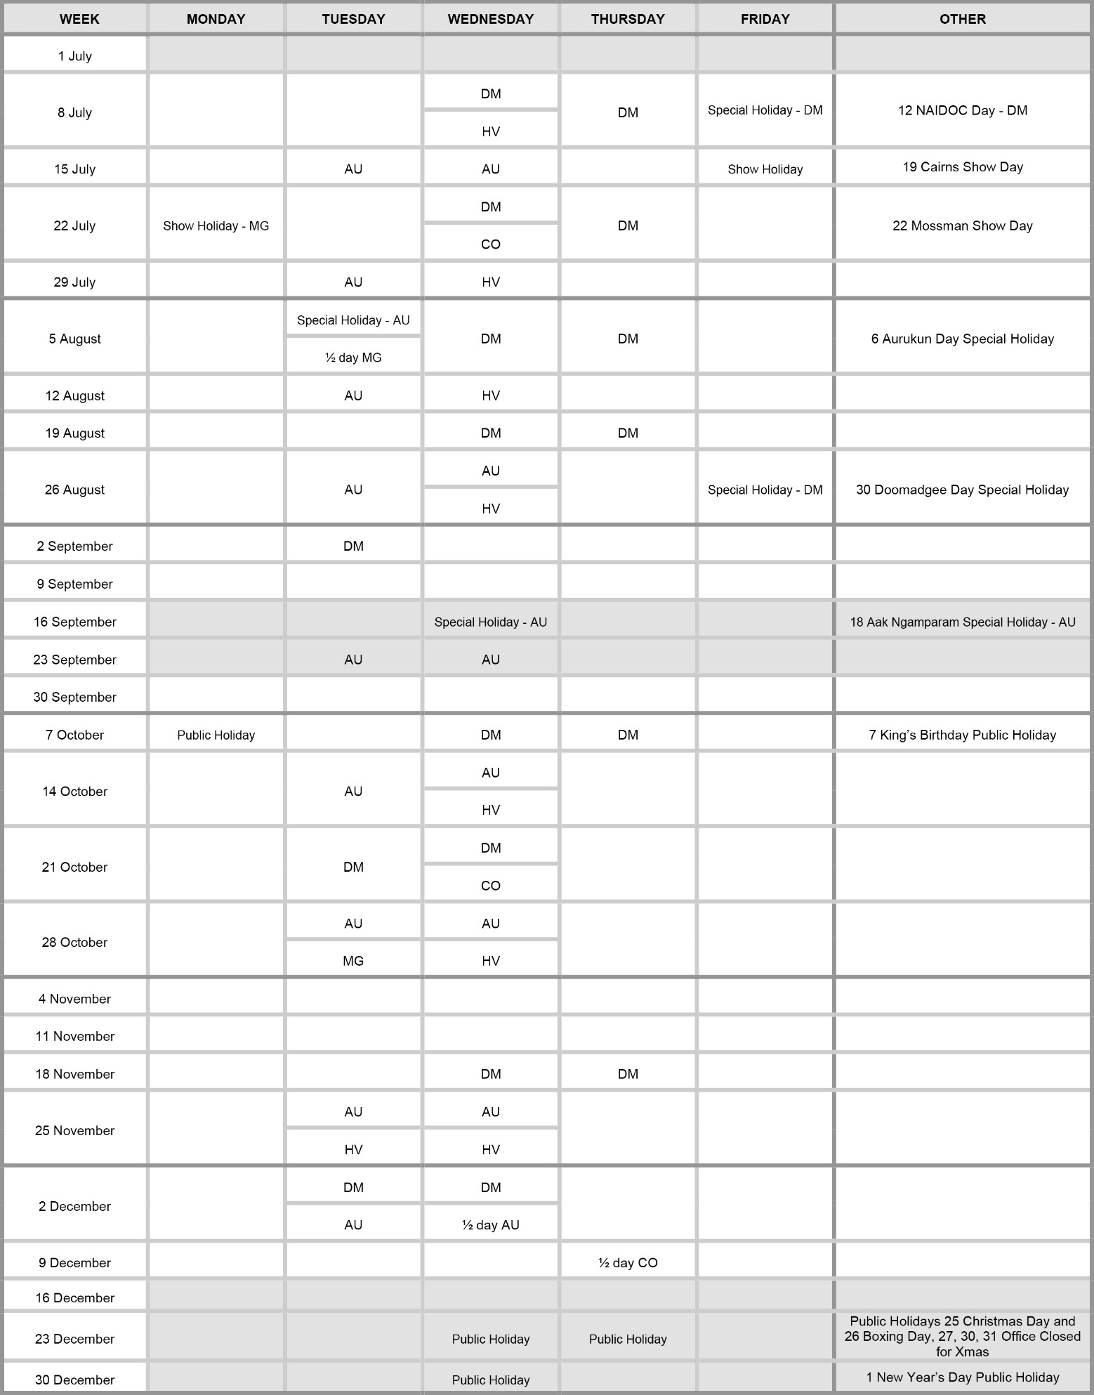
Family Responsibilities Commission 1 July 2024 to 31 December 2024

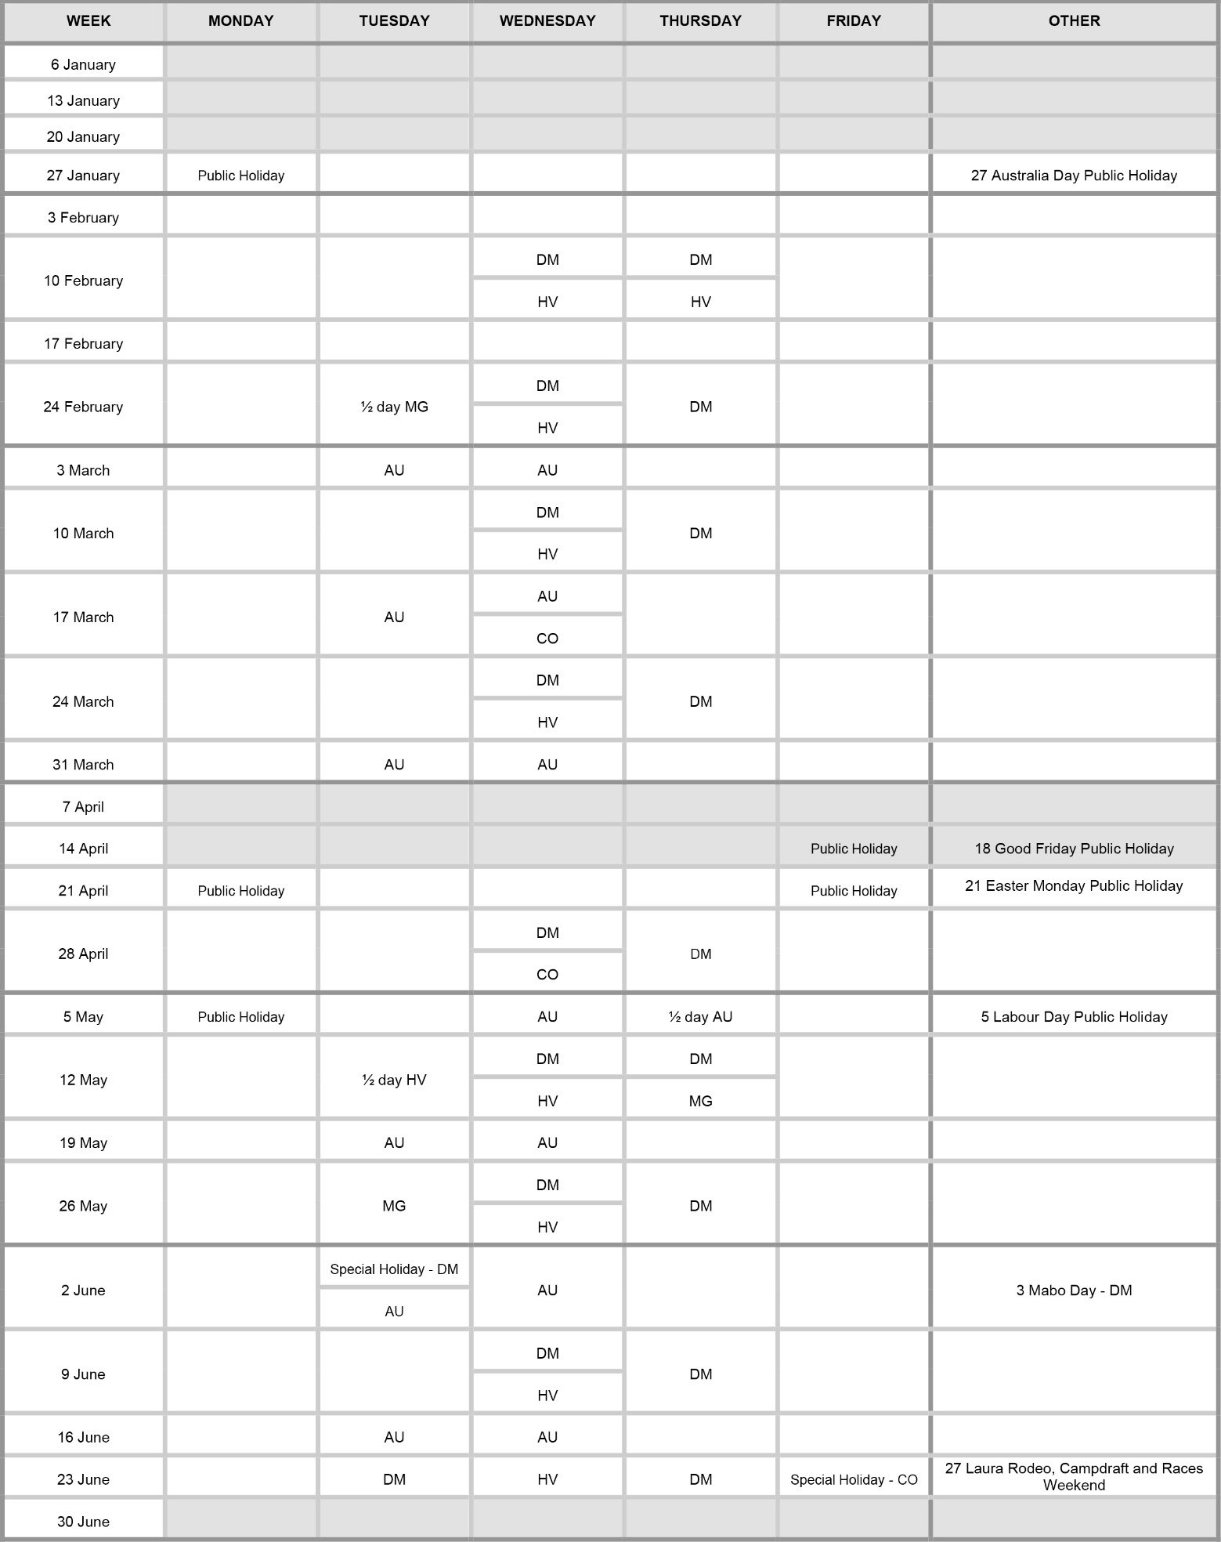
Family Responsibilities Commission 1 January 2025 to 30 June 2025

Appendix E – Client Engagement activities

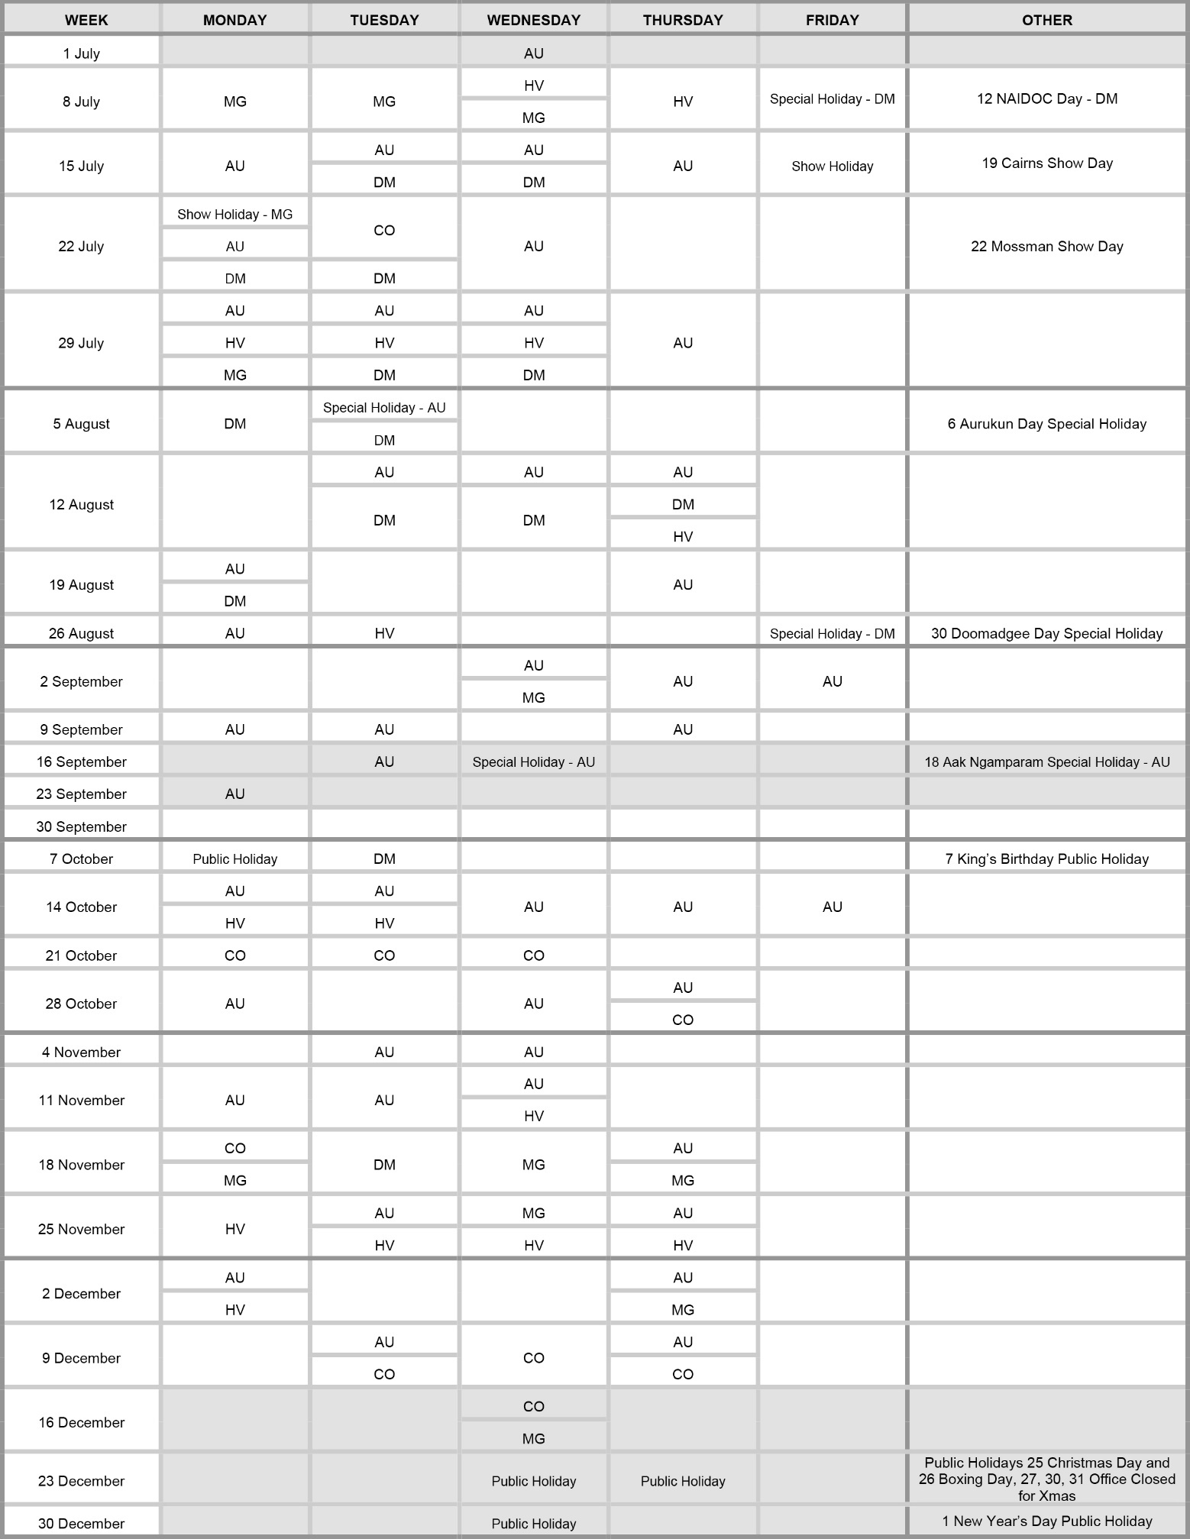
Family Responsibilities Commission 1 July 2024 to 31 December 2024

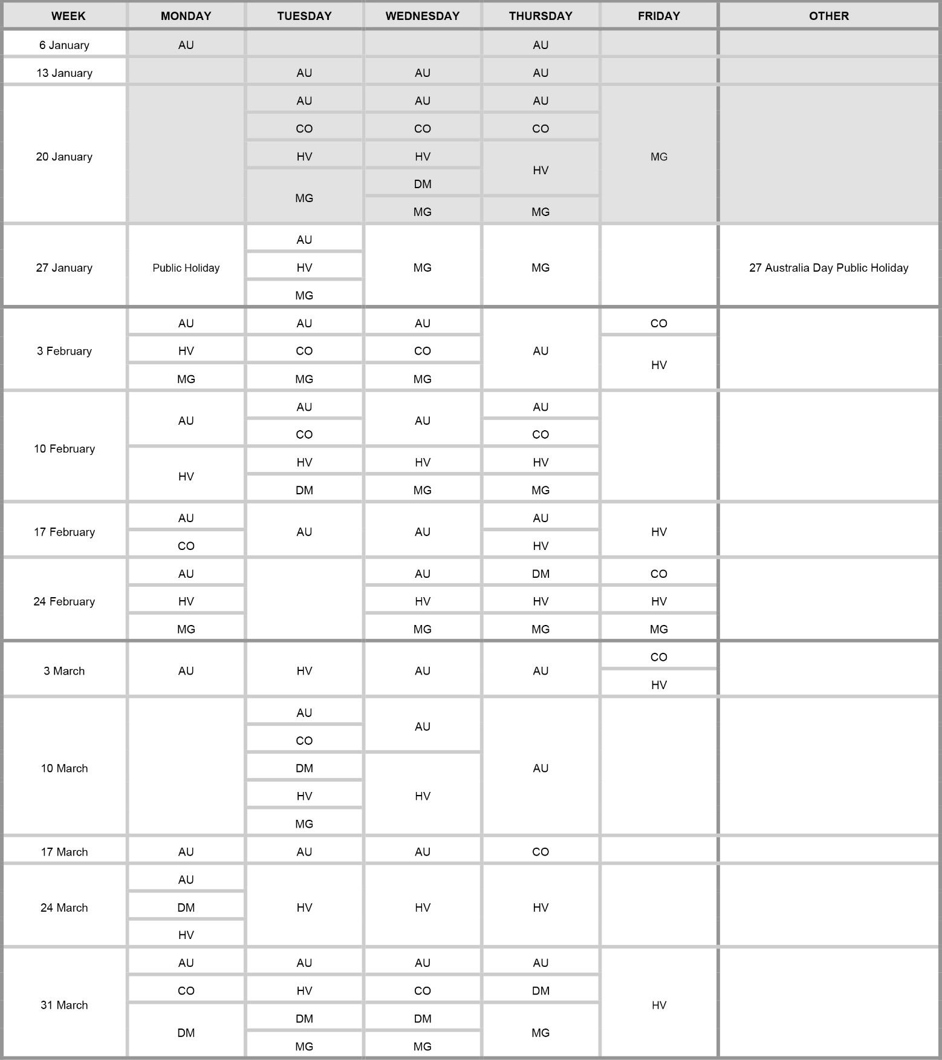
Family Responsibilities Commission 1 January 2025 to 6 April 2025

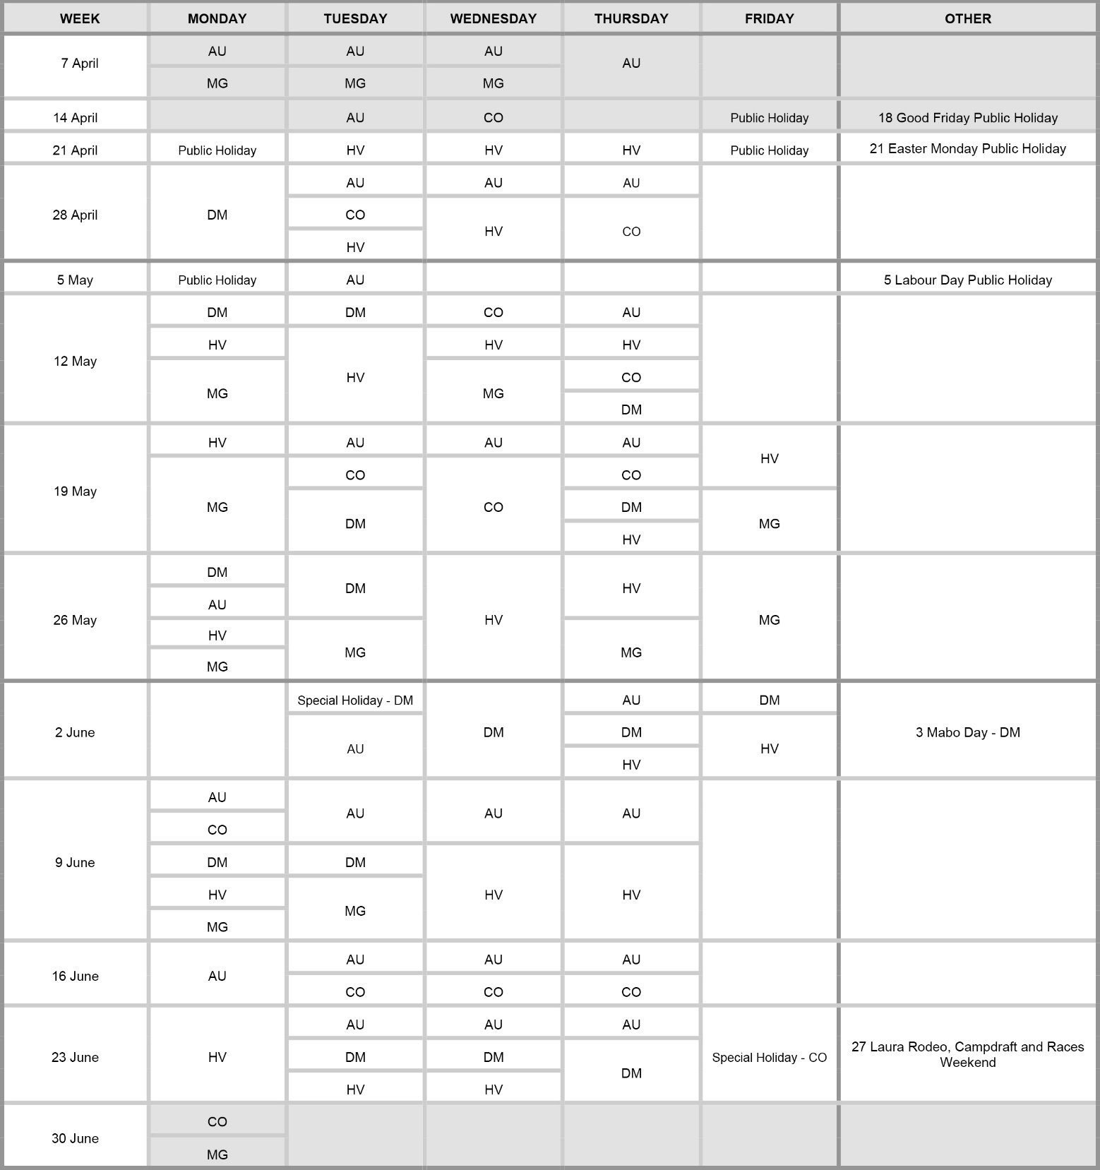
Family Responsibilities Commission 7 April 2025 to 30 June 2025

Appendix F – Compliance checklist

Family Responsibilities Commission 2024-25 annual report
Summary of requirement |  | Basis for requirement | Annual report reference
Letter of compliance | - A letter of compliance from the accountable officer or statutory body to the relevant Minister/s | ARRs – section 7 | Page 4
Accessibility | - Table of contents  - Glossary | ARRs – section 9.1 | Page 5  Page 152
Accessibility | - Public availability | ARRs – section 9.2 | Page 2
Accessibility | - Interpreter service statement | Queensland Government Language Services Policy  ARRs – section 9.3 | Page 2
Accessibility | - Copyright notice | Copyright Act 1968  ARRs – section 9.4 | Page 2
Accessibility | - Information licensing | QGEA – Information Licensing  ARRs – section 9.5 | N/A
General information | - Introductory Information | ARRs – section 10 | Pages 8-41,  73-88, 126-127
Non-financial performance | - Government’s objectives for the community and whole-of-government plans/specific initiatives | ARRs – section 11.1 | Pages 42-43, 128-129
Non-financial performance | - Agency objectives and performance indicators | ARRs – section 11.2 | Pages 15-72, 126-127
Non-financial performance | - Agency service areas and service standards | ARRs – section 11.3 | Pages 15-72
Financial performance | - Summary of financial performance | ARRs – section 12.1 | Pages 101-102
Governance – management and structure | - Organisational structure | ARRs – section 13.1 | Pages 11-12, 28-31, 89-90
Governance – management and structure | - Executive management | ARRs – section 13.2 | Pages 28, 90-91
Governance – management and structure | - Government bodies (statutory bodies and other entities) | ARRs – section 13.3 | N/A
Governance – management and structure | - Public Sector Ethics | Public Sector Ethics Act 1994  ARRs – section 13.4 | Page 92
Governance – management and structure | - Human Rights | Human Rights Act 2019  ARRs – section 13.5 | Pages 92-93
Governance – management and structure | - Queensland public service values | ARRs – section 13.6 | Page 91

Summary of requirement |  | Basis for requirement | Annual report reference
Governance – risk management and accountability | - Risk management | ARRs – section 14.1 | Page 93
Governance – risk management and accountability | - Audit committee | ARRs – section 14.2 | Page 94
Governance – risk management and accountability | - Internal audit | ARRs – section 14.3 | Page 94
Governance – risk management and accountability | - External scrutiny | ARRs – section 14.4 | Pages 94-95
Governance – risk management and accountability | - Information systems and record keeping | ARRs – section 14.5 | Page 95
Governance – risk management and accountability | - Information security attestation | ARRs – section 14.6 | N/A
Governance – human resources | - Strategic workforce planning and performance | ARRs – section 15.1 | Pages 95-100
Governance – human resources | - Early retirement, redundancy and retrenchment | Directive No. 04/18 Early Retirement, Redundancy and Retrenchment  ARRs – section 15.2 | Page 97
Open Data | - Statement advising publication of information | ARRs – section 16 | Page100
Open Data | - Consultancies | ARRs – section 31.1 | Page 100
Open Data | - Overseas travel | ARRs – section 31.2 | Page 100
Open Data | - Queensland Language Services Policy | ARRs – section 31.3 | N/A
Open Data | - Charter of Victims’ Rights | VCSVRB Act 2024  ARRs – section 31.4 | Page 97
Financial statements | - Certification of financial statements | FAA – section 62  FPMS – sections 38, 39 and 46  ARRs – section 17.1 | Pages 18-20
Financial statements | - Independent Auditor’s Report | FAA – section 62  FPMS – section 46  ARRs – section 17.2 | Pages19-20 of 20

Appendix G – Communities’ resident population
Aurukun
Aurukun is on the western coast of Cape York and is approximately 900 kilometres northwest of Cairns, and about 200 kilometres south of Weipa. The community had an estimated resident adult population of 813 people as at 30 June 2024.,
Coen
The township of Coen is approximately halfway between Cairns and the tip of Cape York. It is not a discrete Aboriginal community and is part of Cook Shire. The township had an estimated resident adult population of 208 people as at 30 June 2024.^{1,}
Doomadgee
Doomadgee lies alongside the Nicholson River, one of the permanent freshwater rivers that flow from the ranges behind Lawn Hill National Park in North-West Queensland. Doomadgee is the first (or last) township on the Queensland section of the Savannah Way. It is 630 kilometres by road to Mt Isa and 1035 kilometres west of Cairns. The community had an estimated resident adult population of 929 people as at 30 June 2024.^{1,2}
Hope Vale
Hope Vale is situated on the Cape York Peninsula and is 46 kilometres northwest of Cooktown. The estimated resident adult population of Hope Vale was 677 people as at 30 June 2024.^{1,2}
Mossman Gorge
Mossman Gorge is a small Aboriginal community 75 kilometres north of Cairns, 4 kilometres from Mossman (the nearest town), and approximately 25 kilometres by road from Port Douglas. It is not a discrete Aboriginal community and is part of the Douglas Shire Council area. The community had an estimated resident population of 102 people as at 30 June 2024.^{1,}

Abbreviations
ABS Australian Bureau of Statistics |  | DSS Department of Social Services
AD Dame of the Order of Australia |  | DTATSIPCA  Department of Treaty, Aboriginal and Torres Strait Islander Partnerships, Communities and the Arts
ARRs Annual Report Requirements for Queensland Government agencies |  | DV Domestic Violence
ATSILS Aboriginal and Torres Strait Islander Legal Service |  | DVB Domestic Violence Breach
AU Aurukun |  | DVO Domestic Violence Order
BBNAC Bamanga Bubu Ngadimunku Aboriginal Corporation |  | DWATSIPM  Department of Women, Aboriginal and Torres Strait Islander Partnerships and Multiculturalism
BCI Business Continuity Institute |  | EMT Executive Management Team
BCP Business Continuity Plan |  | EQ Education Queensland School Attendance
C&LP Corporate and Legal Policy |  | ERP Estimated Resident Population
CCP Conditional Case Plan |  | ESR Elevated School Response
CDC Cashless Debit Card |  | FAA Financial Accountability Act 2009
CE Client Engagement |  | FPMS Financial and Performance Management Standard 2019
CEO Chief Executive Officer |  | FRA Family Responsibilities Agreement
CHI Childrens Court |  | FRC Family Responsibilities Commission
CIM Conditional Income Management |  | FTE Full time Equivalent
CIPD Chartered Institute of Personnel and Development |  | HR Human Resources
CM&M Case Management and Monitoring |  | HT Housing Tenancy
CO Coen  CPI Consumer Price Index |  | HV Hope Vale
CRM Customer Relationship Management |  | ICT Information and Communications Technology
CS Child Safety and Welfare |  | MAG Magistrates Court
CVO Commander of the Royal Victorian Order |  | MG Mossman Gorge
CYAAA Cape York Aboriginal Australian Academy |  | MoU Memorandum of Understanding
CYI Cape York Institute |  | NAIDOC National Aborigines and Islanders Observance Committee
C&LP Corporate and Legal Policy |  | NIAA National Indigenous Australians Agency
DFV Domestic and Family Violence |  | NWRH North and West Remote Health
DIS District Court |  | OAM Medal of the Order of Australia
DM Doomadgee |  | PDA Performance and Development Agreement

Abbreviations continued
PID Personal Information Disclosure |  | SA Services Australia
PJCHR Australian Parliamentary Joint Committee on Human Rights |  | SAO School Attendance Officer
PPD Police Protection Direction |  | SEN School Enrolment Notice
PSC Public Service Commission |  | TAFE Technical and Further Education
QCS Queensland Corrective Services |  | TCHHS Torres and Cape Hospital and Health Service
QGAO Queensland Government Accommodation Office |  | UK United Kingdom
QGSO Queensland Government Statistician’s Office |  | VCP Voluntary Case Plan
QLD Queensland |  | VIM Voluntary Income Management
RAATSICC Remote Area Aboriginal and Torres Strait Islander Child Care |  | WBC Wellbeing Centre
RFDS Royal Flying Doctor Service |  | YJRS Youth Justice Reform Select
RFQ Request for Quote

Also:
Charter of Victim’s Right (the Charter)
Family Responsibilities Board (FR Board)
Family Responsibilities Commission (the Commission)
Family Responsibilities Commission Act 2008 (FRC Act)
Domestic and Family Violence Protection and Other Legislation Amendment Bill 2025 (DFVOLA Bill)
Family Responsibilities Commission registry (the registry)
Ms Tammy Williams, Family Responsibilities Commissioner (the Commissioner)

Family Responsibilities Commission
Cairns registry
PO Box 5438, Cairns Qld 4870
Level 3, 107 Lake Street, Cairns 4870
Ph (07) 4081 8400
Fax (07) 4041 0974
www.frcq.org.au
Aurukun
CJG Building, Wuungkam Street, Aurukun 4892
Ph (07) 4060 6185
Fax (07) 4041 0974
Coen
Coen Hub, 7 Taylor Street, Coen 4892
Ph 0417 798 392
Fax (07) 4041 0974
Doomadgee
Doomadgee Community Justice Centre, Office 4/15 Sharpe Street, Doomadgee 4830
Ph (07) 4745 8111
Fax (07) 4041 0974
Hope Vale
Office 1, Hope Vale Business Service Centre, 3 Muni Street, Hope Vale 4895
Ph (07) 4060 9153
Fax (07) 4041 0974
Mossman Gorge
Lot 152 Mossman Gorge Road, Mossman Gorge 4873
Ph 0417 798 392
Fax (07) 4041 0974
For more information on the communities and population compositions, view the Quarterly Reports at: https://www.dwatsipm.qld.gov.au/our-work/aboriginal-torres-strait-islander-partnerships/discrete-remote-communities/welfare-reform and https://statistics.qgso.qld.gov.au/qld-regional-profiles.

Inside back cover

Outside back cover

Section 24 of the Family Responsibilities Commission Act 2008.
Excluding decisions on amend/end applications.
The Australian Institute of Health and Welfare defines an “Older Indigenous Australian” as aged 50 and over.
When a client is entering into a voluntary agreement, they may choose one or more option to reflect their individual circumstances and reasons for participating in voluntary income management.
A client may choose one or more option to reflect their individual reasons in participating in voluntary income management.
A client may choose one or more option to reflect their individual circumstances in participating in voluntary income management.
There were no decision by agreements for income management pursuant to section 68(2)(b) FRC Act 2008 made during 2024-25.
In 2024-25 there was a total of 2,339 CE activities relating to 840 clients. These activities include both contact and non-contact activities. Of these, 50 instances were related to administrative support, such as preparation for upcoming CEs and 493 instances involved unsuccessful attempts to engage with a client for the following reasons: medical, no longer living in community, not suitable time, out of the community, in prison, sorry business, substance affected/aggressive and unable to locate.
Number of not served conference slots due to medical, no longer living in community, not suitable time, out of the community, in prison, sorry business or substance affected.
Number of non-contact CE activities with 50 instances related to administrative support, such as preparation for upcoming CEs and 493 instances involved unsuccessful attempts to engage with a client for to the following reasons: medical, no longer living in community, not suitable time, out of the community, in prison, sorry business, substance affected/aggressive and unable to locate.
This figure records the total time attributable to all CE activities inclusive of contact and non-contact activities. In December 2024 the time spent field of the CE spreadsheet was updated from 15 minute graduations to 5 minute graduations to provide more practical options reflective of the time spent for each CE activity.
Number of not served conference slots due to medical, no longer living in community, not suitable time, out of the community, in prison, sorry business or substance affected.
Number of non-contact CE activities with 50 instances related to administrative support, such as preparation for upcoming CEs and 493 instances involved unsuccessful attempts to engage with a client for to the following reasons: medical, no longer living in community, not suitable time, out of the community, in prison, sorry business, substance affected/aggressive and unable to locate.
This figure records the total time attributable to all CE activities inclusive of contact and non-contact activities. In December 2024 the time spent field of the CE spreadsheet was updated from 15 minute graduations to 5 minute graduations to provide more practical options reflective of the time spent for each client engagement activity.
A pool of Local Commissioners for each welfare reform community area are appointed by Governor in Council for a term: section 12(2) and (3) of the FRC Act.
Counts in this table only include clients who had a combination of a VIM and CCP only and VIM, VCP and a CCP only, in other words there has been no CIM issued.
Counts in this table only include clients who had a VIM or VCP and no CIM or CCP.
Note the 241 clients on a CCP without a CIM does include 12 clients who were on a CCP, VCP and VIM and 13 clients who were on a CCP and VIM.
A case plan can have multiple referrals e.g. a client may be referred to both the Wellbeing Centre and MPower under the same case plan.
Department of Education, Department of Families, Seniors, Disability Services and Child Safety, Department of Housing and Public Works, Department of Justice and Attorney-General (Queensland Courts) and the Queensland Police Service.
Agency notices for the community of Doomadgee are presently received from the Department of Education and the Department of Families, Seniors, Disability Services and Child Safety only.
Descriptions for each type of notice acronym can be found in the glossary.
In 2024-25 there was a total of 2,339 CE activities undertaken by the FRC to support clients outside of conference inclusive of contact and non-contact activities relating to 840 clients.
.A client may choose one or more options to reflect their individual reasons and circumstances in participating in voluntary income management and therefore the percentage is derived by using the number of VIM agreements as the divisor.
Inclusive of one application to end a CIM made under a decision by order (s69 of the FRC Act) which did not proceed to a hearing as the client was out of community and could not be served the notice to attend the hearing. After a period of two months had elapsed the application was refused under section 101 of the FRC Act.
This figure records the total number of all client engagement activities undertaken in Aurukun by the FRC to support clients outside of conference. These activities include both contact and non-contact activities. Of these, 8 instances were related to administrative support, such as preparation for upcoming client engagements and 107 instances involved unsuccessful attempts to engage with a client for the following reasons: medical, no longer living in community, not suitable time, out of the community, in prison, sorry business, substance affected/aggressive and unable to locate.
This figure records the total number of Aurukun community members identified with a client engagement activity outside of conference inclusive of contact and non-contact activities.
This figure records the total number of all client engagement activities undertaken in Coen by the FRC to support clients outside of conference. These include both contact and non-contact activities. Of these, 18 instances were related to administrative support including preparation for upcoming client engagements and 51 instances involved unsuccessful attempts to engage with a client for to the following reasons: medical, no longer living in community, not suitable time, out of the community, in prison, sorry business, substance affected/aggressive and unable to locate.
This figure records the total number of Coen community members identified with a client engagement activity outside of conference inclusive of contact and non-contact activities.
Australian Statistical Geography Standard Edition 3, July 2021 – June 2026 boundaries for statistical areas level 1 (SA1s) of 31501139616 for Coen. Adults 18 years and over provided by QGSO, Queensland Treasury, based on the ABS unpublished preliminary ERP data by age and sex at the Statistical Area level 1 for 30 June 2024.
Section 20(1)(iii) disqualifies a person from being a Local Commissioner if ‘the person is, or has been, the subject of a family responsibilities agreement or a decision of the Commission under section 69(1)(b)’.
This figure records the total number of all client engagement activities undertaken in Doomadgee by the FRC to support clients outside of conference. These include both contact and non-contact activities. Of these, 3 instances were related to administrative support including preparation for upcoming client engagements and 185 instances involved unsuccessful attempts to engage with a client for to the following reasons: medical, no longer living in community, not suitable time, out of the community, in prison, sorry business, substance affected/aggressive and unable to locate.
This figure records the total number of Doomadgee community members identified with a client engagement activity outside of conference inclusive of contact and non-contact activities.
This figure records the total number of all client engagement activities undertaken in Hope Vale by the FRC to support clients outside of conference. These include both contact and non-contact activities. Of these, 15 instances were related to administrative support including preparation for upcoming client engagements and 106 instances involved unsuccessful attempts to engage with a client for the following reasons: medical, no longer living in community, not suitable time, out of the community, in prison, sorry business, substance affected/aggressive and unable to locate.
This figure records the total number of Hope Vale community members identified with a client engagement activity outside of conference inclusive of contact and non-contact activities.
This figure records the total number of all client engagement activities undertaken in Mossman Gorge by the FRC to support clients outside of conference. These include both contact and non-contact activities. Of these, 6 instances were related to administrative support including preparation for upcoming client engagements and 44 instances involved unsuccessful attempts to engage with a client for the following reasons: medical, no longer living in community, not suitable time, out of the community, in prison, sorry business, substance affected/aggressive and unable to locate.
This figure records the total number of Mossman Gorge community members identified with a client engagement activity outside of conference inclusive of contact and non-contact activities.
“Report No. 3 — 58th Parliament, May 2025”, tabled on 23 May 2025 reference number 5825T0538.
Family Responsibilities Commission 2023-24 Annual Report, page 10
Family Responsibilities Commission Act 2008 Explanatory Note, page 3
Ibid
Cape York Institute: Overcoming Entrenched Disadvantage by Building Family Responsibility, July 2022, page 20
Ibid
Premier’s Charter Letter to Minister Simpson
https://www.housing.qld.gov.au/about/department/business-areas/public-works/qbuild/about-qbuild
https://www.housing.qld.gov.au/__data/assets/pdf_file/0024/64329/qbuild-regional-map.pdf
When the link to the listed jobs in clicked the following message is displayed: “Sorry, the requested job cannot be displayed as it has most likely closed or been removed.”
Prescribed entity is defined in s90 of the FRC Act.
Relevant information is defined in s91 of the FRC Act.
Sections 92 and 93.
Section 43.
This includes Aboriginal and Torres Strait Islander languages or Australian South Sea Islander languages spoken at home.
Note: Australian Statistical Geography Standard Edition 3, July 2021 – June 2026 boundaries for local government areas of Aurukun, Doomadgee and Hope Vale, and statistical areas level 1 (SA1s) of 31501139616 for Coen and 30604116408 for Mossman Gorge.
Note: Adults 18 years and over provided by the Queensland Government Statistician’s Office (QGSO), Queensland Treasury, based on the ABS unpublished preliminary Estimated Resident Population (ERP) data by age and sex at the Local Government Area level for 30 June 2024.
Note: Adults 18 years and over provided by QGSO, Queensland Treasury, based on the ABS unpublished preliminary ERP data by age and sex at the Statistical Area level 1 for 30 June 2024.
Note: Total population provided by QGSO, Queensland Treasury, not 18 years and older, due to the small size of the total population from the ABS unpublished preliminary ERP data at the Statistical Area level 1 for 30 June 2024.
Post 30 June 2025 the FRC Cairns registry has relocated to 184 Mulgrave Road, Cairns QLD 4870. Our postal address, phone and fax numbers have not changed.
After inspecting our office in Mossman Gorge following Cyclone Jasper in December 2023, the office was deemed as unusable due to damage from the flooding event which further exacerbated the pre-existing mould infestation. As a consequence, the FRC has been renting a room at the Mossman Gateway Centre to conduct its business including conferencing.

